CALCULUS · UNIT 1: PRECALCULUS REVIEW  Phone Battery Lab  Review function families by modeling a phone’s battery, charging, and app data. | CP1  2–3 class periods

Name: ________________________________ Date: ______________ Period: ______
The Scenario
A phone company wants a student lab to test its new phone. The battery drains while streaming, charges quickly at first and then slowly, the screen brightness follows the sunlight, and the data plan has a price that changes after a limit.
You will use the function families you need for calculus to model the phone and answer the company’s questions.
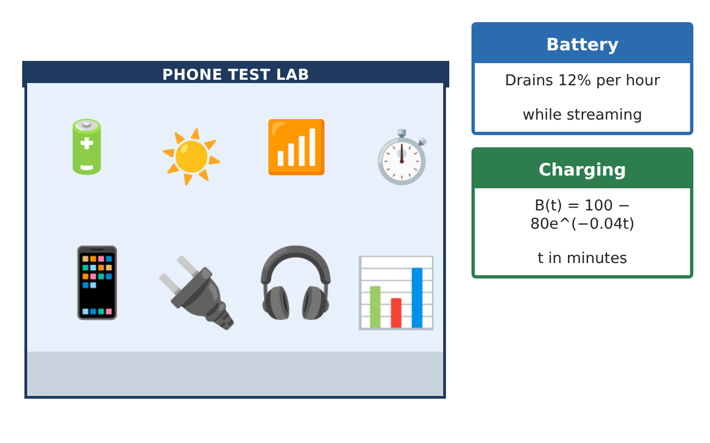
Learning Goals
- I can build and interpret linear, exponential, logarithmic, and trig models.
- I can compose, invert, and transform functions.
- I can analyze end behavior and asymptotes.
Project Timeline
When | What you will do
Day 1 | Drain & Charge
Day 2 | Function Toolkit
Day 3 | Brightness Cycle
Final | Battery Lab Report + reflection
Part 1: Drain & Charge
Day 1 · Use the Lab Data Cards.
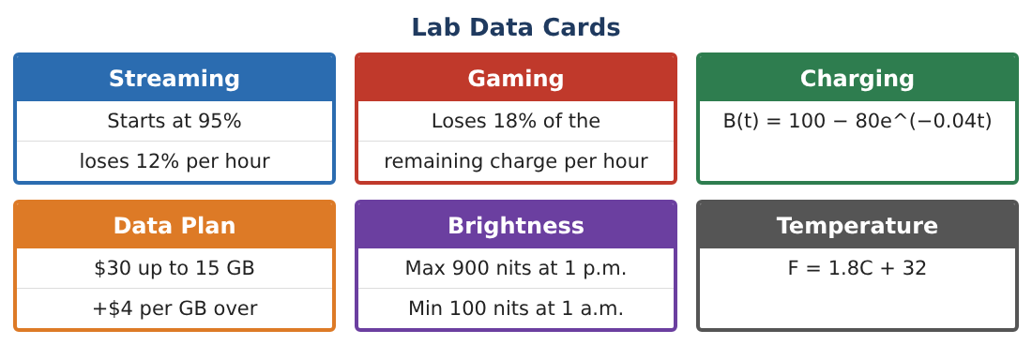
1. When are the streaming (95 − 12t) and gaming (95(0.82)ᵗ) batteries equal after t = 0? Use a graph or table.

2. Solve B(t) = 95 for the charging model.

3. Describe the end behavior of B(t) and write its horizontal asymptote.

4. Write the inverse of B(t) and explain what it tells you.

Part 2: Function Toolkit
Day 2 · Plans and conversions.
5. Write P(g) as a piecewise function and graph it. Is it continuous at g = 15?

6. Let C(F) = $\frac{F − 32}{1.8}$ and W(C) = 0.02C² (heat warning level). Find W(C(104)).

7. Describe the transformation from y = eᵗ to y = 100 − 80e^(−0.04t).

8. Find the average rate of change of B on [0, 30] and on [30, 60]. What do you notice?

Part 3: Brightness Cycle
Day 3 · Max 900 nits at 1 p.m. (t = 13), min 100 at 1 a.m.
9. Write a cosine model L(t) for brightness, t in hours after midnight.

10. Find L(8) and L(20).

11. When is brightness at least 700 nits?

Final Product: Battery Lab Report
Your final product must include:
- Comparison of drain models
- Charging inverse and asymptote
- Composition and continuity
- Brightness model and interval
- Lab report with graphs
Reflection
R1. What does the average rate of change tell you that a single value does not?

R2. Why is continuity of the data plan important to customers?

Scoring Rubric
Criteria | 4 – Exceeds | 3 – Meets | 2 – Approaching | 1 – Beginning
Mathematical Accuracy | All calculations and solutions are correct; answers include units and are checked. | Nearly all work is correct; minor errors do not change conclusions. | Several errors; some conclusions are affected. | Many errors or missing work.
Reasoning & Justification | Clear, complete explanations connect every answer to the situation; uses precise vocabulary. | Explanations are mostly clear and connected to the situation. | Explanations are brief or partly unclear. | Little or no explanation.
Application & Design | Models for battery, charging, plans, and brightness are built and used correctly. Goes beyond the minimum with a creative, realistic choice. | Models for battery, charging, plans, and brightness are built and used correctly. | Design is incomplete or only partly uses the math from the unit. | Design is missing or unrelated to the unit math.
Communication & Presentation | Lab report includes models, graphs, calculations, and conclusions. Polished, organized, and visually engaging. | Lab report includes models, graphs, calculations, and conclusions. Organized and easy to follow. | Product is missing required parts or is hard to follow. | Product is mostly missing.

