CALCULUS · UNIT 1: PRECALCULUS REVIEW  Phone Battery Lab  Review function families by modeling a phone’s battery, charging, and app data. | CP2  2–3 class periods

Name: ________________________________ Date: ______________ Period: ______
The Scenario
A phone company wants a student lab to test its new phone. The battery drains while streaming, charges quickly at first and then slowly, the screen brightness follows the sunlight, and the data plan has a price that changes after a limit.
You will use the function families you need for calculus to model the phone and answer the company’s questions.
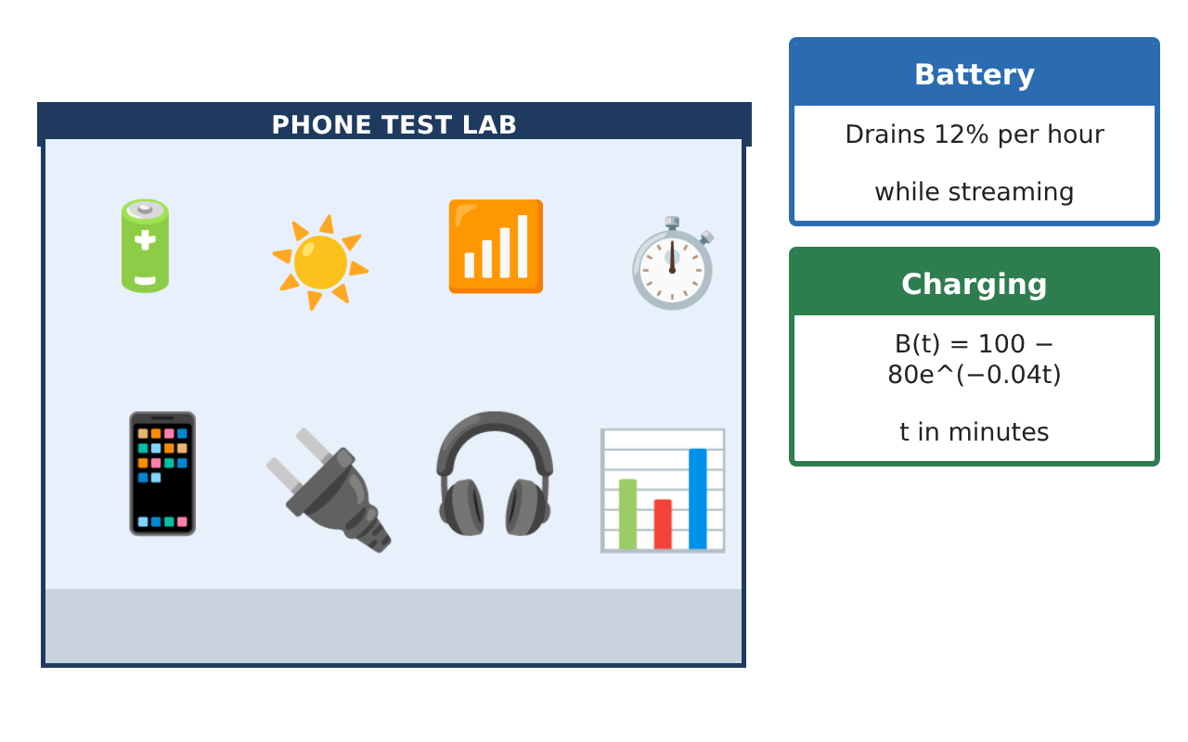
Learning Goals
- I can write and use linear and exponential models.
- I can evaluate piecewise functions and compositions.
- I can use logarithms to solve for time.
Project Timeline
When | What you will do
Day 1 | Battery Models
Day 2 | Plans & Conversions
Day 3 | Charging & Brightness
Final | Battery Lab Report + reflection
Part 1: Battery Models
Day 1 · Use the Lab Data Cards. t is in hours.
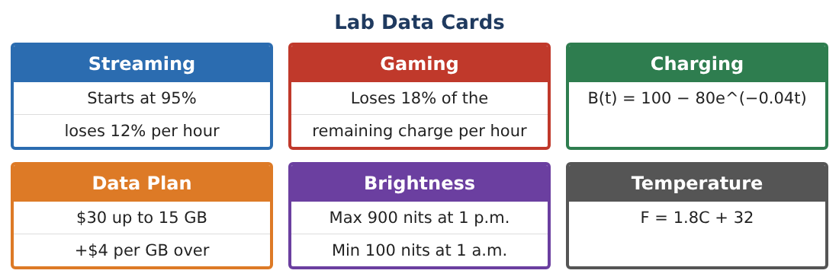
1. Write a linear model for streaming: S(t) = 95 − 12t. When is the battery at 20%?

2. Write an exponential model for gaming starting at 95%.
Starter: G(t) = 95(1 − ___)ᵗ

3. Find G(3) and S(3). Which drains faster in the first 3 hours?

4. What is the domain of S in this context?

Part 2: Plans & Conversions
Day 2 · Data plan: $30 up to 15 GB, then $4 per GB over 15.
5. Write the cost as a piecewise function P(g).

6. Find P(12) and P(20).

7. The phone’s temperature is 35°C. Use F = 1.8C + 32 to convert. Then find the inverse function C(F).

8. Is P(g) one-to-one? Explain.

Part 3: Charging & Brightness
Day 3 · B(t) = 100 − 80e^(−0.04t), t in minutes.
9. Find B(0), B(30), and B(60).

10. Solve B(t) = 90 using logarithms.

11. Brightness has a maximum 900 at 1 p.m. and a minimum 100 at 1 a.m. Find the midline, amplitude, and period.

Final Product: Battery Lab Report
Your final product must include:
- Battery models with graphs
- Piecewise data plan
- Conversion and inverse
- Charging time with logarithms
- Lab report
Reflection
R1. How can you tell from a table whether data is linear or exponential?

R2. Why does the charging model level off at 100?

Scoring Rubric
Criteria | 4 – Exceeds | 3 – Meets | 2 – Approaching | 1 – Beginning
Mathematical Accuracy | All calculations and solutions are correct; answers include units and are checked. | Nearly all work is correct; minor errors do not change conclusions. | Several errors; some conclusions are affected. | Many errors or missing work.
Reasoning & Justification | Clear, complete explanations connect every answer to the situation; uses precise vocabulary. | Explanations are mostly clear and connected to the situation. | Explanations are brief or partly unclear. | Little or no explanation.
Application & Design | Models for battery, charging, plans, and brightness are built and used correctly. Goes beyond the minimum with a creative, realistic choice. | Models for battery, charging, plans, and brightness are built and used correctly. | Design is incomplete or only partly uses the math from the unit. | Design is missing or unrelated to the unit math.
Communication & Presentation | Lab report includes models, graphs, calculations, and conclusions. Polished, organized, and visually engaging. | Lab report includes models, graphs, calculations, and conclusions. Organized and easy to follow. | Product is missing required parts or is hard to follow. | Product is mostly missing.

