CALCULUS · UNIT 3: DERIVATIVES  Sprint Coach Analytics  Use derivatives to analyze a sprinter’s position, velocity, and acceleration in a 100-meter race. | CP1  2–3 class periods

Name: ________________________________ Date: ______________ Period: ______
The Scenario
Your track team bought laser timing gates that record a sprinter’s position every second of a 100-meter race. The coach wants to know the top speed, when the sprinter accelerates fastest, and how to improve.
You will use derivatives to turn position data into velocity and acceleration and give the coach a report.
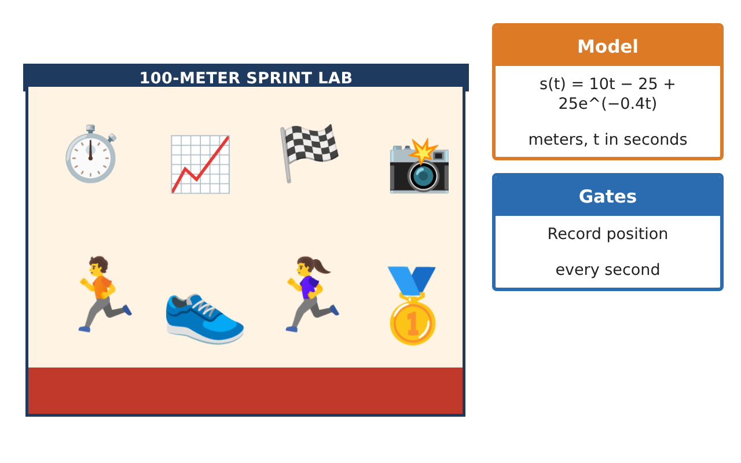
Learning Goals
- I can estimate and compute derivatives from data and formulas.
- I can use the power, product, quotient, and chain rules.
- I can interpret velocity and acceleration and use tangent lines.
Project Timeline
When | What you will do
Day 1 | Data to Derivatives
Day 2 | Model Derivatives
Day 3 | Rules Practice
Final | Coaching Analytics Report + reflection
Part 1: Data to Derivatives
Day 1 · Use the Timing Gate Data.
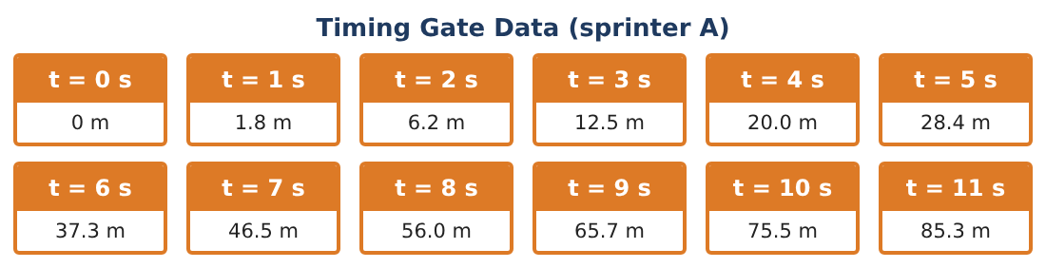
1. Estimate s′(2), s′(5), and s′(10) using symmetric differences.

2. Estimate the acceleration at t = 5 using velocity estimates at t = 4 and t = 6 (s′(4) ≈ 7.95, s′(6) ≈ 9.05).

3. Is the sprinter’s velocity increasing at a decreasing rate? Explain with the data.

4. Sketch the velocity graph from your estimates.

Part 2: Model Derivatives
Day 2 · s(t) = 10t − 25 + 25e^(−0.4t).
5. Find v(t) = s′(t).

6. Find a(t) = v′(t).

7. Find v(5) and a(5). Compare with your data estimates.

8. What value does v(t) approach? Interpret.

Part 3: Rules Practice
Day 3 · Other runners have different models.
9. Runner B: s(t) = t²(12 − t) ÷ 4 for 0 ≤ t ≤ 8. Use the product rule to find v(t). When is v greatest?

10. Runner C: s(t) = $\frac{12t²}{t + 2}$. Use the quotient rule to find v(t) and v(4).

11. Write the tangent line to s(t) = 10t − 25 + 25e^(−0.4t) at t = 8 and estimate the position at 8.5 s.

Final Product: Coaching Analytics Report
Your final product must include:
- Derivative estimates from data
- Velocity and acceleration models
- Product and quotient rule analyses
- Tangent-line estimate
- Coaching report
Reflection
R1. Why does the acceleration approach 0 as the race goes on?

R2. How did the data estimates compare with the model’s derivatives?

Scoring Rubric
Criteria | 4 – Exceeds | 3 – Meets | 2 – Approaching | 1 – Beginning
Mathematical Accuracy | All calculations and solutions are correct; answers include units and are checked. | Nearly all work is correct; minor errors do not change conclusions. | Several errors; some conclusions are affected. | Many errors or missing work.
Reasoning & Justification | Clear, complete explanations connect every answer to the situation; uses precise vocabulary. | Explanations are mostly clear and connected to the situation. | Explanations are brief or partly unclear. | Little or no explanation.
Application & Design | Derivatives are estimated and computed correctly and interpreted as velocity and acceleration to guide training. Goes beyond the minimum with a creative, realistic choice. | Derivatives are estimated and computed correctly and interpreted as velocity and acceleration to guide training. | Design is incomplete or only partly uses the math from the unit. | Design is missing or unrelated to the unit math.
Communication & Presentation | Report includes data tables, models, derivative work, graphs, and coaching tips. Polished, organized, and visually engaging. | Report includes data tables, models, derivative work, graphs, and coaching tips. Organized and easy to follow. | Product is missing required parts or is hard to follow. | Product is mostly missing.

