CALCULUS · UNIT 3: DERIVATIVES  Sprint Coach Analytics  Use derivatives to analyze a sprinter’s position, velocity, and acceleration in a 100-meter race. | CP2  2–3 class periods

Name: ________________________________ Date: ______________ Period: ______
The Scenario
Your track team bought laser timing gates that record a sprinter’s position every second of a 100-meter race. The coach wants to know the top speed, when the sprinter accelerates fastest, and how to improve.
You will use derivatives to turn position data into velocity and acceleration and give the coach a report.
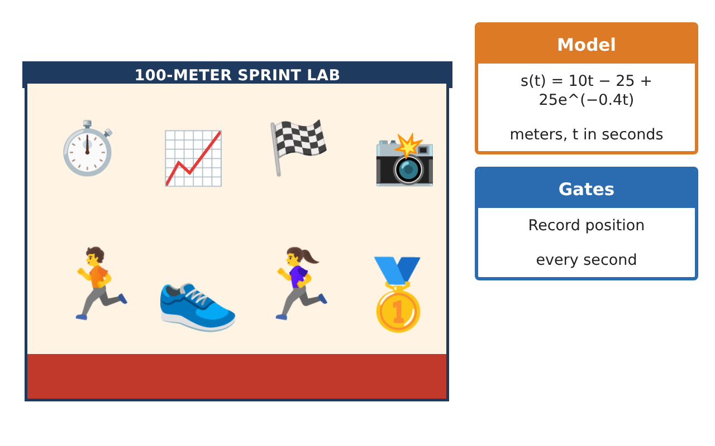
Learning Goals
- I can find average velocity from data.
- I can estimate instantaneous velocity.
- I can use the power rule to find velocity from a position function.
Project Timeline
When | What you will do
Day 1 | Average Velocity
Day 2 | Power Rule
Day 3 | Tangent Lines
Final | Coaching Analytics Report + reflection
Part 1: Average Velocity
Day 1 · Use the Timing Gate Data.
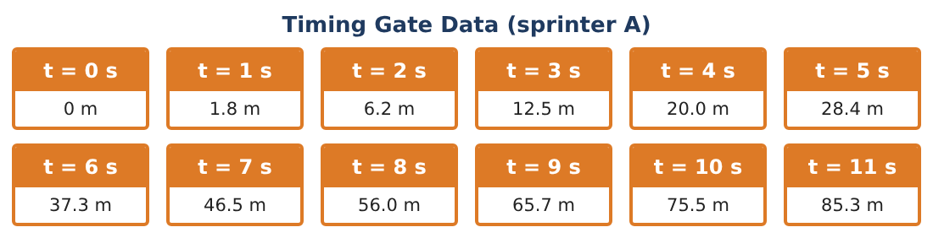
1. Find the average velocity from t = 0 to t = 11 s.
Starter: $\frac{s(11) − s(0)}{11 − 0}$

2. Find the average velocity from t = 1 to 2 s and from t = 9 to 10 s. What do you notice?

3. Estimate the instantaneous velocity at t = 5 s using t = 4 and t = 6.

4. When does the sprinter seem to reach top speed? Use the data.

Part 2: Power Rule
Day 2 · A simpler model for a younger runner is s(t) = 0.5t² for 0 ≤ t ≤ 8.
5. Use the limit definition to find s′(t) for s(t) = 0.5t².
Starter: s′(t) = lim_{h→0} $\frac{s(t + h) − s(t)}{h}$

6. Find the velocity at t = 4 and t = 8.

7. Use the power rule to find the derivative of s(t) = 0.2t³ + t.

8. Find the acceleration a(t) = v′(t) for s(t) = 0.5t².

Part 3: Tangent Lines
Day 3 · Use s(t) = 0.5t².
9. Write the tangent line at t = 6.

10. Use the tangent line to estimate s(6.2). Compare with the actual value.

11. Write two coaching tips based on your velocity results.

Final Product: Coaching Analytics Report
Your final product must include:
- Average and instantaneous velocities
- Derivative by the limit definition
- Power-rule velocities and acceleration
- Tangent-line estimate
- Coaching report
Reflection
R1. How is instantaneous velocity different from average velocity?

R2. What does a positive acceleration mean for the sprinter?

Scoring Rubric
Criteria | 4 – Exceeds | 3 – Meets | 2 – Approaching | 1 – Beginning
Mathematical Accuracy | All calculations and solutions are correct; answers include units and are checked. | Nearly all work is correct; minor errors do not change conclusions. | Several errors; some conclusions are affected. | Many errors or missing work.
Reasoning & Justification | Clear, complete explanations connect every answer to the situation; uses precise vocabulary. | Explanations are mostly clear and connected to the situation. | Explanations are brief or partly unclear. | Little or no explanation.
Application & Design | Derivatives are estimated and computed correctly and interpreted as velocity and acceleration to guide training. Goes beyond the minimum with a creative, realistic choice. | Derivatives are estimated and computed correctly and interpreted as velocity and acceleration to guide training. | Design is incomplete or only partly uses the math from the unit. | Design is missing or unrelated to the unit math.
Communication & Presentation | Report includes data tables, models, derivative work, graphs, and coaching tips. Polished, organized, and visually engaging. | Report includes data tables, models, derivative work, graphs, and coaching tips. Organized and easy to follow. | Product is missing required parts or is hard to follow. | Product is mostly missing.

