CALCULUS · UNIT 3: DERIVATIVES  Sprint Coach Analytics  Use derivatives to analyze a sprinter’s position, velocity, and acceleration in a 100-meter race. | Honors  2–3 class periods

Name: ________________________________ Date: ______________ Period: ______
The Scenario
Your track team bought laser timing gates that record a sprinter’s position every second of a 100-meter race. The coach wants to know the top speed, when the sprinter accelerates fastest, and how to improve.
You will use derivatives to turn position data into velocity and acceleration and give the coach a report.
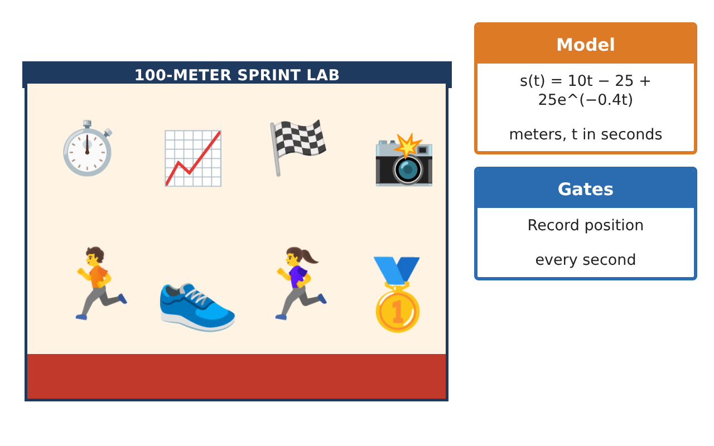
Learning Goals
- I can connect derivative estimates, definitions, and rules.
- I can use the chain rule and implicit reasoning in context.
- I can use derivatives to compare and optimize performance.
Project Timeline
When | What you will do
Day 1 | Model Fitting
Day 2 | Rules & Rates
Day 3 | Comparing Runners
Final | Coaching Analytics Report + reflection
Part 1: Model Fitting
Day 1 · Use the Timing Gate Data and s(t) = vₘₐₓt − $\frac{vₘₐₓ}{k}$(1 − e^(−kt)).
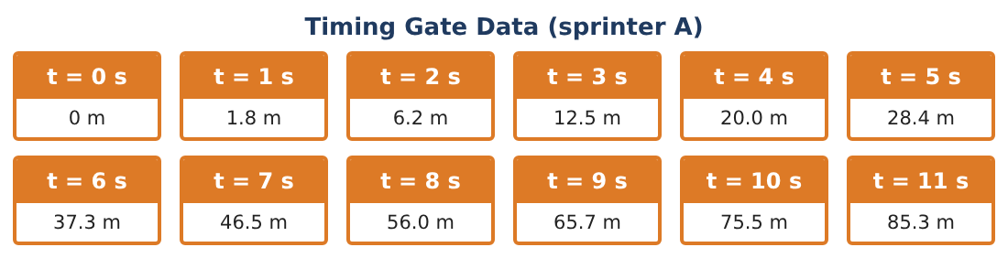
1. Show that the given model s(t) = 10t − 25 + 25e^(−0.4t) has this form. What are vₘₐₓ and k?

2. Find v(t) and show v(0) = 0.

3. Predict the 100-m time using the model (solve s(t) = 100 numerically).

4. The coach improves the start so k = 0.5 (same top speed). Find the new 100-m time.

Part 2: Rules & Rates
Day 2 · Use derivative rules.
5. The sprinter’s stride length is L(v) = 0.18v + 0.6 m. Find $\frac{dL}{dt}$ at t = 3 using the chain rule.

6. Stride rate is r = $\frac{v}{L(v)}$ strides per second. Find $\frac{dr}{dv}$ using the quotient rule.

7. Is stride rate increasing as velocity increases? Explain.

8. Find the jerk (derivative of acceleration) at t = 2 and interpret its sign.

Part 3: Comparing Runners
Day 3 · Runner A: model above. Runner B: s(t) = t²(12 − t) ÷ 4 for 0 ≤ t ≤ 8, then constant velocity.
9. Find when Runner B’s acceleration is 0 and her velocity then.

10. Compare positions at t = 4 and t = 8. Who leads?

11. Write the coaching report recommending one training focus for each runner, citing derivatives.

Final Product: Coaching Analytics Report
Your final product must include:
- Model fitting with parameters
- Predicted and improved race times
- Chain and quotient rule analyses
- Runner comparison
- Coaching report
Reflection
R1. What does the parameter k control in the sprint model?

R2. Why is the chain rule needed for stride length over time?

Scoring Rubric
Criteria | 4 – Exceeds | 3 – Meets | 2 – Approaching | 1 – Beginning
Mathematical Accuracy | All calculations and solutions are correct; answers include units and are checked. | Nearly all work is correct; minor errors do not change conclusions. | Several errors; some conclusions are affected. | Many errors or missing work.
Reasoning & Justification | Clear, complete explanations connect every answer to the situation; uses precise vocabulary. | Explanations are mostly clear and connected to the situation. | Explanations are brief or partly unclear. | Little or no explanation.
Application & Design | Derivatives are estimated and computed correctly and interpreted as velocity and acceleration to guide training. Goes beyond the minimum with a creative, realistic choice. | Derivatives are estimated and computed correctly and interpreted as velocity and acceleration to guide training. | Design is incomplete or only partly uses the math from the unit. | Design is missing or unrelated to the unit math.
Communication & Presentation | Report includes data tables, models, derivative work, graphs, and coaching tips. Polished, organized, and visually engaging. | Report includes data tables, models, derivative work, graphs, and coaching tips. Organized and easy to follow. | Product is missing required parts or is hard to follow. | Product is mostly missing.

