CALCULUS · UNIT 2: LIMITS AND CONTINUITY  Toll Road Pricing  Use limits and continuity to design fair prices for a new toll road and parking garage. | CP1  2–3 class periods

Name: ________________________________ Date: ______________ Period: ______
The Scenario
The state highway authority is opening a new express toll road with a parking garage at the end. Drivers complain when prices jump suddenly, and the authority wants prices that are fair and predictable.
You will use limits and continuity to analyze the current prices and propose better ones.
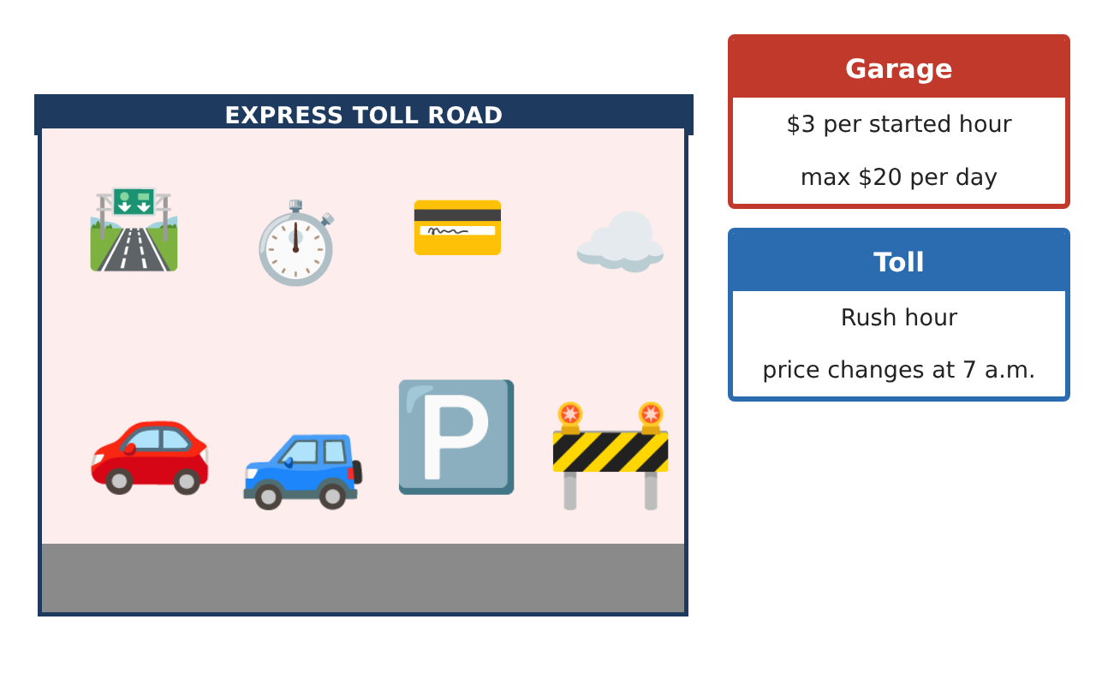
Learning Goals
- I can evaluate limits graphically, numerically, and algebraically.
- I can determine continuity and fix discontinuities.
- I can use limits at infinity and the IVT in context.
Project Timeline
When | What you will do
Day 1 | Discontinuities
Day 2 | Continuous Tolls
Day 3 | Pass vs. Pay
Final | Pricing Proposal + reflection
Part 1: Discontinuities
Day 1 · Use the Pricing Data Cards.
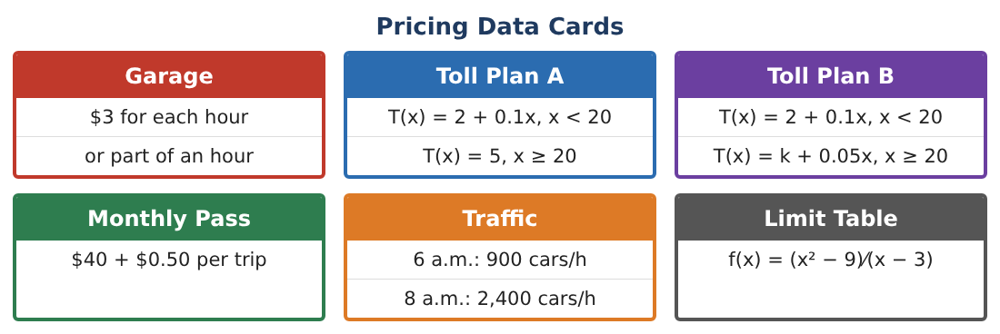
1. Classify the discontinuities of the garage price P(t) for 0 < t ≤ 6.

2. With the $20 daily maximum, write P(t) for 6 < t ≤ 24.

3. Find lim_{x→3} $\frac{x² − 9}{x − 3}$ and classify the discontinuity of f at x = 3.

4. Redefine f to make it continuous at x = 3.

Part 2: Continuous Tolls
Day 2 · Toll Plan B.
5. Find k so that Plan B is continuous at x = 20. Show the three continuity conditions.

6. Design a toll T(x) = ax² + b for x ≥ 20 that is continuous at 20 and costs $8 at 40 miles.

7. Find lim_{x→20} of your design from both sides to confirm.

8. Is there a value of k that makes Plan A continuous? Explain.

Part 3: Pass vs. Pay
Day 3 · Monthly pass: $40 + $0.50 per trip. Average cost per trip A(n) = $\frac{40 + 0.5n}{n}$.
9. Find lim_{n→∞} A(n) and interpret.

10. Find lim_{n→0⁺} A(n) and interpret.

11. Use the IVT to show that the average cost equals $3 for some number of trips between 10 and 30. Then find it.

Final Product: Pricing Proposal
Your final product must include:
- Classified discontinuities
- Continuous toll designs with justification
- Limits at infinity for the pass
- IVT argument
- Pricing proposal
Reflection
R1. What are the three conditions for continuity?

R2. How do limits at infinity help compare plans?

Scoring Rubric
Criteria | 4 – Exceeds | 3 – Meets | 2 – Approaching | 1 – Beginning
Mathematical Accuracy | All calculations and solutions are correct; answers include units and are checked. | Nearly all work is correct; minor errors do not change conclusions. | Several errors; some conclusions are affected. | Many errors or missing work.
Reasoning & Justification | Clear, complete explanations connect every answer to the situation; uses precise vocabulary. | Explanations are mostly clear and connected to the situation. | Explanations are brief or partly unclear. | Little or no explanation.
Application & Design | Limits and continuity conditions are applied correctly to analyze and design fair prices. Goes beyond the minimum with a creative, realistic choice. | Limits and continuity conditions are applied correctly to analyze and design fair prices. | Design is incomplete or only partly uses the math from the unit. | Design is missing or unrelated to the unit math.
Communication & Presentation | Proposal includes graphs, limit work, continuity conditions, and a recommendation. Polished, organized, and visually engaging. | Proposal includes graphs, limit work, continuity conditions, and a recommendation. Organized and easy to follow. | Product is missing required parts or is hard to follow. | Product is mostly missing.

