CALCULUS · UNIT 2: LIMITS AND CONTINUITY  Toll Road Pricing  Use limits and continuity to design fair prices for a new toll road and parking garage. | CP2  2–3 class periods

Name: ________________________________ Date: ______________ Period: ______
The Scenario
The state highway authority is opening a new express toll road with a parking garage at the end. Drivers complain when prices jump suddenly, and the authority wants prices that are fair and predictable.
You will use limits and continuity to analyze the current prices and propose better ones.
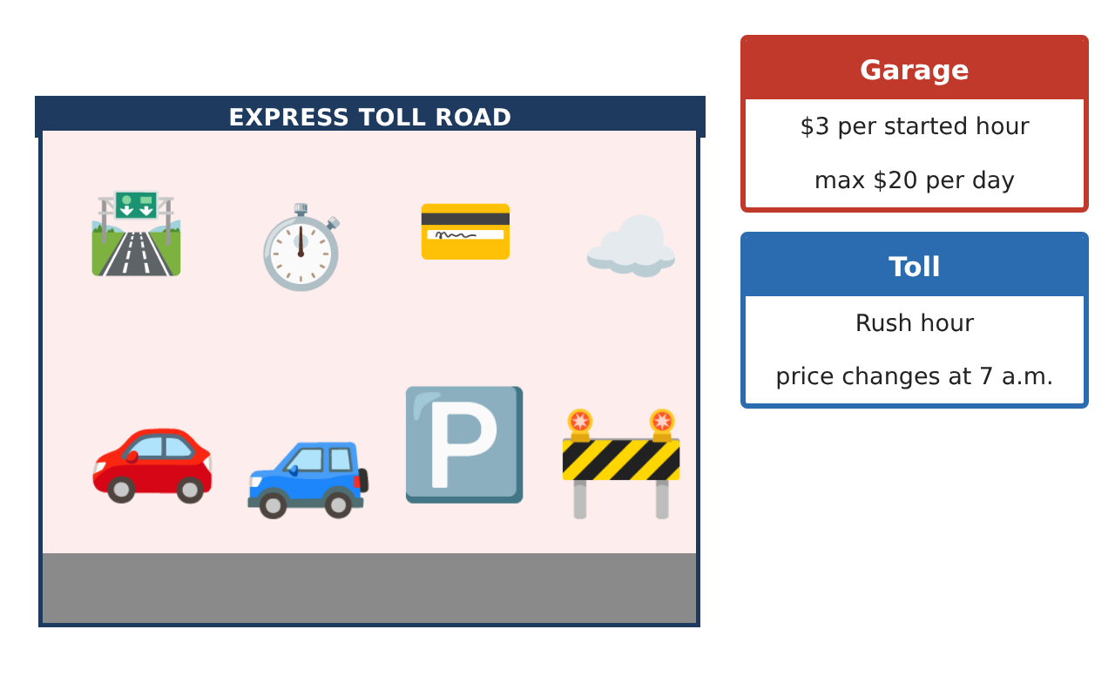
Learning Goals
- I can estimate limits from tables and graphs.
- I can find one-sided limits at a jump.
- I can decide whether a function is continuous at a point.
Project Timeline
When | What you will do
Day 1 | Garage Prices
Day 2 | Toll Plan A
Day 3 | Fix the Price
Final | Pricing Proposal + reflection
Part 1: Garage Prices
Day 1 · The garage charges $3 for each hour or part of an hour.
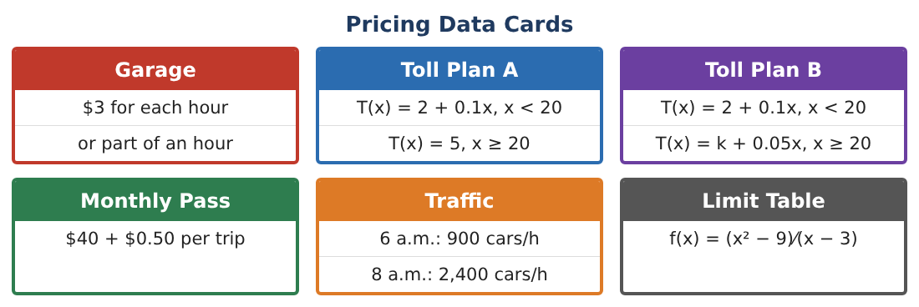
1. Make a table of the price for 0.5, 1, 1.5, 2, and 2.5 hours.

2. Find the limit of the price as t → 1⁻ and as t → 1⁺.

3. Does lim_{t→1} P(t) exist? Explain.
Starter: Left limit = ___, right limit = ___

4. Is the garage price continuous at t = 1.5? Explain.

Part 2: Toll Plan A
Day 2 · T(x) = 2 + 0.1x for x < 20 miles and T(x) = 5 for x ≥ 20.
5. Find lim_{x→20⁻} T(x) and lim_{x→20⁺} T(x).

6. Is Toll Plan A continuous at x = 20? Why do drivers complain?

7. Use a table to estimate lim_{x→3} $\frac{x² − 9}{x − 3}$.

8. Find the same limit algebraically.

Part 3: Fix the Price
Day 3 · Toll Plan B: T(x) = 2 + 0.1x for x < 20 and k + 0.05x for x ≥ 20.
9. Find k so that Plan B is continuous at x = 20.

10. Find the Plan B toll for 30 miles.

11. Traffic was 900 cars/h at 6 a.m. and 2,400 at 8 a.m. Explain why traffic must have been exactly 1,500 cars/h at some time in between.

Final Product: Pricing Proposal
Your final product must include:
- Garage price table and graph
- One-sided limits at the jumps
- Continuous Plan B
- IVT traffic explanation
- Pricing proposal
Reflection
R1. What does it mean for a price function to be continuous?

R2. Why can a limit exist even if the function is not defined there?

Scoring Rubric
Criteria | 4 – Exceeds | 3 – Meets | 2 – Approaching | 1 – Beginning
Mathematical Accuracy | All calculations and solutions are correct; answers include units and are checked. | Nearly all work is correct; minor errors do not change conclusions. | Several errors; some conclusions are affected. | Many errors or missing work.
Reasoning & Justification | Clear, complete explanations connect every answer to the situation; uses precise vocabulary. | Explanations are mostly clear and connected to the situation. | Explanations are brief or partly unclear. | Little or no explanation.
Application & Design | Limits and continuity conditions are applied correctly to analyze and design fair prices. Goes beyond the minimum with a creative, realistic choice. | Limits and continuity conditions are applied correctly to analyze and design fair prices. | Design is incomplete or only partly uses the math from the unit. | Design is missing or unrelated to the unit math.
Communication & Presentation | Proposal includes graphs, limit work, continuity conditions, and a recommendation. Polished, organized, and visually engaging. | Proposal includes graphs, limit work, continuity conditions, and a recommendation. Organized and easy to follow. | Product is missing required parts or is hard to follow. | Product is mostly missing.

