CALCULUS · UNIT 2: LIMITS AND CONTINUITY  Toll Road Pricing  Use limits and continuity to design fair prices for a new toll road and parking garage. | Honors  2–3 class periods

Name: ________________________________ Date: ______________ Period: ______
The Scenario
The state highway authority is opening a new express toll road with a parking garage at the end. Drivers complain when prices jump suddenly, and the authority wants prices that are fair and predictable.
You will use limits and continuity to analyze the current prices and propose better ones.
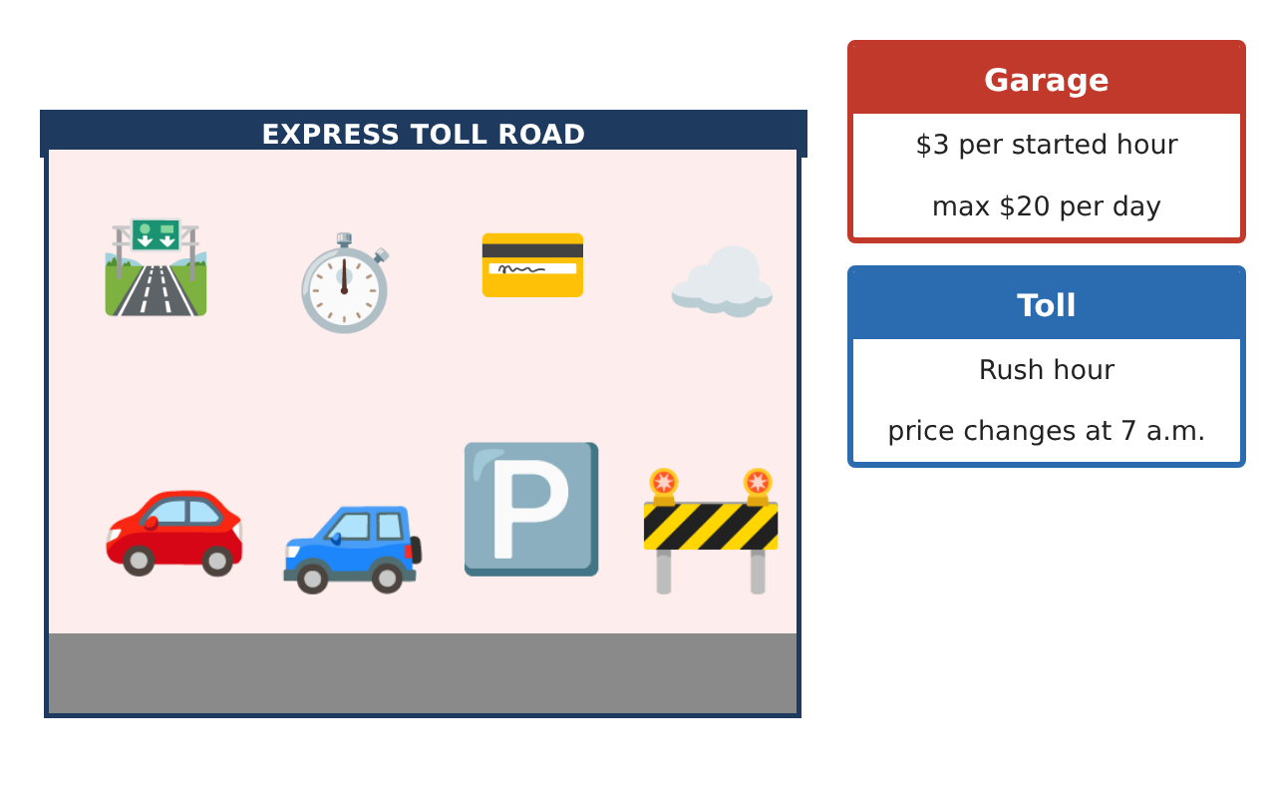
Learning Goals
- I can evaluate limits using algebra and the Squeeze Theorem.
- I can design continuous and differentiable pricing.
- I can justify claims with the IVT and limit definitions.
Project Timeline
When | What you will do
Day 1 | Price Behavior
Day 2 | Smooth Tolls
Day 3 | Traffic & IVT
Final | Pricing Proposal + reflection
Part 1: Price Behavior
Day 1 · Use the Pricing Data Cards.
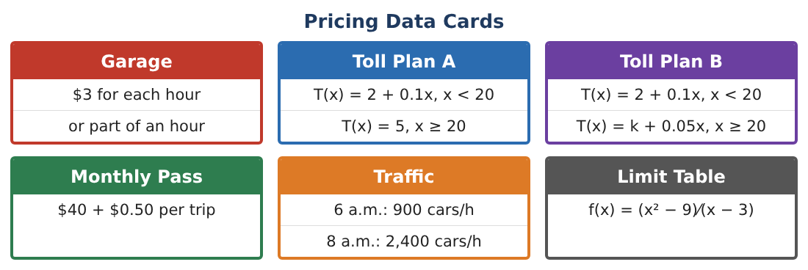
1. Write the garage price using the ceiling function and find lim_{t→2⁻} P(t), lim_{t→2⁺} P(t), and P(2).

2. Find lim_{h→0} $\frac{√(9 + h) − 3}{h}$ and interpret it as a rate.

3. A price-smoothing fee is g(x) = x² sin($\frac{1}{x}$) for x ≠ 0, g(0) = 0. Use the Squeeze Theorem to show g is continuous at 0.

4. Find lim_{x→∞} $\frac{3x² − 5x}{6x² + 7}$.

Part 2: Smooth Tolls
Day 2 · Plan C: T(x) = 2 + 0.1x for x < 20 and ax² + bx + c for x ≥ 20.
5. Find a, b, c so that T is continuous at 20, has slope 0.1 at x = 20 (no sudden change in rate), and costs $10 at 60 miles.

6. Verify continuity of Plan C at 20 with one-sided limits.

7. Why might a smooth price be fairer to drivers than a continuous one with a corner?

8. Does Plan C ever charge less for a longer trip? Explain.

Part 3: Traffic & IVT
Day 3 · Traffic counts: 6 a.m. 900, 7 a.m. 1,700, 8 a.m. 2,400, 9 a.m. 1,600 cars/h.
9. Using the IVT, what is the minimum number of times traffic equals 2,000 cars/h between 6 and 9 a.m.?

10. Could traffic have equaled 3,000 cars/h? Explain what the IVT does and does not say.

11. Write your pricing proposal with one discontinuous plan analyzed and one smooth plan designed.

Final Product: Pricing Proposal
Your final product must include:
- Ceiling-function garage model with limits
- Squeeze Theorem argument
- Smooth toll design (continuity and slope)
- IVT traffic analysis
- Pricing proposal
Reflection
R1. What extra condition makes Plan C smooth and not just continuous?

R2. Why does the IVT require continuity?

Scoring Rubric
Criteria | 4 – Exceeds | 3 – Meets | 2 – Approaching | 1 – Beginning
Mathematical Accuracy | All calculations and solutions are correct; answers include units and are checked. | Nearly all work is correct; minor errors do not change conclusions. | Several errors; some conclusions are affected. | Many errors or missing work.
Reasoning & Justification | Clear, complete explanations connect every answer to the situation; uses precise vocabulary. | Explanations are mostly clear and connected to the situation. | Explanations are brief or partly unclear. | Little or no explanation.
Application & Design | Limits and continuity conditions are applied correctly to analyze and design fair prices. Goes beyond the minimum with a creative, realistic choice. | Limits and continuity conditions are applied correctly to analyze and design fair prices. | Design is incomplete or only partly uses the math from the unit. | Design is missing or unrelated to the unit math.
Communication & Presentation | Proposal includes graphs, limit work, continuity conditions, and a recommendation. Polished, organized, and visually engaging. | Proposal includes graphs, limit work, continuity conditions, and a recommendation. Organized and easy to follow. | Product is missing required parts or is hard to follow. | Product is mostly missing.

