CALCULUS · UNIT 9: AP CALCULUS REVIEW  Water Park Engineering  Review AP Calculus by engineering a water park: rates, motion, accumulation, area, volume, and differential equations. | CP1  2–3 class periods

Name: ________________________________ Date: ______________ Period: ______
The Scenario
Splash Valley Water Park is opening next summer and has hired your engineering team. The pool fills from pumps, rafts float down the lazy river, the wave pool has a curved shape, and the chlorine must stay safe.
Each part of the project is written like an AP free-response question. Show every setup, use correct units, and justify your answers.
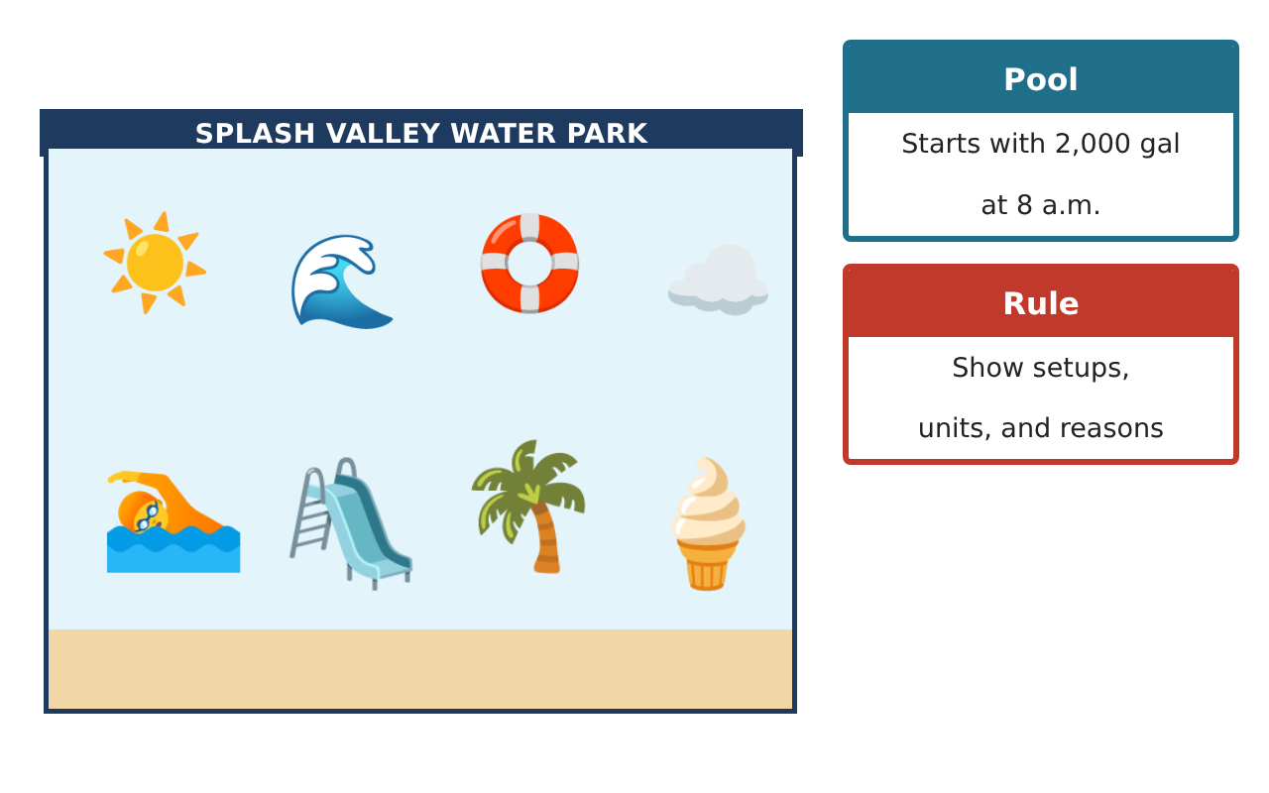
Learning Goals
- I can analyze tabular rates with Riemann sums, the MVT, and the FTC.
- I can analyze particle motion.
- I can compute areas, volumes, and solve differential equations.
Project Timeline
When | What you will do
Day 1 | Filling the Pool
Day 2 | Lazy River Raft
Day 3 | Wave Pool & Chlorine
Final | AP-Style Engineering Portfolio + reflection
Part 1: Filling the Pool
Day 1 · Use the Pump Rate Table. Water drains at D(t) = 100 + 0.5t gal/min.
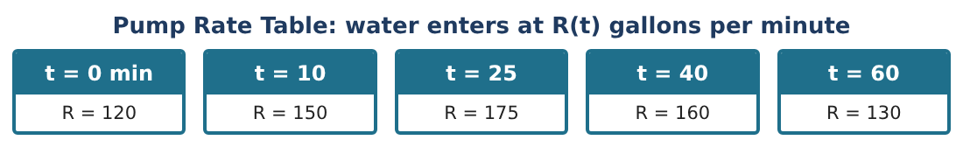
1. Estimate ∫₀⁶⁰ R(t) dt with a trapezoidal sum.

2. Find the amount of water at t = 60 if the pool starts with 2,000 gal.

3. Is the amount of water increasing or decreasing at t = 40? Justify.

4. Must there be a time in (10, 40) when R′(t) = $\frac{1}{3}$? Justify. (Assume R is differentiable.)

Part 2: Lazy River Raft
Day 2 · v(t) = 3 sin($\frac{πt}{6}$) ft/min, 0 ≤ t ≤ 12, starting at the dock x(0) = 0.
5. When is the raft moving right? Left?

6. Find the acceleration at t = 4 and whether the speed is increasing or decreasing.

7. Find the position at t = 6 and the maximum distance from the dock.

8. Find the total distance traveled from 0 to 12.

Part 3: Wave Pool & Chlorine
Day 3 · Wave pool region: between y = 9 − x² and y = x + 3.
9. Find the area of the region.

10. Cross sections perpendicular to the x-axis are rectangles with depth 2 m. Find the volume.

11. Chlorine decays by $\frac{dC}{dt}$ = −0.2C (ppm per hour) with C(0) = 3. Solve and find when C = 1 ppm.

Final Product: AP-Style Engineering Portfolio
Your final product must include:
- Trapezoid estimate and pool amount
- MVT justification
- Particle motion analysis
- Area and volume of the wave pool
- Chlorine model
Reflection
R1. How do you justify that an amount is increasing on the AP exam?

R2. When can you use the MVT on a table?

Scoring Rubric
Criteria | 4 – Exceeds | 3 – Meets | 2 – Approaching | 1 – Beginning
Mathematical Accuracy | All calculations and solutions are correct; answers include units and are checked. | Nearly all work is correct; minor errors do not change conclusions. | Several errors; some conclusions are affected. | Many errors or missing work.
Reasoning & Justification | Clear, complete explanations connect every answer to the situation; uses precise vocabulary. | Explanations are mostly clear and connected to the situation. | Explanations are brief or partly unclear. | Little or no explanation.
Application & Design | Each AP-style part is set up and solved correctly with units and justifications. Goes beyond the minimum with a creative, realistic choice. | Each AP-style part is set up and solved correctly with units and justifications. | Design is incomplete or only partly uses the math from the unit. | Design is missing or unrelated to the unit math.
Communication & Presentation | Portfolio presents every part clearly with setups, answers, units, and reasoning. Polished, organized, and visually engaging. | Portfolio presents every part clearly with setups, answers, units, and reasoning. Organized and easy to follow. | Product is missing required parts or is hard to follow. | Product is mostly missing.

