CALCULUS · UNIT 9: AP CALCULUS REVIEW  Water Park Engineering  Review AP Calculus by engineering a water park: rates, motion, accumulation, area, volume, and differential equations. | CP2  2–3 class periods

Name: ________________________________ Date: ______________ Period: ______
The Scenario
Splash Valley Water Park is opening next summer and has hired your engineering team. The pool fills from pumps, rafts float down the lazy river, the wave pool has a curved shape, and the chlorine must stay safe.
Each part of the project is written like an AP free-response question. Show every setup, use correct units, and justify your answers.
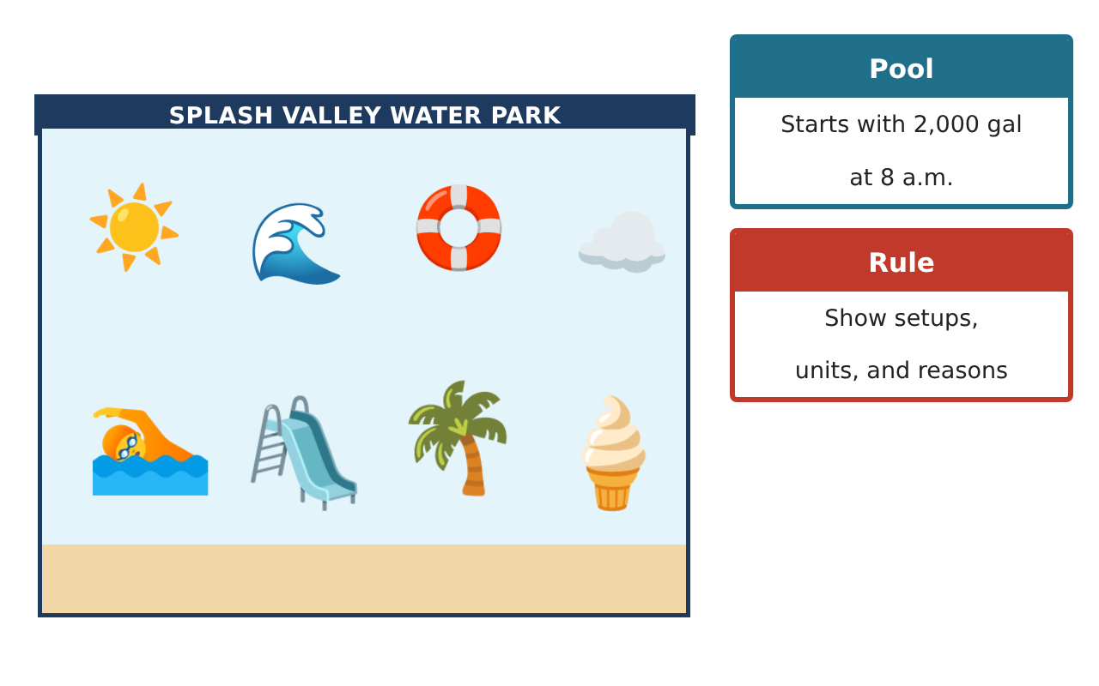
Learning Goals
- I can use a table of rates to estimate an accumulation.
- I can find velocity, acceleration, and displacement for a moving object.
- I can set up area and volume integrals.
Project Timeline
When | What you will do
Day 1 | Filling the Pool
Day 2 | Lazy River Raft
Day 3 | Wave Pool
Final | AP-Style Engineering Portfolio + reflection
Part 1: Filling the Pool
Day 1 · Use the Pump Rate Table. Water also drains at a constant 100 gal/min.
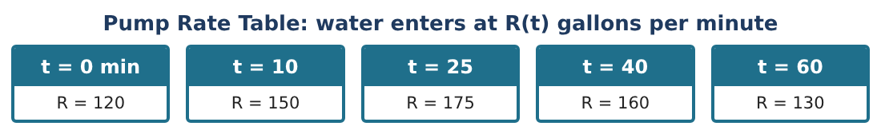
1. Use a left Riemann sum with the four intervals to estimate the water pumped in from t = 0 to t = 60.
Starter: Δt × left value for each interval, then add

2. Find the total water drained from t = 0 to 60.

3. Estimate the amount of water in the pool at t = 60.

4. Estimate R′(30) using the table and give units.

Part 2: Lazy River Raft
Day 2 · A raft moves with velocity v(t) = 2t − 6 feet per minute for 0 ≤ t ≤ 8.
5. When is the raft at rest? When is it moving backward?

6. Find the acceleration.

7. Find the displacement from t = 0 to t = 8.

8. Find the total distance traveled.

Part 3: Wave Pool
Day 3 · The wave pool is the region between y = 9 − x² and y = 0 (in meters).
9. Find the surface area of the wave pool.

10. The depth is 2 m everywhere. Find the volume of water.

11. Write one AP-style sentence that explains what ∫₀⁶⁰ R(t) dt means.

Final Product: AP-Style Engineering Portfolio
Your final product must include:
- Riemann sum and pool amount
- Derivative estimate with units
- Raft motion analysis
- Wave pool area and volume
- Portfolio with AP-style explanations
Reflection
R1. Why are units so important on AP free-response questions?

R2. How is displacement different from total distance?

Scoring Rubric
Criteria | 4 – Exceeds | 3 – Meets | 2 – Approaching | 1 – Beginning
Mathematical Accuracy | All calculations and solutions are correct; answers include units and are checked. | Nearly all work is correct; minor errors do not change conclusions. | Several errors; some conclusions are affected. | Many errors or missing work.
Reasoning & Justification | Clear, complete explanations connect every answer to the situation; uses precise vocabulary. | Explanations are mostly clear and connected to the situation. | Explanations are brief or partly unclear. | Little or no explanation.
Application & Design | Each AP-style part is set up and solved correctly with units and justifications. Goes beyond the minimum with a creative, realistic choice. | Each AP-style part is set up and solved correctly with units and justifications. | Design is incomplete or only partly uses the math from the unit. | Design is missing or unrelated to the unit math.
Communication & Presentation | Portfolio presents every part clearly with setups, answers, units, and reasoning. Polished, organized, and visually engaging. | Portfolio presents every part clearly with setups, answers, units, and reasoning. Organized and easy to follow. | Product is missing required parts or is hard to follow. | Product is mostly missing.

