GEOMETRY · UNIT 9: CIRCLES  Pizza Parlor Geometry  Use circle area, arcs, sectors, and angles to price and slice pizza. | CP1  2–3 class periods

Name: ________________________________ Date: ______________ Period: ______
The Scenario
Slice of Pi Pizzeria wants to update its menu, and customers keep asking: is two mediums really more pizza than one large?
Every question on the menu is a circle question: area, crust length, slice size, and delivery range. You will answer them and design a fair menu.
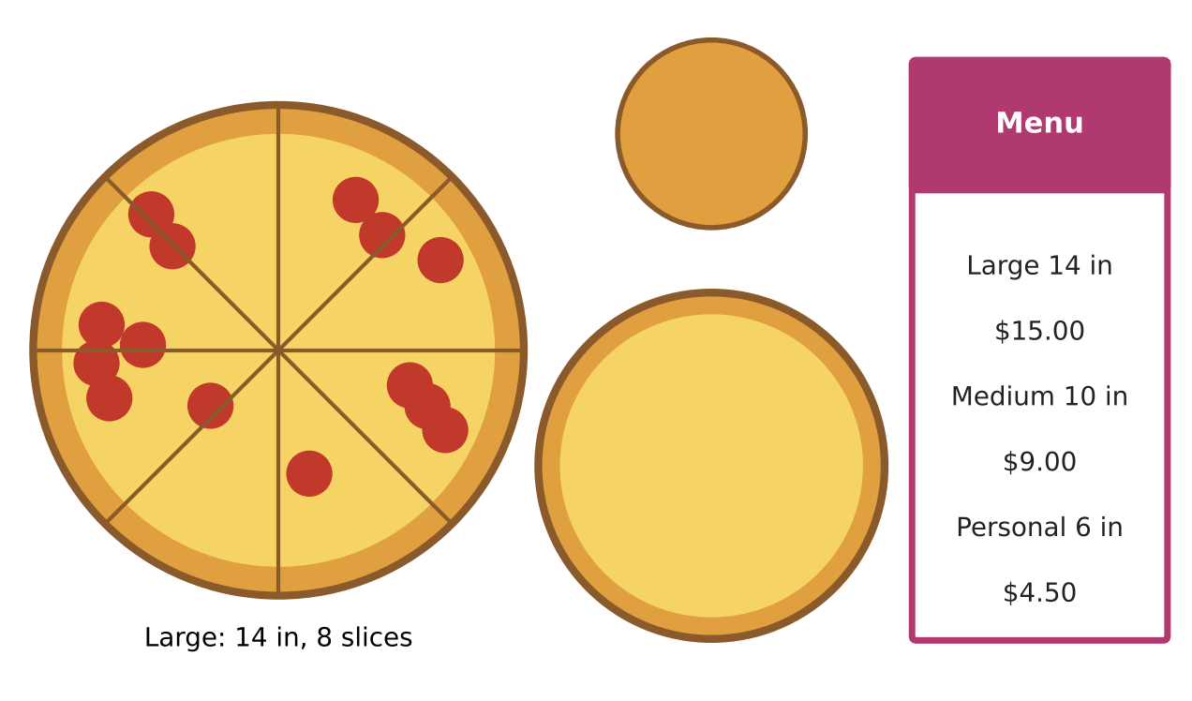
Learning Goals
- I can find arc lengths, sector areas, and central angles.
- I can use inscribed angles, chords, and tangents.
- I can write and use the equation of a circle.
Project Timeline
When | What you will do
Day 1 | Value & Slices
Day 2 | Cutting & Boxing
Day 3 | Design a Menu
Final | Pizza Menu Proposal + reflection

Part 1: Value & Slices
Day 1 · Use the menu.
1. Compare one large with two mediums using exact areas and price per square inch.

2. A customer wants a 30 in² slice from a large pizza. What central angle should the cut have?

3. A slice of a large pizza has a crust (arc) length of 7 in. Find its central angle and area.

Part 2: Cutting & Boxing
Day 2 · Use circle theorems.
4. A straight cut is made 3 in from the center of a large pizza. How long is the cut (the chord)?

5. Three points on the crust form a triangle. One angle of the triangle intercepts an arc of 100°. What is that angle?

6. A large pizza fits exactly in a square box. Each side of the box is tangent to the crust. How long is each side? Explain using tangents.

7. The delivery zone is a circle centered at the shop (0, 0) with radius 5 miles. Write its equation. Is a house at (3, 4.5) in the zone?

Part 3: Design a Menu
Day 3 · Design three sizes and a delivery zone.
8. Choose sizes and prices with a nearly equal price per square inch.

9. Decide how many slices each size gets so that every slice is between 15 and 25 in². Show sector areas.

10. Write the equation of your delivery zone and test two addresses.

Final Product: Pizza Menu Proposal
Your final product must include:
- Menu with sizes, prices, and slice counts
- Sector area table
- Delivery zone equation and tests
- Answers to the cutting and boxing questions
Reflection
R1. Why is an inscribed angle half its intercepted arc?

R2. How does the circle equation come from the Pythagorean Theorem?

Scoring Rubric
Criteria | 4 – Exceeds | 3 – Meets | 2 – Approaching | 1 – Beginning
Mathematical Accuracy | All calculations and solutions are correct; answers include units and are checked. | Nearly all work is correct; minor errors do not change conclusions. | Several errors; some conclusions are affected. | Many errors or missing work.
Reasoning & Justification | Clear, complete explanations connect every answer to the situation; uses precise vocabulary. | Explanations are mostly clear and connected to the situation. | Explanations are brief or partly unclear. | Little or no explanation.
Application & Design | Prices are fair (similar price per square inch) and every circle calculation is correct. Goes beyond the minimum with a creative, realistic choice. | Prices are fair (similar price per square inch) and every circle calculation is correct. | Design is incomplete or only partly uses the math from the unit. | Design is missing or unrelated to the unit math.
Communication & Presentation | Menu proposal shows each size's area, price per square inch, slice sizes, and a pricing recommendation. Polished, organized, and visually engaging. | Menu proposal shows each size's area, price per square inch, slice sizes, and a pricing recommendation. Organized and easy to follow. | Product is missing required parts or is hard to follow. | Product is mostly missing.

