GEOMETRY · UNIT 9: CIRCLES  Pizza Parlor Geometry  Use circle area, arcs, sectors, and angles to price and slice pizza. | CP2  2–3 class periods

Name: ________________________________ Date: ______________ Period: ______
The Scenario
Slice of Pi Pizzeria wants to update its menu, and customers keep asking: is two mediums really more pizza than one large?
Every question on the menu is a circle question: area, crust length, slice size, and delivery range. You will answer them and design a fair menu.
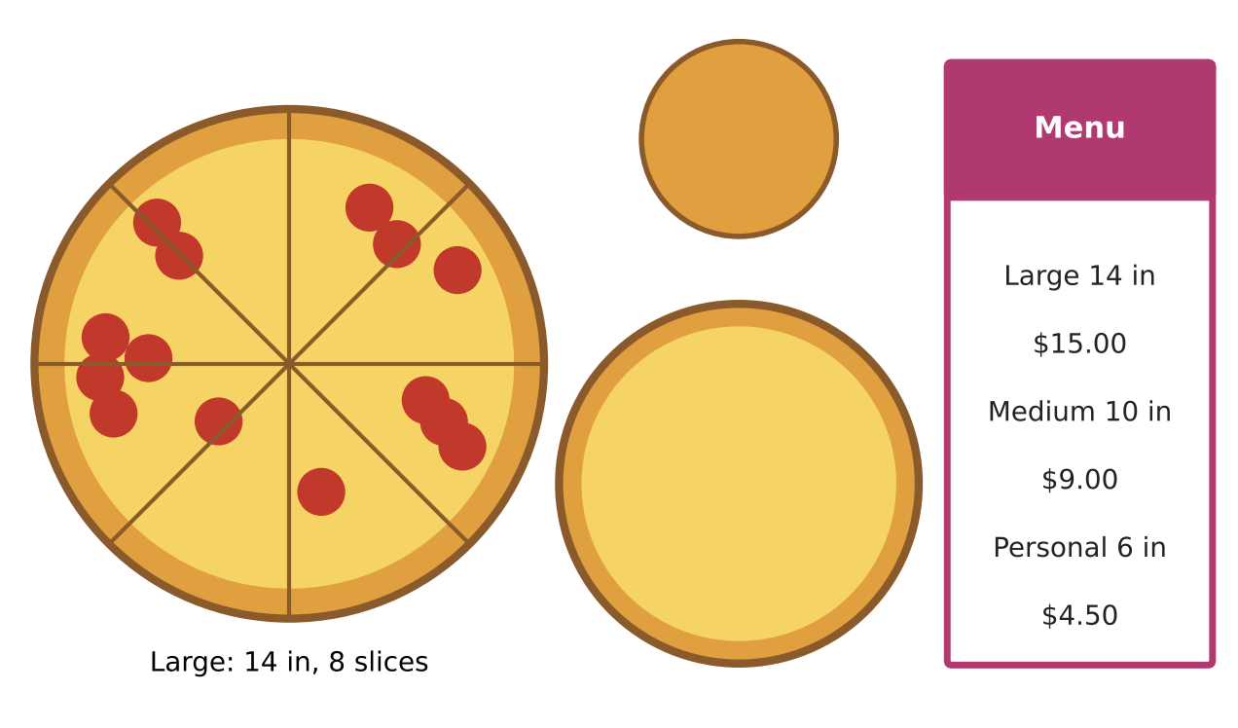
Learning Goals
- I can find circumference and area of circles.
- I can compare value with price per square inch.
- I can find arc length and sector area for slices.
Project Timeline
When | What you will do
Day 1 | Which Pizza Is the Better Deal?
Day 2 | Slices
Day 3 | Design a Menu
Final | Pizza Menu Proposal + reflection

Part 1: Which Pizza Is the Better Deal?
Day 1 · Use the menu. The size is the diameter.
1. Find the area of a large (14-inch) pizza. Give an exact answer in terms of π and a decimal.

2. Find the area of one medium (10-inch) pizza and of two mediums. Which is more pizza: one large or two mediums?

3. Find the price per square inch for the large and for two mediums. Which is the better deal?

4. How long is the crust (circumference) of a large pizza?

Part 2: Slices
Day 2 · Each large pizza is cut into 8 equal slices.
5. What is the central angle of each slice?

6. Find the crust length (arc length) of one slice.
Starter: Arc length = (angle ÷ 360) × circumference

7. Find the area of one slice (sector area).

8. A 12-inch pizza is cut into 6 slices. Is one of its slices bigger or smaller than a large slice?

Part 3: Design a Menu
Day 3 · Design a menu with three sizes.
9. Choose three diameters and find each area.

10. Set prices so that the price per square inch is about the same for all sizes. Show your work.

11. Make a menu card with sizes, prices, and slices per pizza.

Final Product: Pizza Menu Proposal
Your final product must include:
- Menu card with three sizes and prices
- Area and price per square inch for each
- Slice size comparison
- A sign that answers 'one large or two mediums?'
Reflection
R1. Why does a 14-inch pizza have almost twice the area of a 10-inch pizza?

R2. What is the difference between arc length and arc measure?

Scoring Rubric
Criteria | 4 – Exceeds | 3 – Meets | 2 – Approaching | 1 – Beginning
Mathematical Accuracy | All calculations and solutions are correct; answers include units and are checked. | Nearly all work is correct; minor errors do not change conclusions. | Several errors; some conclusions are affected. | Many errors or missing work.
Reasoning & Justification | Clear, complete explanations connect every answer to the situation; uses precise vocabulary. | Explanations are mostly clear and connected to the situation. | Explanations are brief or partly unclear. | Little or no explanation.
Application & Design | Prices are fair (similar price per square inch) and every circle calculation is correct. Goes beyond the minimum with a creative, realistic choice. | Prices are fair (similar price per square inch) and every circle calculation is correct. | Design is incomplete or only partly uses the math from the unit. | Design is missing or unrelated to the unit math.
Communication & Presentation | Menu proposal shows each size's area, price per square inch, slice sizes, and a pricing recommendation. Polished, organized, and visually engaging. | Menu proposal shows each size's area, price per square inch, slice sizes, and a pricing recommendation. Organized and easy to follow. | Product is missing required parts or is hard to follow. | Product is mostly missing.

