GEOMETRY · UNIT 9: CIRCLES  Pizza Parlor Geometry  Use circle area, arcs, sectors, and angles to price and slice pizza. | Honors  2–3 class periods

Name: ________________________________ Date: ______________ Period: ______
The Scenario
Slice of Pi Pizzeria wants to update its menu, and customers keep asking: is two mediums really more pizza than one large?
Every question on the menu is a circle question: area, crust length, slice size, and delivery range. You will answer them and design a fair menu.
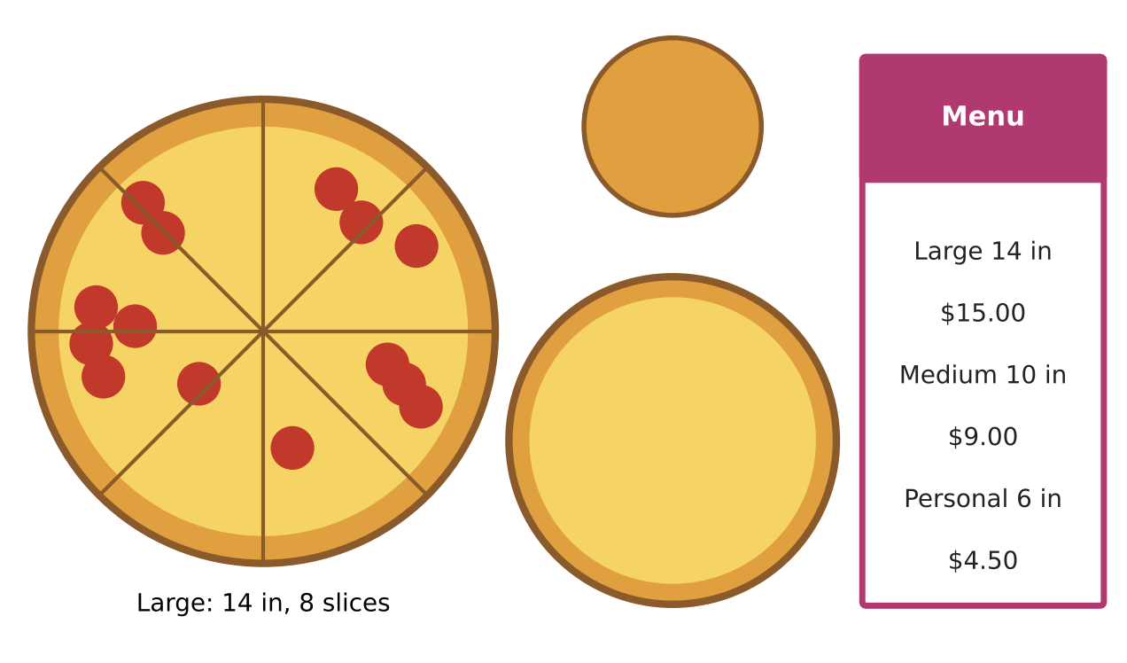
Learning Goals
- I can find segment areas and use chord, secant, and tangent relationships.
- I can write circle equations in standard and general form.
- I can design a pricing model and justify it.
Project Timeline
When | What you will do
Day 1 | Value & Shapes
Day 2 | Circle Theorems
Day 3 | Design a Pricing Model
Final | Pizza Menu Proposal + reflection

Part 1: Value & Shapes
Day 1 · Exact answers first.
1. Show that the ratio of the areas of two pizzas equals the square of the ratio of their diameters. Use the large and medium.

2. A slice is cut along a straight chord (not through the center) that spans a 90° arc of a large pizza. Find the area of this segment.

3. Find the diameter of a single pizza with the same area as two mediums.

Part 2: Circle Theorems
Day 2 · Justify each answer.
4. Two cuts (chords) cross inside a pizza. One is divided into 4 in and 6 in; the other has a 3-in piece. Find the other piece.

5. From a point outside the pizza, a tangent segment is 6 in long. A secant from the same point passes through 4 in outside the pizza before reaching the crust. Find the length of the secant inside the pizza.

6. The delivery zone is x² + y² − 6x + 4y − 12 = 0. Write it in standard form and find the center and radius.

7. Is the address (7, 2) inside the zone? What about (1, 1)?

Part 3: Design a Pricing Model
Day 3 · Write a pricing formula P(d) for a pizza of diameter d.
8. Write P(d) = a + b · (area) with a base cost a and a price per square inch b. Choose a and b and justify them.

9. Show that with a base cost, larger pizzas are a better value per square inch.

10. Present a menu with three sizes and your formula.

Final Product: Pizza Menu Proposal
Your final product must include:
- Area ratio proof
- Segment area and theorem solutions
- Delivery zone in standard form
- Pricing model and menu
Reflection
R1. Why do pizza shops usually charge a lower price per square inch for larger sizes?

R2. How do you complete the square to find a circle's center?

Scoring Rubric
Criteria | 4 – Exceeds | 3 – Meets | 2 – Approaching | 1 – Beginning
Mathematical Accuracy | All calculations and solutions are correct; answers include units and are checked. | Nearly all work is correct; minor errors do not change conclusions. | Several errors; some conclusions are affected. | Many errors or missing work.
Reasoning & Justification | Clear, complete explanations connect every answer to the situation; uses precise vocabulary. | Explanations are mostly clear and connected to the situation. | Explanations are brief or partly unclear. | Little or no explanation.
Application & Design | Prices are fair (similar price per square inch) and every circle calculation is correct. Goes beyond the minimum with a creative, realistic choice. | Prices are fair (similar price per square inch) and every circle calculation is correct. | Design is incomplete or only partly uses the math from the unit. | Design is missing or unrelated to the unit math.
Communication & Presentation | Menu proposal shows each size's area, price per square inch, slice sizes, and a pricing recommendation. Polished, organized, and visually engaging. | Menu proposal shows each size's area, price per square inch, slice sizes, and a pricing recommendation. Organized and easy to follow. | Product is missing required parts or is hard to follow. | Product is mostly missing.

