GEOMETRY · UNIT 10: AREA, SURFACE AREA AND VOLUME  Popcorn Container Challenge  Compare volume and surface area to design the best popcorn container. | CP1  2–3 class periods

Name: ________________________________ Date: ______________ Period: ______
The Scenario
The movie theater is choosing a new popcorn container. The manager wants the best value for customers and the least cardboard for the environment.
You will compare three containers, explore how volume changes when dimensions change, and design and pitch your own container.
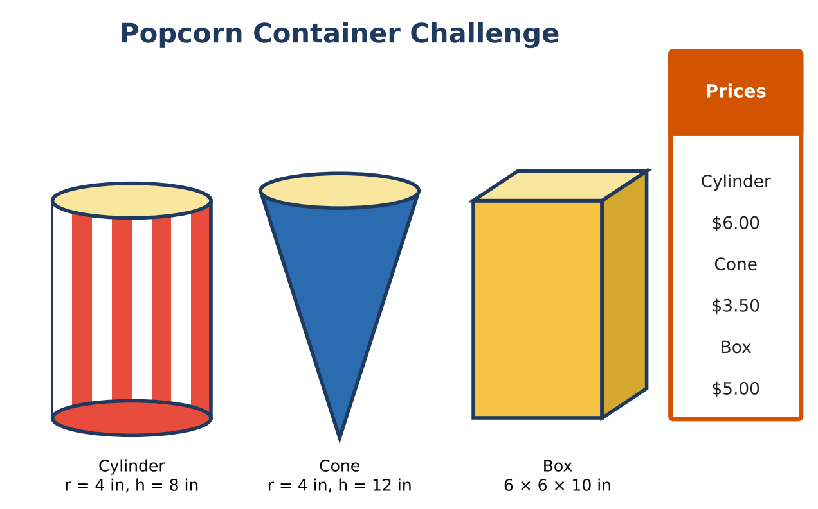
Learning Goals
- I can find volume and surface area of prisms, cylinders, pyramids, cones, and spheres.
- I can use scale factors for similar solids.
- I can design and justify a container.
Project Timeline
When | What you will do
Day 1 | Which Holds the Most?
Day 2 | Scale & Value
Day 3 | Design a Container
Final | Container Design Pitch + reflection

Part 1: Which Holds the Most?
Day 1 · Use the container cards.
1. Find the volume of each container. Rank them.

2. A new upside-down square pyramid container has an 8-in base and a 9-in height. Find its volume.

3. Popcorn balls have a radius of 1.5 in. Find the volume of one ball. About how many would fill the cylinder by volume?

4. Find the cone's slant height and lateral (side) area.

Part 2: Scale & Value
Day 2 · Similar containers have all dimensions multiplied by the same scale factor k.
5. A "jumbo" cylinder doubles the radius but keeps the height. How many times as much popcorn does it hold?

6. A "mega" box is similar to the box with scale factor 1.5. Find its volume and how many times larger it is.

7. The theater wants the mega box priced fairly (same price per cubic inch as the box). What should it cost?

8. The cylinder's label wraps around its side. Find the label's area.

Part 3: Design a Container
Day 3 · Design a container that holds 300 to 320 in³ and uses less cardboard than the box.
9. Choose a shape and dimensions and show the volume is in range.

10. Find the surface area and compare with the box.

11. Sketch a net with dimensions.

Final Product: Container Design Pitch
Your final product must include:
- Net or model of your container
- Volume, surface area, and scale calculations
- Fair price for a similar container
- Pitch comparing all containers
Reflection
R1. Why does doubling the radius make the volume four times as large?

R2. How do scale factors affect area and volume differently?

Scoring Rubric
Criteria | 4 – Exceeds | 3 – Meets | 2 – Approaching | 1 – Beginning
Mathematical Accuracy | All calculations and solutions are correct; answers include units and are checked. | Nearly all work is correct; minor errors do not change conclusions. | Several errors; some conclusions are affected. | Many errors or missing work.
Reasoning & Justification | Clear, complete explanations connect every answer to the situation; uses precise vocabulary. | Explanations are mostly clear and connected to the situation. | Explanations are brief or partly unclear. | Little or no explanation.
Application & Design | Design meets the volume target and uses less material than at least one other container, with correct formulas. Goes beyond the minimum with a creative, realistic choice. | Design meets the volume target and uses less material than at least one other container, with correct formulas. | Design is incomplete or only partly uses the math from the unit. | Design is missing or unrelated to the unit math.
Communication & Presentation | Pitch includes a net or model, volume and surface area, price per cubic inch, and a comparison with the other containers. Polished, organized, and visually engaging. | Pitch includes a net or model, volume and surface area, price per cubic inch, and a comparison with the other containers. Organized and easy to follow. | Product is missing required parts or is hard to follow. | Product is mostly missing.

