GEOMETRY · UNIT 10: AREA, SURFACE AREA AND VOLUME  Popcorn Container Challenge  Compare volume and surface area to design the best popcorn container. | CP2  2–3 class periods

Name: ________________________________ Date: ______________ Period: ______
The Scenario
The movie theater is choosing a new popcorn container. The manager wants the best value for customers and the least cardboard for the environment.
You will compare three containers, explore how volume changes when dimensions change, and design and pitch your own container.
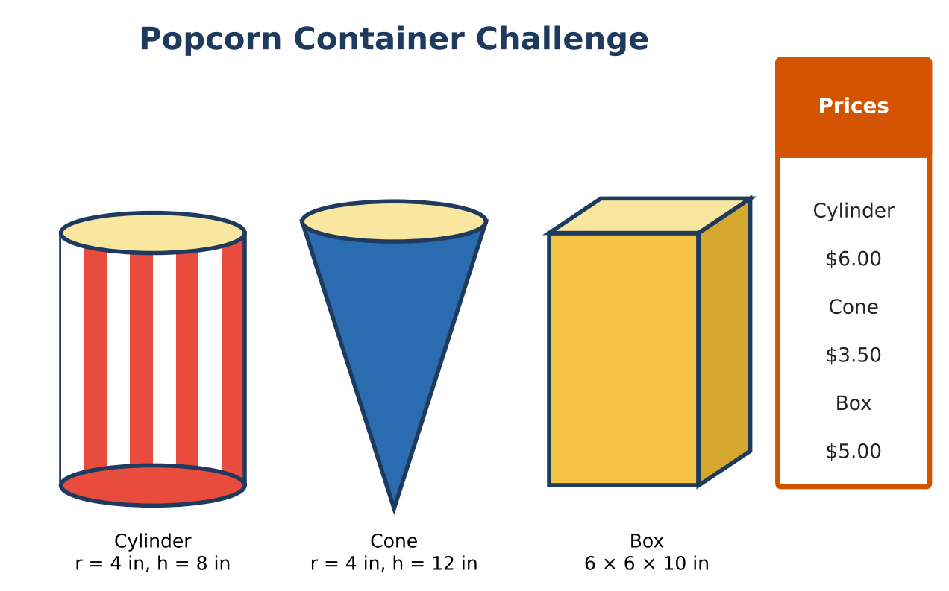
Learning Goals
- I can find the volume of cylinders, cones, and prisms.
- I can find surface area of open containers.
- I can compare value with price per cubic inch.
Project Timeline
When | What you will do
Day 1 | Which Holds the Most?
Day 2 | Value & Material
Day 3 | Design a Container
Final | Container Design Pitch + reflection

Part 1: Which Holds the Most?
Day 1 · Use the container cards. Give exact answers and decimals.
1. Find the volume of the cylinder (V = πr²h).

2. Find the volume of the cone (V = ⅓πr²h).

3. Find the volume of the box (V = lwh).

4. Rank the containers from most to least popcorn.

Part 2: Value & Material
Day 2 · Use the prices.
5. Find the price per cubic inch for each container. Which is the best value?

6. The cylinder has an open top. Its surface area is the bottom plus the side: πr² + 2πrh. Find it.

7. The box has an open top. Find its surface area (bottom plus four sides).

8. Which container uses less cardboard for each cubic inch of popcorn, the cylinder or the box?

Part 3: Design a Container
Day 3 · Design a container that holds about 300 in³.
9. Choose a shape and dimensions. Show that the volume is close to 300 in³.

10. Find the surface area (open top).

11. Choose a price and find the price per cubic inch. Is it a good deal compared with the others?

Final Product: Container Design Pitch
Your final product must include:
- A sketch or model of your container
- Volume and surface area calculations
- Price per cubic inch comparison
- A pitch to the manager
Reflection
R1. Why does the cone hold so much less than the cylinder with the same base?

R2. Why do stores care about surface area?

Scoring Rubric
Criteria | 4 – Exceeds | 3 – Meets | 2 – Approaching | 1 – Beginning
Mathematical Accuracy | All calculations and solutions are correct; answers include units and are checked. | Nearly all work is correct; minor errors do not change conclusions. | Several errors; some conclusions are affected. | Many errors or missing work.
Reasoning & Justification | Clear, complete explanations connect every answer to the situation; uses precise vocabulary. | Explanations are mostly clear and connected to the situation. | Explanations are brief or partly unclear. | Little or no explanation.
Application & Design | Design meets the volume target and uses less material than at least one other container, with correct formulas. Goes beyond the minimum with a creative, realistic choice. | Design meets the volume target and uses less material than at least one other container, with correct formulas. | Design is incomplete or only partly uses the math from the unit. | Design is missing or unrelated to the unit math.
Communication & Presentation | Pitch includes a net or model, volume and surface area, price per cubic inch, and a comparison with the other containers. Polished, organized, and visually engaging. | Pitch includes a net or model, volume and surface area, price per cubic inch, and a comparison with the other containers. Organized and easy to follow. | Product is missing required parts or is hard to follow. | Product is mostly missing.

