GEOMETRY · UNIT 10: AREA, SURFACE AREA AND VOLUME  Popcorn Container Challenge  Compare volume and surface area to design the best popcorn container. | Honors  2–3 class periods

Name: ________________________________ Date: ______________ Period: ______
The Scenario
The movie theater is choosing a new popcorn container. The manager wants the best value for customers and the least cardboard for the environment.
You will compare three containers, explore how volume changes when dimensions change, and design and pitch your own container.
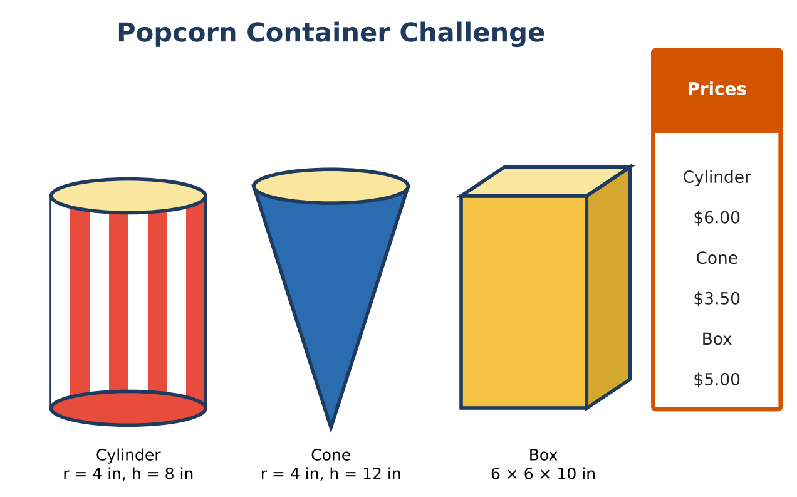
Learning Goals
- I can justify volume formulas with Cavalieri's principle.
- I can optimize a design for a fixed volume.
- I can write a mathematical argument for a design.
Project Timeline
When | What you will do
Day 1 | Volumes & Cavalieri
Day 2 | Optimize
Day 3 | Design & Prove
Final | Container Design Pitch + reflection

Part 1: Volumes & Cavalieri
Day 1 · Exact answers.
1. Find the exact volumes of all three containers.

2. Explain with Cavalieri's principle why a slanted (oblique) cylinder with r = 4 and height 8 holds the same amount as the straight one.

3. A hemisphere bowl and a cone have the same radius r and the cone's height is r. Show the bowl holds twice as much.

Part 2: Optimize
Day 2 · Design an open-top cylinder that holds exactly 400 in³ with the least cardboard.
4. Write h in terms of r. Then write the surface area S(r) = πr² + 2πrh in terms of r only.

5. Make a table of S(r) for r = 3, 4, 5, 6, 7. Which r gives the least cardboard?

6. The best design has r = h. Find this r to the nearest hundredth and the surface area.

7. How much cardboard does the best design save compared with the current cylinder (which holds 402 in³)?

Part 3: Design & Prove
Day 3 · Design a container of your own shape that holds 400 in³.
8. Optimize one dimension using a table or graph.

9. Compare your design with the optimal cylinder.

10. Write a pitch that uses your math to persuade the manager.

Final Product: Container Design Pitch
Your final product must include:
- Exact volumes and Cavalieri argument
- Optimization table and best cylinder
- Original optimized design
- Pitch
Reflection
R1. Why does an open-top cylinder use the least material when r = h?

R2. How could the theater use your math to save money?

Scoring Rubric
Criteria | 4 – Exceeds | 3 – Meets | 2 – Approaching | 1 – Beginning
Mathematical Accuracy | All calculations and solutions are correct; answers include units and are checked. | Nearly all work is correct; minor errors do not change conclusions. | Several errors; some conclusions are affected. | Many errors or missing work.
Reasoning & Justification | Clear, complete explanations connect every answer to the situation; uses precise vocabulary. | Explanations are mostly clear and connected to the situation. | Explanations are brief or partly unclear. | Little or no explanation.
Application & Design | Design meets the volume target and uses less material than at least one other container, with correct formulas. Goes beyond the minimum with a creative, realistic choice. | Design meets the volume target and uses less material than at least one other container, with correct formulas. | Design is incomplete or only partly uses the math from the unit. | Design is missing or unrelated to the unit math.
Communication & Presentation | Pitch includes a net or model, volume and surface area, price per cubic inch, and a comparison with the other containers. Polished, organized, and visually engaging. | Pitch includes a net or model, volume and surface area, price per cubic inch, and a comparison with the other containers. Organized and easy to follow. | Product is missing required parts or is hard to follow. | Product is mostly missing.

