GEOMETRY · UNIT 5: SIMILARITY  Shadow Detectives  Measure what you can't reach with similar triangles, shadows, and mirrors. | CP1  2–3 class periods

Name: ________________________________ Date: ______________ Period: ______
The Scenario
The yearbook staff wants the heights of the tallest things on campus, but nobody can climb the flagpole. Ancient mathematicians measured pyramids with shadows, and you can do the same.
When the sun's rays are parallel, the triangles formed by objects and their shadows are similar. You will measure the unreachable, then plan your own field measurement.
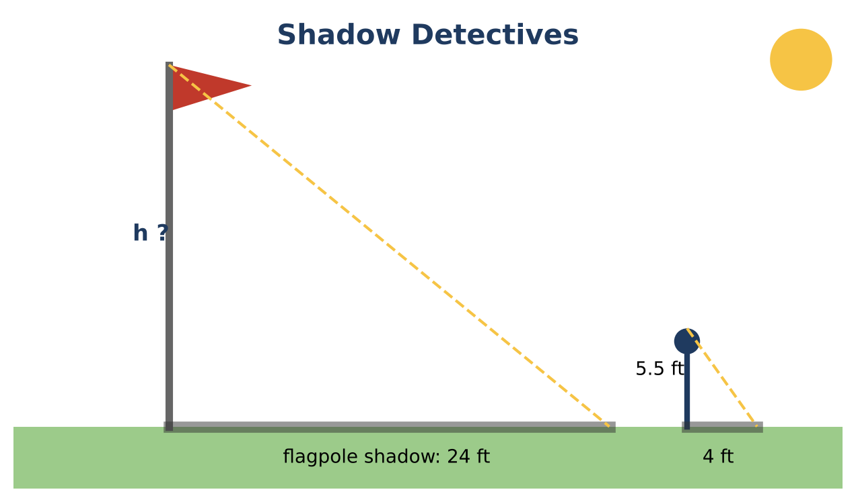
Learning Goals
- I can justify triangle similarity with AA, SAS, or SSS.
- I can use the Side-Splitter Theorem.
- I can relate scale factors to perimeter and area.
Project Timeline
When | What you will do
Day 1 | Shadows & Mirrors
Day 2 | River & Logo
Day 3 | Two-Method Measurement
Final | Field Measurement Report + reflection

Part 1: Shadows & Mirrors
Day 1 · Justify each similarity.
1. Find the flagpole height from the shadow data. State the similarity criterion and why it applies.

2. Mirror method: eye height 5 ft, 4 ft to the mirror, 20 ft from the mirror to a tree. Find the tree's height. Then find it again if the eye height was measured as 5.25 ft. How much does a small error change the answer?

3. A student 6 ft tall casts a 7.5-ft shadow while a tree casts a 30-ft shadow, measured 2 hours later. Explain why the result may be wrong.

Part 2: River & Logo
Day 2 · Use the Side-Splitter Theorem and scale factors.
4. To measure a river, a surveyor uses parallel segments as shown. Find the river width w.
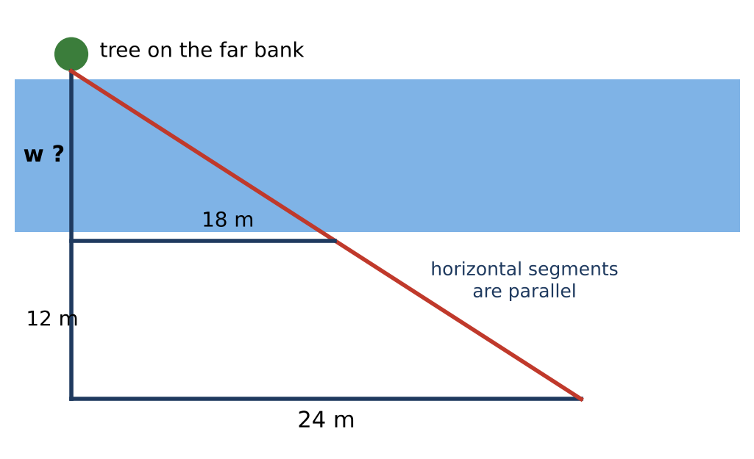

5. In △ABC, DE ∥ BC with D on AB and E on AC. AD = 12, DB = 8, and AE = 15. Find EC.

6. The logo (area 2.9 cm²) is enlarged by a scale factor of 3. Find the banner's area. What scale factor would make the area 100 times larger?

Part 3: Two-Method Measurement
Day 3 · Plan to measure a campus object two ways.
7. Draw diagrams for the shadow method and the mirror method.

8. Use realistic made-up (or real) data to compute the height both ways.

9. Compare the results and explain which method is more reliable.

Final Product: Field Measurement Report
Your final product must include:
- Justified similarity for each method
- River and side-splitter solutions
- Area scale analysis
- Two-method measurement report
Reflection
R1. Why do parallel sun rays guarantee AA similarity?

R2. How did a small measurement error affect the result?

Scoring Rubric
Criteria | 4 – Exceeds | 3 – Meets | 2 – Approaching | 1 – Beginning
Mathematical Accuracy | All calculations and solutions are correct; answers include units and are checked. | Nearly all work is correct; minor errors do not change conclusions. | Several errors; some conclusions are affected. | Many errors or missing work.
Reasoning & Justification | Clear, complete explanations connect every answer to the situation; uses precise vocabulary. | Explanations are mostly clear and connected to the situation. | Explanations are brief or partly unclear. | Little or no explanation.
Application & Design | Measurement plan uses a valid similarity method with a clear diagram and realistic data. Goes beyond the minimum with a creative, realistic choice. | Measurement plan uses a valid similarity method with a clear diagram and realistic data. | Design is incomplete or only partly uses the math from the unit. | Design is missing or unrelated to the unit math.
Communication & Presentation | Report includes diagrams, the similar-triangle justification, proportions solved with units, and an error analysis. Polished, organized, and visually engaging. | Report includes diagrams, the similar-triangle justification, proportions solved with units, and an error analysis. Organized and easy to follow. | Product is missing required parts or is hard to follow. | Product is mostly missing.

