GEOMETRY · UNIT 5: SIMILARITY  Shadow Detectives  Measure what you can't reach with similar triangles, shadows, and mirrors. | CP2  2–3 class periods

Name: ________________________________ Date: ______________ Period: ______
The Scenario
The yearbook staff wants the heights of the tallest things on campus, but nobody can climb the flagpole. Ancient mathematicians measured pyramids with shadows, and you can do the same.
When the sun's rays are parallel, the triangles formed by objects and their shadows are similar. You will measure the unreachable, then plan your own field measurement.
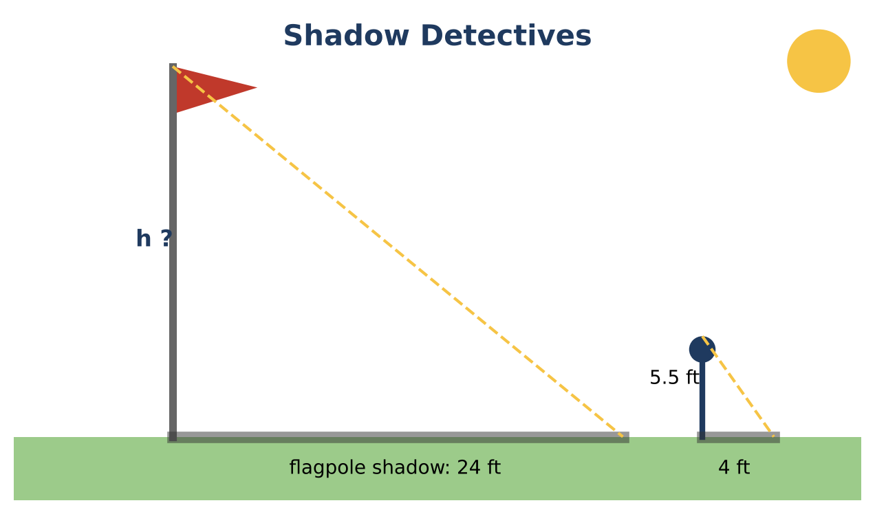
Learning Goals
- I can use similar triangles to find unknown heights.
- I can dilate a figure by a scale factor.
- I can use scale drawings.
Project Timeline
When | What you will do
Day 1 | Shadows & Mirrors
Day 2 | Dilations & Scale
Day 3 | Plan a Measurement
Final | Field Measurement Report + reflection

Part 1: Shadows & Mirrors
Day 1 · Sun rays are parallel, so the triangles are similar.
1. A 5.5-foot student casts a 4-foot shadow. At the same time, the flagpole casts a 24-foot shadow. Write a proportion and find the flagpole's height.
Starter: 5.5 ÷ 4 = h ÷ 24

2. A mirror lies on the ground 4 feet from a student whose eyes are 5 feet high, and 20 feet from a tree. The student sees the top of the tree in the mirror. How tall is the tree?

3. Why are the two triangles in the mirror method similar?

Part 2: Dilations & Scale
Day 2 · Use scale factors.
4. The school logo is a triangle with sides 2 cm, 3 cm, and 4 cm. It is enlarged by a scale factor of 3 for a banner. Find the new sides.

5. How does the banner's perimeter compare with the logo's? How does its area compare?

6. On a campus map, 1 inch represents 40 feet. The gym is 3.5 inches long on the map. How long is the real gym?

7. The football field is 360 feet long. How long is it on the map?

Part 3: Plan a Measurement
Day 3 · Choose a tall object on campus.
8. Choose the shadow or mirror method. Draw a labeled diagram of your plan.

9. Make up realistic measurements and calculate the height.

10. List two sources of error and how to reduce them.

Final Product: Field Measurement Report
Your final product must include:
- Diagrams and proportions for the flagpole and the tree
- Logo dilation with perimeter and area comparison
- Map scale answers
- Your measurement plan
Reflection
R1. Why must the shadows be measured at the same time of day?

R2. Why does the area grow faster than the perimeter when you enlarge a figure?

Scoring Rubric
Criteria | 4 – Exceeds | 3 – Meets | 2 – Approaching | 1 – Beginning
Mathematical Accuracy | All calculations and solutions are correct; answers include units and are checked. | Nearly all work is correct; minor errors do not change conclusions. | Several errors; some conclusions are affected. | Many errors or missing work.
Reasoning & Justification | Clear, complete explanations connect every answer to the situation; uses precise vocabulary. | Explanations are mostly clear and connected to the situation. | Explanations are brief or partly unclear. | Little or no explanation.
Application & Design | Measurement plan uses a valid similarity method with a clear diagram and realistic data. Goes beyond the minimum with a creative, realistic choice. | Measurement plan uses a valid similarity method with a clear diagram and realistic data. | Design is incomplete or only partly uses the math from the unit. | Design is missing or unrelated to the unit math.
Communication & Presentation | Report includes diagrams, the similar-triangle justification, proportions solved with units, and an error analysis. Polished, organized, and visually engaging. | Report includes diagrams, the similar-triangle justification, proportions solved with units, and an error analysis. Organized and easy to follow. | Product is missing required parts or is hard to follow. | Product is mostly missing.

