GEOMETRY · UNIT 5: SIMILARITY  Shadow Detectives  Measure what you can't reach with similar triangles, shadows, and mirrors. | Honors  2–3 class periods

Name: ________________________________ Date: ______________ Period: ______
The Scenario
The yearbook staff wants the heights of the tallest things on campus, but nobody can climb the flagpole. Ancient mathematicians measured pyramids with shadows, and you can do the same.
When the sun's rays are parallel, the triangles formed by objects and their shadows are similar. You will measure the unreachable, then plan your own field measurement.
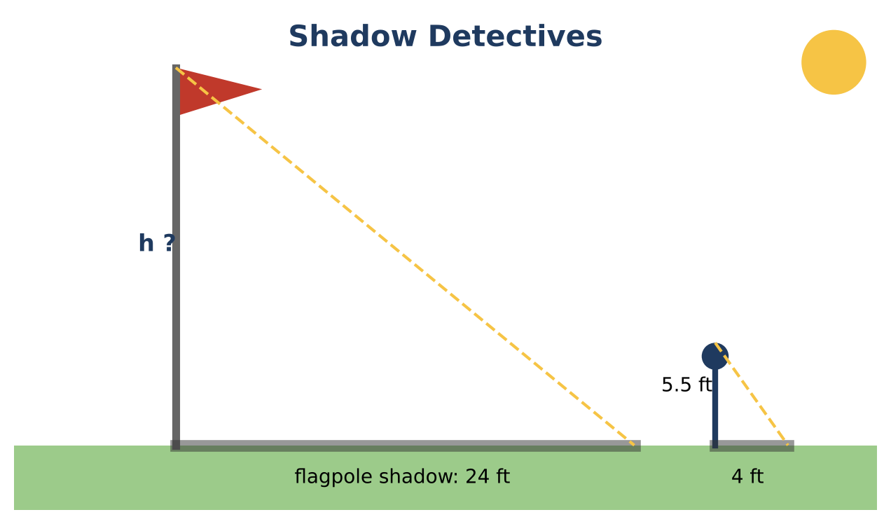
Learning Goals
- I can prove similarity and use it for indirect measurement.
- I can use geometric means in right triangles.
- I can analyze measurement error.
Project Timeline
When | What you will do
Day 1 | Prove & Measure
Day 2 | Side-Splitters & Geometric Means
Day 3 | Field Report
Final | Field Measurement Report + reflection

Part 1: Prove & Measure
Day 1 · Write justifications as proofs.
1. Prove that the two triangles in the mirror method are similar (the angle of incidence equals the angle of reflection).

2. Mirror data: eye height e, distance to mirror a, mirror to tree b. Write a formula for the tree height h. Use e = 5, a = 4, b = 20.

3. If each distance can be off by ±0.25 ft, find the smallest and largest possible tree heights.

Part 2: Side-Splitters & Geometric Means
Day 2 · Use similarity theorems.
4. Find the river width w in the diagram.
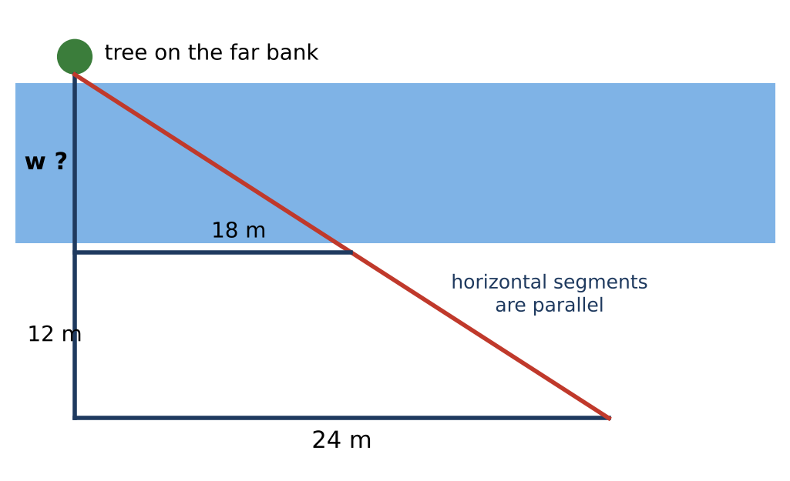

5. Prove the Side-Splitter Theorem: if DE ∥ BC in △ABC, then AD ÷ DB = AE ÷ EC.

6. In a right triangle, the altitude to the hypotenuse divides it into segments of 4 and 9. Find the altitude and both legs.

Part 3: Field Report
Day 3 · Measure (or plan to measure) one object with two methods.
7. Give diagrams, data, and both calculations.

8. Use your error ranges to decide whether the two results agree.

9. Write the report with a recommendation for the yearbook.

Final Product: Field Measurement Report
Your final product must include:
- Mirror-method proof and formula
- Error range analysis
- Side-Splitter proof and geometric mean solutions
- Two-method field report
Reflection
R1. How does an error range change how you report a measurement?

R2. Why are the three triangles formed by an altitude in a right triangle all similar?

Scoring Rubric
Criteria | 4 – Exceeds | 3 – Meets | 2 – Approaching | 1 – Beginning
Mathematical Accuracy | All calculations and solutions are correct; answers include units and are checked. | Nearly all work is correct; minor errors do not change conclusions. | Several errors; some conclusions are affected. | Many errors or missing work.
Reasoning & Justification | Clear, complete explanations connect every answer to the situation; uses precise vocabulary. | Explanations are mostly clear and connected to the situation. | Explanations are brief or partly unclear. | Little or no explanation.
Application & Design | Measurement plan uses a valid similarity method with a clear diagram and realistic data. Goes beyond the minimum with a creative, realistic choice. | Measurement plan uses a valid similarity method with a clear diagram and realistic data. | Design is incomplete or only partly uses the math from the unit. | Design is missing or unrelated to the unit math.
Communication & Presentation | Report includes diagrams, the similar-triangle justification, proportions solved with units, and an error analysis. Polished, organized, and visually engaging. | Report includes diagrams, the similar-triangle justification, proportions solved with units, and an error analysis. Organized and easy to follow. | Product is missing required parts or is hard to follow. | Product is mostly missing.

