GEOMETRY · UNIT 7: QUADRILATERALS AND POLYGONS  Tile & Quilt Designer  Use polygon angles and quadrilateral properties to design tilings and quilt blocks. | CP1  2–3 class periods

Name: ________________________________ Date: ______________ Period: ______
The Scenario
A local quilting guild and a tile store are teaming up for a community art wall. They want student designs built from polygons that fit together with no gaps or overlaps.
Whether polygons fit depends on their angles, and quilt blocks depend on the properties of quadrilaterals. You will test the math behind good patterns and then design your own.
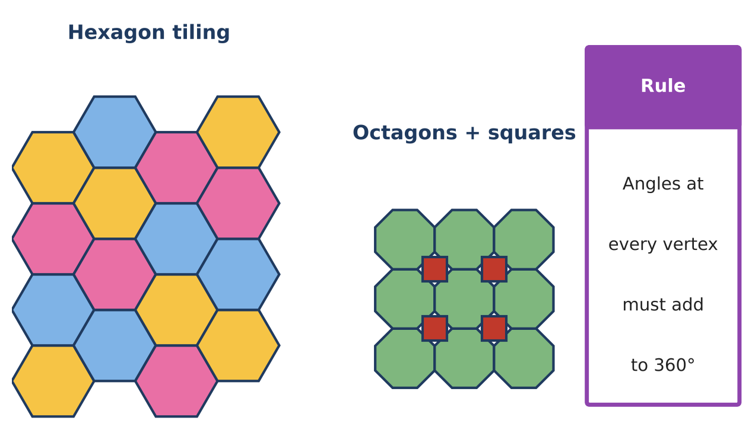
Learning Goals
- I can use polygon angle sums and exterior angles.
- I can use properties of special quadrilaterals with algebra.
- I can prove a quadrilateral's type using coordinates.
Project Timeline
When | What you will do
Day 1 | Which Shapes Tile?
Day 2 | Prove the Quilt Block
Day 3 | Design Your Pattern
Final | Pattern Design Board + reflection

Part 1: Which Shapes Tile?
Day 1 · Use angle sums.
1. Write a formula for each interior angle of a regular n-gon. Use it to explain why only triangles, squares, and hexagons tile alone.

2. A regular polygon has interior angles of 150°. How many sides does it have?

3. Can regular pentagons and regular decagons tile together with one pentagon and two decagons at each vertex? Check the angles.

Part 2: Prove the Quilt Block
Day 2 · Quilt block ABCD has A(0, 0), B(6, 2), C(8, 8), and D(2, 6).
4. Use slopes to show ABCD is a parallelogram.
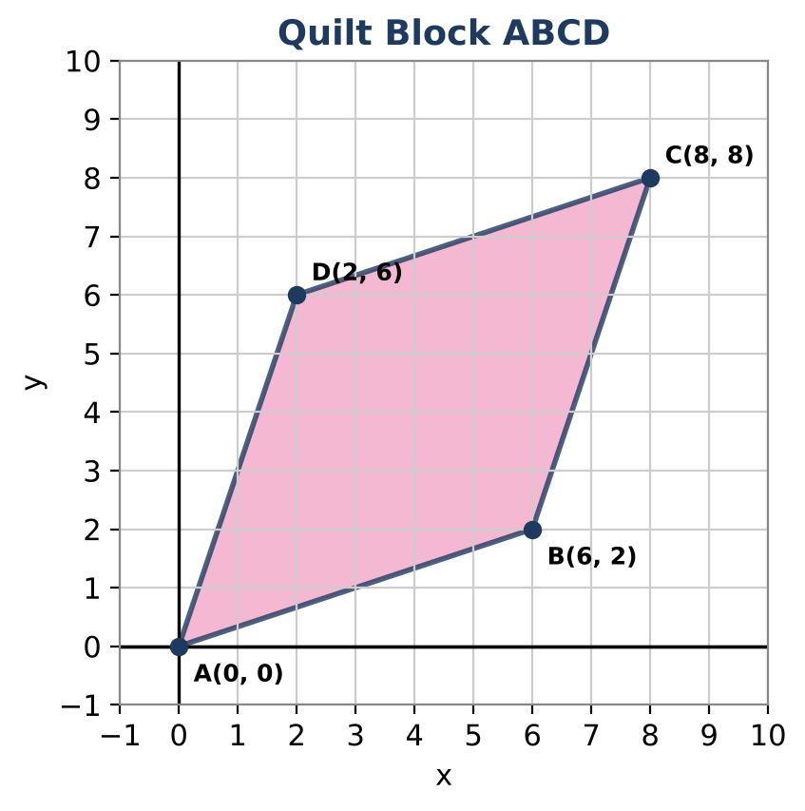

5. Use side lengths to show it is a rhombus.

6. Is it a square? Use slopes of adjacent sides to decide. Then show the diagonals are perpendicular.

7. A kite piece has two congruent opposite angles of 110° and a third angle of 50°. Find the fourth angle.

Part 3: Design Your Pattern
Day 3 · Design a quilt block on a coordinate grid.
8. Draw a block with at least two different quadrilaterals. Give the coordinates of every vertex.

9. Prove the type of one quadrilateral with slopes and distances.

10. Show that your block (or tile) fits with copies of itself at every vertex.

Final Product: Pattern Design Board
Your final product must include:
- Tessellation analysis
- Coordinate proof for ABCD
- Your coordinate quilt block with a proof
- Artist statement
Reflection
R1. What is the difference between a rhombus and a square in terms of slopes?

R2. How do angle sums decide whether shapes tile?

Scoring Rubric
Criteria | 4 – Exceeds | 3 – Meets | 2 – Approaching | 1 – Beginning
Mathematical Accuracy | All calculations and solutions are correct; answers include units and are checked. | Nearly all work is correct; minor errors do not change conclusions. | Several errors; some conclusions are affected. | Many errors or missing work.
Reasoning & Justification | Clear, complete explanations connect every answer to the situation; uses precise vocabulary. | Explanations are mostly clear and connected to the situation. | Explanations are brief or partly unclear. | Little or no explanation.
Application & Design | Pattern tiles the plane (angles at each vertex add to 360°) and uses at least one quadrilateral property correctly. Goes beyond the minimum with a creative, realistic choice. | Pattern tiles the plane (angles at each vertex add to 360°) and uses at least one quadrilateral property correctly. | Design is incomplete or only partly uses the math from the unit. | Design is missing or unrelated to the unit math.
Communication & Presentation | Design board shows the pattern, the angle check at a vertex, and the quadrilateral properties used. Polished, organized, and visually engaging. | Design board shows the pattern, the angle check at a vertex, and the quadrilateral properties used. Organized and easy to follow. | Product is missing required parts or is hard to follow. | Product is mostly missing.

