GEOMETRY · UNIT 7: QUADRILATERALS AND POLYGONS  Tile & Quilt Designer  Use polygon angles and quadrilateral properties to design tilings and quilt blocks. | CP2  2–3 class periods

Name: ________________________________ Date: ______________ Period: ______
The Scenario
A local quilting guild and a tile store are teaming up for a community art wall. They want student designs built from polygons that fit together with no gaps or overlaps.
Whether polygons fit depends on their angles, and quilt blocks depend on the properties of quadrilaterals. You will test the math behind good patterns and then design your own.
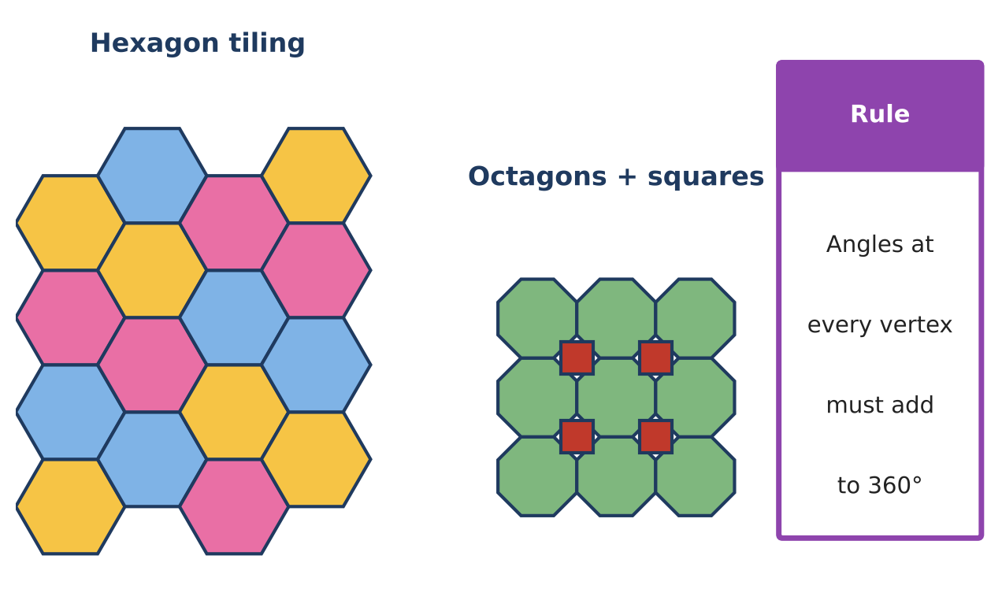
Learning Goals
- I can find interior angle sums and angle measures of regular polygons.
- I can decide which regular polygons tessellate.
- I can use properties of quadrilaterals to solve problems.
Project Timeline
When | What you will do
Day 1 | Which Shapes Tile?
Day 2 | Quilt Shapes
Day 3 | Design Your Pattern
Final | Pattern Design Board + reflection

Part 1: Which Shapes Tile?
Day 1 · A regular polygon tiles the floor alone if 360 ÷ (its angle) is a whole number.
1. Complete the table. Interior angle sum = (n − 2) × 180°.
Regular polygon | Sides n | Interior angle sum | Each interior angle | 360 ÷ angle | Tiles alone?
Triangle | 3 | 180°
Square | 4
Pentagon | 5
Hexagon | 6
Octagon | 8

2. Which regular polygons tile the floor by themselves?

3. Octagons and squares tile together. Show why using the angles at one vertex.

4. Each exterior angle of a regular polygon is 360° ÷ n. A regular polygon has exterior angles of 24°. How many sides does it have?

Part 2: Quilt Shapes
Day 2 · Use quadrilateral properties.
5. A parallelogram quilt piece has opposite angles of (3x + 10)° and (5x − 30)°. Find x and all four angles.

6. A rectangle's diagonals measure (2y + 4) in and (5y − 11) in. Find y and the length of each diagonal.

7. A trapezoid border piece has bases of 10 in and 16 in. Find the length of its midsegment.

Part 3: Design Your Pattern
Day 3 · Design a tile or quilt pattern.
8. Choose your shapes. Show that the angles at one vertex add to 360°.

9. Include at least one quadrilateral and name two of its properties that you used.

10. Color and label your design.

Final Product: Pattern Design Board
Your final product must include:
- Pattern design with a vertex angle check
- Completed polygon table
- Quilt-shape answers
- A title and artist statement
Reflection
R1. Why can't regular pentagons tile a floor by themselves?

R2. Which quadrilateral property was most useful in your design?

Scoring Rubric
Criteria | 4 – Exceeds | 3 – Meets | 2 – Approaching | 1 – Beginning
Mathematical Accuracy | All calculations and solutions are correct; answers include units and are checked. | Nearly all work is correct; minor errors do not change conclusions. | Several errors; some conclusions are affected. | Many errors or missing work.
Reasoning & Justification | Clear, complete explanations connect every answer to the situation; uses precise vocabulary. | Explanations are mostly clear and connected to the situation. | Explanations are brief or partly unclear. | Little or no explanation.
Application & Design | Pattern tiles the plane (angles at each vertex add to 360°) and uses at least one quadrilateral property correctly. Goes beyond the minimum with a creative, realistic choice. | Pattern tiles the plane (angles at each vertex add to 360°) and uses at least one quadrilateral property correctly. | Design is incomplete or only partly uses the math from the unit. | Design is missing or unrelated to the unit math.
Communication & Presentation | Design board shows the pattern, the angle check at a vertex, and the quadrilateral properties used. Polished, organized, and visually engaging. | Design board shows the pattern, the angle check at a vertex, and the quadrilateral properties used. Organized and easy to follow. | Product is missing required parts or is hard to follow. | Product is mostly missing.

