GEOMETRY · UNIT 7: QUADRILATERALS AND POLYGONS  Tile & Quilt Designer  Use polygon angles and quadrilateral properties to design tilings and quilt blocks. | Honors  2–3 class periods

Name: ________________________________ Date: ______________ Period: ______
The Scenario
A local quilting guild and a tile store are teaming up for a community art wall. They want student designs built from polygons that fit together with no gaps or overlaps.
Whether polygons fit depends on their angles, and quilt blocks depend on the properties of quadrilaterals. You will test the math behind good patterns and then design your own.
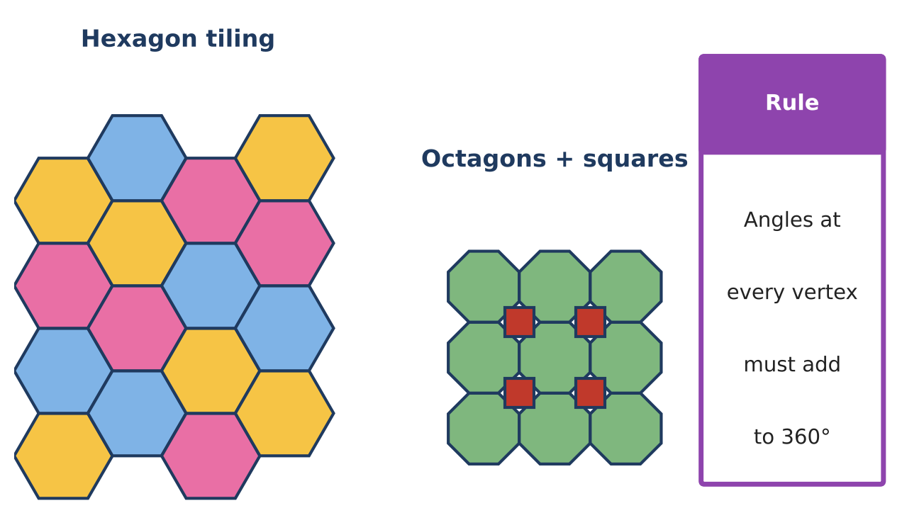
Learning Goals
- I can analyze semi-regular tessellations.
- I can prove quadrilateral properties in general with coordinates.
- I can design and justify a complex pattern.
Project Timeline
When | What you will do
Day 1 | Semi-Regular Tilings
Day 2 | General Proofs
Day 3 | Design & Prove
Final | Pattern Design Board + reflection

Part 1: Semi-Regular Tilings
Day 1 · A semi-regular tiling uses two or more regular polygons with the same arrangement at every vertex.
1. Verify that these vertex arrangements add to 360°: 4.8.8; 3.12.12; 4.6.12; 3.3.3.3.6.

2. Find every regular polygon whose interior angle is a whole number of degrees and less than 180°, with n ≤ 12, and explain how to search for 3-polygon vertex arrangements.

3. Prove the exterior angles of any convex polygon add to 360°.

Part 2: General Proofs
Day 2 · Use general coordinates.
4. Prove ABCD with A(0, 0), B(6, 2), C(8, 8), D(2, 6) is a rhombus and not a square.
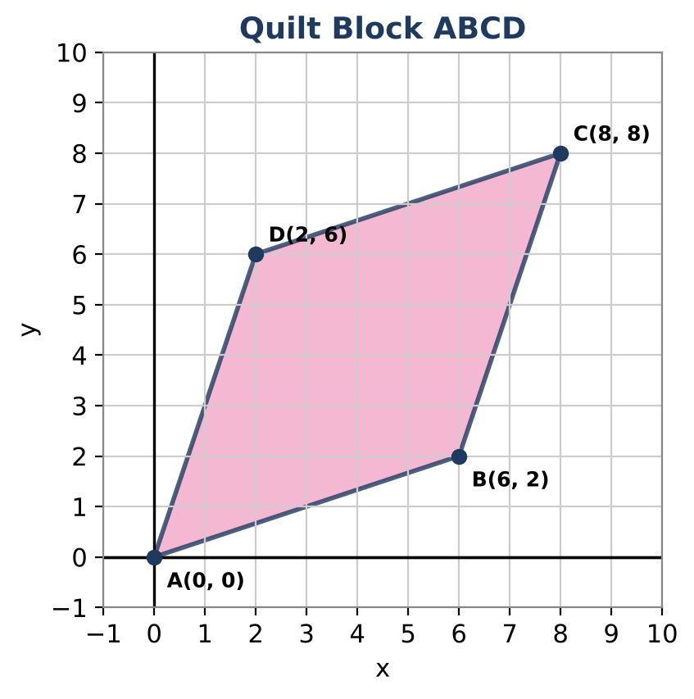

5. Prove: the diagonals of any rhombus are perpendicular. Use A(0, 0), B(a, 0), C(a + b, c), D(b, c) with a² = b² + c².

6. Prove: the midpoints of any quadrilateral form a parallelogram (Varignon's Theorem).

Part 3: Design & Prove
Day 3 · Design a semi-regular tiling or a quilt with at least three quadrilateral types.
7. Draw the design and give the vertex arrangement or coordinates.

8. Write a proof for one quadrilateral or for the vertex angle sum.

9. Write an artist statement that connects your math to the design.

Final Product: Pattern Design Board
Your final product must include:
- Semi-regular tiling analysis
- Three proofs
- Original design with proof
- Artist statement
Reflection
R1. Why do general coordinates make a proof work for every rhombus?

R2. What makes a tiling semi-regular instead of regular?

Scoring Rubric
Criteria | 4 – Exceeds | 3 – Meets | 2 – Approaching | 1 – Beginning
Mathematical Accuracy | All calculations and solutions are correct; answers include units and are checked. | Nearly all work is correct; minor errors do not change conclusions. | Several errors; some conclusions are affected. | Many errors or missing work.
Reasoning & Justification | Clear, complete explanations connect every answer to the situation; uses precise vocabulary. | Explanations are mostly clear and connected to the situation. | Explanations are brief or partly unclear. | Little or no explanation.
Application & Design | Pattern tiles the plane (angles at each vertex add to 360°) and uses at least one quadrilateral property correctly. Goes beyond the minimum with a creative, realistic choice. | Pattern tiles the plane (angles at each vertex add to 360°) and uses at least one quadrilateral property correctly. | Design is incomplete or only partly uses the math from the unit. | Design is missing or unrelated to the unit math.
Communication & Presentation | Design board shows the pattern, the angle check at a vertex, and the quadrilateral properties used. Polished, organized, and visually engaging. | Design board shows the pattern, the angle check at a vertex, and the quadrilateral properties used. Organized and easy to follow. | Product is missing required parts or is hard to follow. | Product is mostly missing.

