GEOMETRY · UNIT 1: FOUNDATIONS OF GEOMETRY  Treasure Map Navigator  Use distance, midpoint, and angle relationships to find buried treasure. | CP1  2–3 class periods

Name: ________________________________ Date: ______________ Period: ______
The Scenario
A pirate's map of Skull Island has turned up in the school library. The landmarks sit on a coordinate grid where each unit is one block.
Each clue uses a geometry idea: distance, midpoint, segment addition, or angle relationships. Solve the clues to find the treasure, then make a map of your own.
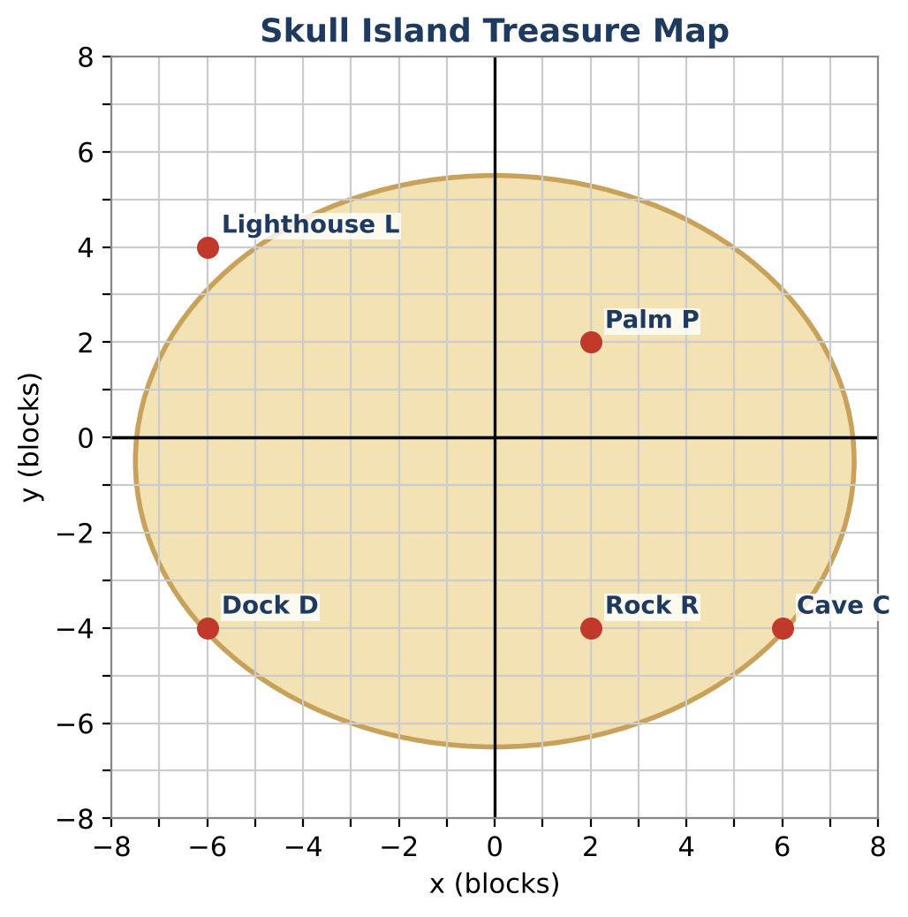
Learning Goals
- I can use the distance and midpoint formulas.
- I can solve for unknowns with segment addition, angle addition, and angle bisectors.
- I can use angle pair relationships to find measures.
Project Timeline
When | What you will do
Day 1 | Distance & Midpoint Clues
Day 2 | Segment & Angle Clues
Day 3 | Design Your Own Map
Final | Treasure Map & Clue Set + reflection

Part 1: Distance & Midpoint Clues
Day 1 · Use the map and the coordinate table.
1. Find DP, PC, and DC. Give exact answers and decimals to the nearest hundredth.
Location | Coordinates
Dock D | (−6, −4)
Palm P | (2, 2)
Cave C | (6, −4)
Lighthouse L | (−6, 4)
Rock R | (2, −4)

2. Find the perimeter of the triangle formed by the Dock, the Palm, and the Cave.

3. The Cave is the midpoint of the Palm and a hidden spot X. Find the coordinates of X.

4. Find the midpoint of the Lighthouse and the Cave. Which landmark is closest to it?

Part 2: Segment & Angle Clues
Day 2 · Write and solve an equation for each clue.
5. D, R, and C are collinear with R between D and C. DR = 2x + 2, RC = x + 1, and DC = 12. Find DR and RC. Do these match the map?

6. Ray PD bisects ∠LPC. m∠LPD = (5x − 4)° and m∠DPC = (3x + 12)°. Find m∠LPC.
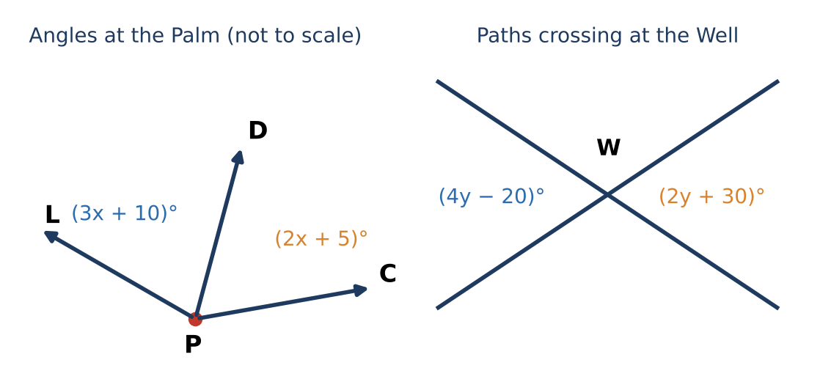

7. Two straight paths cross at the Well. One angle is (4y − 20)° and its vertical angle is (2y + 30)°. Find all four angles formed.

8. Two angles at the Rock are complementary. One is 18° more than twice the other. Find both.

Part 3: Design Your Own Map
Day 3 · Design a map whose treasure can only be found by solving every clue.
9. Place five landmarks and write a clue that uses "the midpoint of A and B is C, find B".

10. Write a segment addition clue and an angle bisector clue with algebra.

11. Write the answer key. Trade with a partner and record any clue they found unclear.

Final Product: Treasure Map & Clue Set
Your final product must include:
- Labeled map with coordinates
- Clues using distance, midpoint (including a missing endpoint), segment addition, and an angle bisector
- Complete answer key
- Partner feedback and revision
Reflection
R1. How can you find a missing endpoint if you know the midpoint?

R2. What is the difference between a bisector and a midpoint?

Scoring Rubric
Criteria | 4 – Exceeds | 3 – Meets | 2 – Approaching | 1 – Beginning
Mathematical Accuracy | All calculations and solutions are correct; answers include units and are checked. | Nearly all work is correct; minor errors do not change conclusions. | Several errors; some conclusions are affected. | Many errors or missing work.
Reasoning & Justification | Clear, complete explanations connect every answer to the situation; uses precise vocabulary. | Explanations are mostly clear and connected to the situation. | Explanations are brief or partly unclear. | Little or no explanation.
Application & Design | Original clues correctly use distance, midpoint, and angle relationships and lead to one location. Goes beyond the minimum with a creative, realistic choice. | Original clues correctly use distance, midpoint, and angle relationships and lead to one location. | Design is incomplete or only partly uses the math from the unit. | Design is missing or unrelated to the unit math.
Communication & Presentation | Map and clue set show labeled coordinates, every clue, and a complete answer key. Polished, organized, and visually engaging. | Map and clue set show labeled coordinates, every clue, and a complete answer key. Organized and easy to follow. | Product is missing required parts or is hard to follow. | Product is mostly missing.

