GEOMETRY · UNIT 1: FOUNDATIONS OF GEOMETRY  Treasure Map Navigator  Use distance, midpoint, and angle relationships to find buried treasure. | CP2  2–3 class periods

Name: ________________________________ Date: ______________ Period: ______
The Scenario
A pirate's map of Skull Island has turned up in the school library. The landmarks sit on a coordinate grid where each unit is one block.
Each clue uses a geometry idea: distance, midpoint, segment addition, or angle relationships. Solve the clues to find the treasure, then make a map of your own.
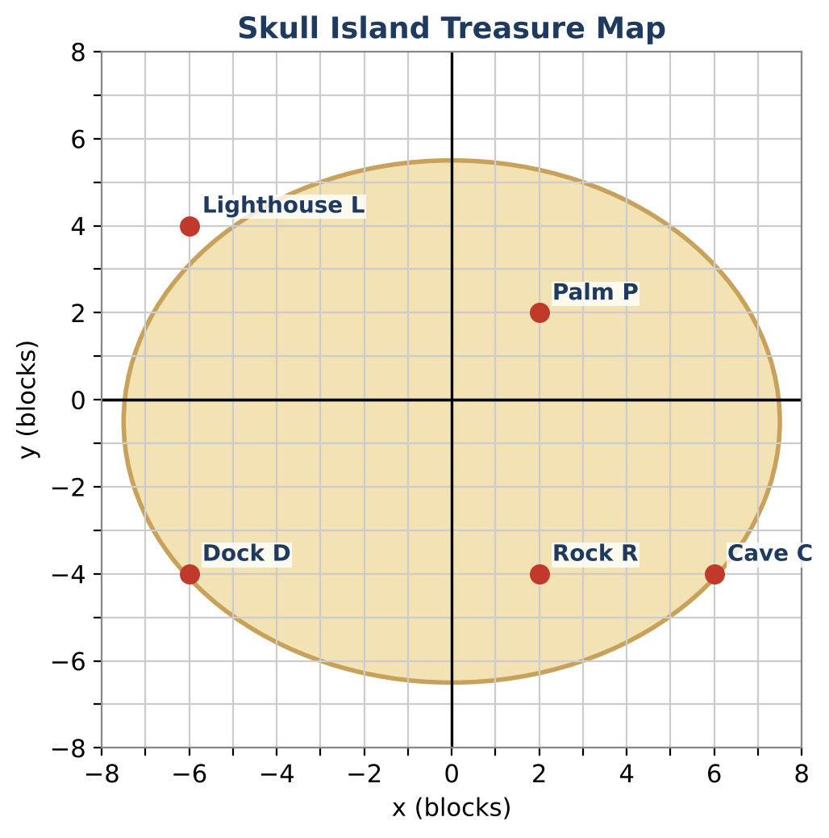
Learning Goals
- I can find distances and midpoints on the coordinate plane.
- I can use segment addition and angle addition to solve for unknowns.
- I can identify vertical angles and linear pairs.
Project Timeline
When | What you will do
Day 1 | Distance & Midpoint Clues
Day 2 | Segment & Angle Clues
Day 3 | Design Your Own Map
Final | Treasure Map & Clue Set + reflection

Part 1: Distance & Midpoint Clues
Day 1 · Use the map and the coordinate table.
1. Clue 1: How far is it from the Dock to the Cave? (They are on the same horizontal line.)
Location | Coordinates
Dock D | (−6, −4)
Palm P | (2, 2)
Cave C | (6, −4)
Lighthouse L | (−6, 4)
Rock R | (2, −4)

2. Clue 2: How far is it from the Dock to the Palm? Draw a right triangle on the grid and use the Pythagorean Theorem.
Starter: legs: 8 and 6

3. Clue 3: The first chest is buried at the midpoint of the Dock and the Palm. Find its coordinates.
Starter: Average the x-coordinates, then average the y-coordinates.

4. Clue 4: The second chest is at the midpoint of the Palm and the Cave. Find its coordinates.

Part 2: Segment & Angle Clues
Day 2 · Use algebra to unlock each clue.
5. The Dock, the Rock, and the Cave are on one straight path. DR = 2x + 2 and RC = x + 1, and DC = 12. Find x, DR, and RC.

6. At the Palm, ray PD splits ∠LPC. m∠LPD = (3x + 10)°, m∠DPC = (2x + 5)°, and m∠LPC = 95°. Find x and both angle measures.
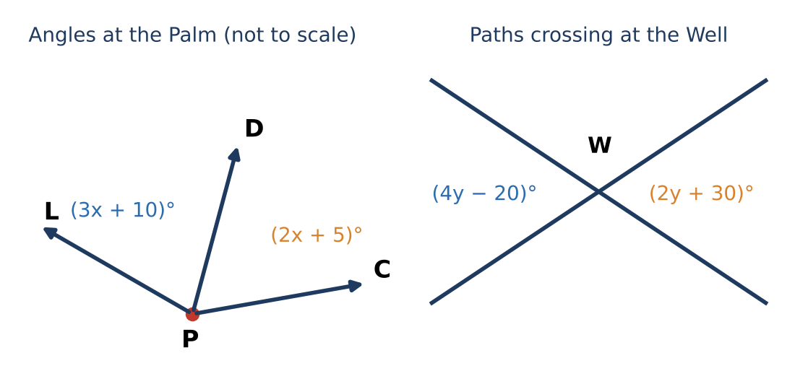

7. Two paths cross at the Well and form vertical angles of (4y − 20)° and (2y + 30)°. Find y and the angle measure.

8. What is the measure of an angle that forms a linear pair with the angle from #7?

Part 3: Design Your Own Map
Day 3 · Make a treasure map on graph paper.
9. Place at least four landmarks on a coordinate grid and list their coordinates.

10. Write a midpoint clue and a distance clue that lead to your treasure. Solve them in an answer key.

11. Write one angle clue (angle addition or vertical angles) with an answer key.

Final Product: Treasure Map & Clue Set
Your final product must include:
- A labeled treasure map on a coordinate grid
- At least three clues (midpoint, distance, angle)
- An answer key with all work
- A short pirate story
Reflection
R1. Why does the midpoint formula average the coordinates?

R2. How did the Pythagorean Theorem help you find a diagonal distance?

Scoring Rubric
Criteria | 4 – Exceeds | 3 – Meets | 2 – Approaching | 1 – Beginning
Mathematical Accuracy | All calculations and solutions are correct; answers include units and are checked. | Nearly all work is correct; minor errors do not change conclusions. | Several errors; some conclusions are affected. | Many errors or missing work.
Reasoning & Justification | Clear, complete explanations connect every answer to the situation; uses precise vocabulary. | Explanations are mostly clear and connected to the situation. | Explanations are brief or partly unclear. | Little or no explanation.
Application & Design | Original clues correctly use distance, midpoint, and angle relationships and lead to one location. Goes beyond the minimum with a creative, realistic choice. | Original clues correctly use distance, midpoint, and angle relationships and lead to one location. | Design is incomplete or only partly uses the math from the unit. | Design is missing or unrelated to the unit math.
Communication & Presentation | Map and clue set show labeled coordinates, every clue, and a complete answer key. Polished, organized, and visually engaging. | Map and clue set show labeled coordinates, every clue, and a complete answer key. Organized and easy to follow. | Product is missing required parts or is hard to follow. | Product is mostly missing.

