GEOMETRY · UNIT 1: FOUNDATIONS OF GEOMETRY  Treasure Map Navigator  Use distance, midpoint, and angle relationships to find buried treasure. | Honors  2–3 class periods

Name: ________________________________ Date: ______________ Period: ______
The Scenario
A pirate's map of Skull Island has turned up in the school library. The landmarks sit on a coordinate grid where each unit is one block.
Each clue uses a geometry idea: distance, midpoint, segment addition, or angle relationships. Solve the clues to find the treasure, then make a map of your own.
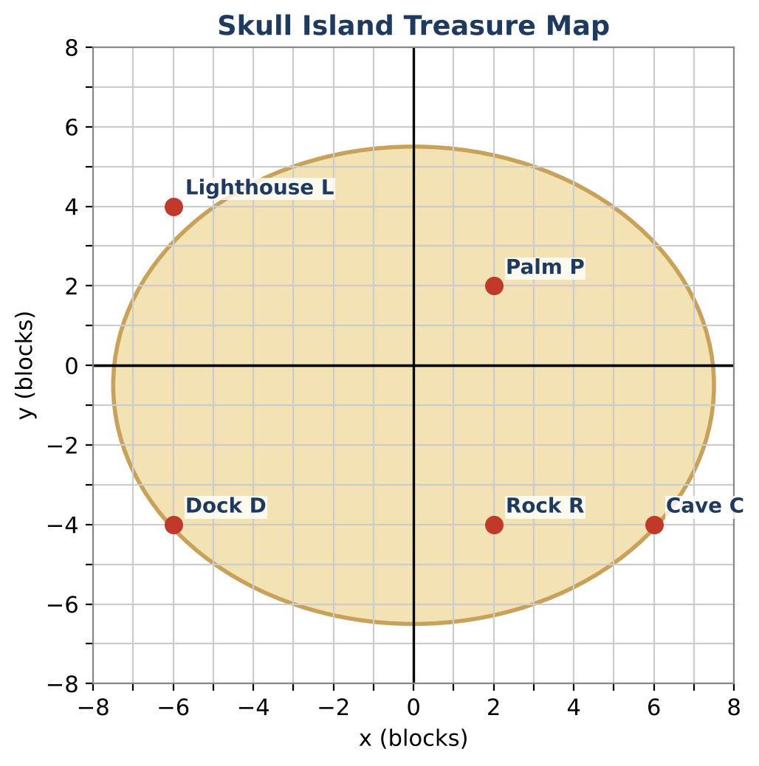
Learning Goals
- I can partition a segment in a given ratio.
- I can use perpendicular bisectors to find points that are equidistant from two points.
- I can design clues that lead to a unique location and justify them.
Project Timeline
When | What you will do
Day 1 | Coordinates & Ratios
Day 2 | Equidistant Clues
Day 3 | Design a Unique-Location Map
Final | Treasure Map & Clue Set + reflection

Part 1: Coordinates & Ratios
Day 1 · Use the map and the coordinate table.
1. Find the exact perimeter of triangle DPC and classify the triangle by its sides.
Location | Coordinates
Dock D | (−6, −4)
Palm P | (2, 2)
Cave C | (6, −4)
Lighthouse L | (−6, 4)
Rock R | (2, −4)

2. The treasure is ¾ of the way from the Dock to the Palm. Find its coordinates.

3. The point Q divides PC so that PQ : QC = 1 : 3. Find Q.

4. The Cave is the midpoint of the Palm and X. Find X, then show that the Rock is not on segment PX.

Part 2: Equidistant Clues
Day 2 · Every point on the perpendicular bisector of a segment is the same distance from both endpoints.
5. Write the equation of the perpendicular bisector of DP in standard form.

6. A clue says the treasure is on the shoreline y = 0 and the same distance from the Dock and the Palm. Find the point two ways: with your bisector and with the distance formula.

7. Ray PD bisects ∠LPC with m∠LPD = (5x − 4)° and m∠DPC = (3x + 12)°. Find m∠LPC and the measure of its supplement.
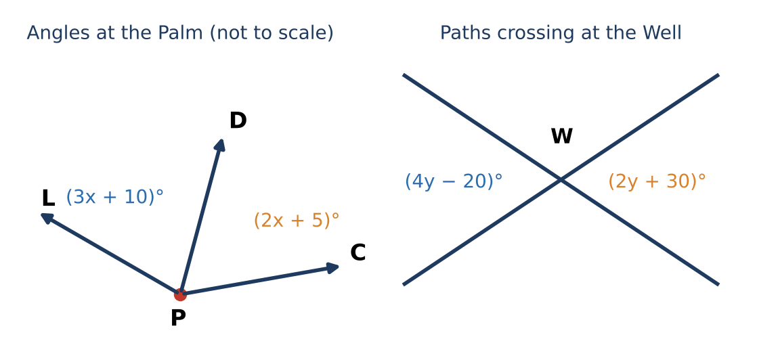

8. Prove that the paths crossing at the Well form two pairs of congruent vertical angles, using the definition of a linear pair.

Part 3: Design a Unique-Location Map
Day 3 · Your clues must lead to exactly one point.
9. Design a map with five landmarks. Include a ratio (partition) clue and an equidistant clue.

10. Prove that your clues lead to exactly one point. Explain what would happen if one clue were removed.

11. Write an answer key and test it with a partner.

Final Product: Treasure Map & Clue Set
Your final product must include:
- Map with coordinates
- Partition and equidistance clues
- Proof that the clues give one point
- Complete answer key
Reflection
R1. Why is the perpendicular bisector the set of all points equidistant from two points?

R2. How did you make sure your clues led to only one location?

Scoring Rubric
Criteria | 4 – Exceeds | 3 – Meets | 2 – Approaching | 1 – Beginning
Mathematical Accuracy | All calculations and solutions are correct; answers include units and are checked. | Nearly all work is correct; minor errors do not change conclusions. | Several errors; some conclusions are affected. | Many errors or missing work.
Reasoning & Justification | Clear, complete explanations connect every answer to the situation; uses precise vocabulary. | Explanations are mostly clear and connected to the situation. | Explanations are brief or partly unclear. | Little or no explanation.
Application & Design | Original clues correctly use distance, midpoint, and angle relationships and lead to one location. Goes beyond the minimum with a creative, realistic choice. | Original clues correctly use distance, midpoint, and angle relationships and lead to one location. | Design is incomplete or only partly uses the math from the unit. | Design is missing or unrelated to the unit math.
Communication & Presentation | Map and clue set show labeled coordinates, every clue, and a complete answer key. Polished, organized, and visually engaging. | Map and clue set show labeled coordinates, every clue, and a complete answer key. Organized and easy to follow. | Product is missing required parts or is hard to follow. | Product is mostly missing.

