6TH GRADE MATH · UNIT 4: EXPRESSIONS AND EQUATIONS  Arcade Party Planner  Write expressions and solve equations to plan a birthday party at the arcade. | CP1  2–3 class periods

Name: ________________________________ Date: ______________ Period: ______
The Scenario
Your cousin wants a birthday party at Pixel Palace Arcade. Each guest needs a game card, the party room costs a flat fee, and prizes are bought with tickets.
You will write expressions and solve equations to compare party packages and plan a party that fits the budget.
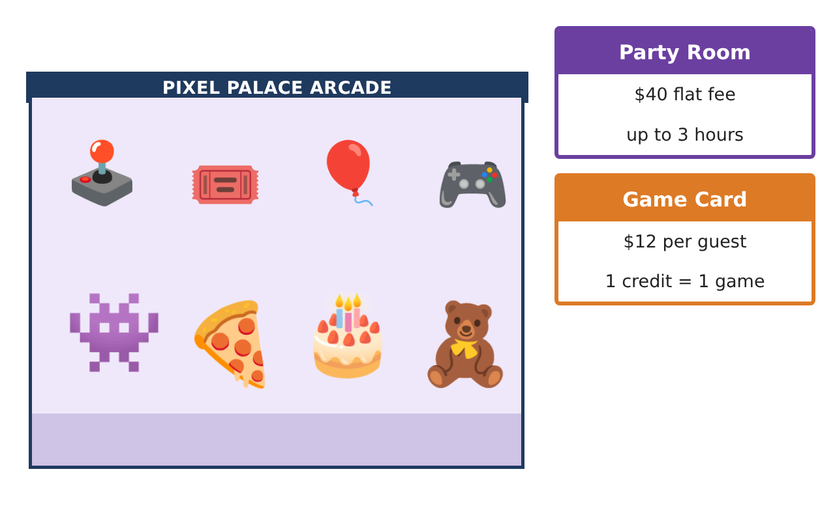
Learning Goals
- I can write and evaluate expressions with variables and exponents.
- I can use properties to write equivalent expressions.
- I can write and solve one-step equations in context.
Project Timeline
When | What you will do
Day 1 | Package Expressions
Day 2 | Equivalent Expressions
Day 3 | Equations & Design
Final | Party Package Proposal + reflection
Part 1: Package Expressions
Day 1 · Let g be the number of guests. Use the Arcade Price Board.
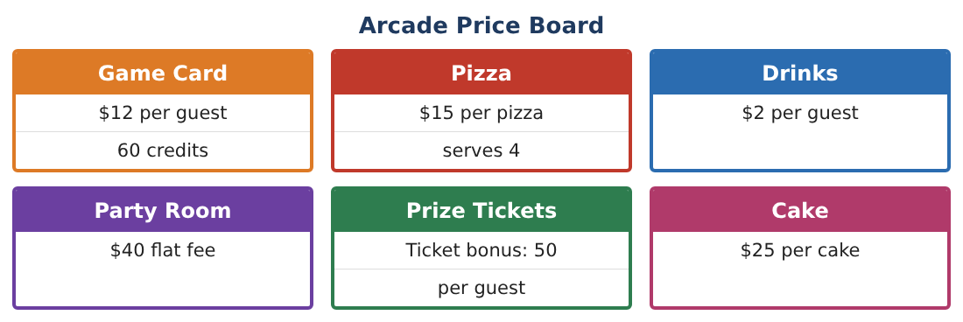
1. Write an expression for the total cost with the room, a game card and a drink for each guest, and one pizza for every 4 guests.

2. Evaluate your expression for 8 guests and for 12 guests.

3. Pixel Palace also offers "The Mega": $20 per guest, everything included, no room fee. Write its expression and evaluate it for 8 and 12 guests.

4. Which package is cheaper for 8 guests? For 20 guests? What do you notice?

Part 2: Equivalent Expressions
Day 2 · Use properties of operations.
5. Use the distributive property to write 6(2g + 5) without parentheses. What could it describe?

6. Factor 18g + 24 using the greatest common factor.

7. Combine like terms: 12g + 40 + 2g + 25 + 3g.

8. A super prize costs 3⁴ tickets and a mega prize costs 4³ tickets. Which costs more and by how much?

Part 3: Equations & Design
Day 3 · Write and solve an equation for each question.
9. The Mega package cost $260. How many guests came?

10. After the room fee was paid, the family had $186 left for game cards and drinks at $14 per guest. How many guests can come?

11. Design your own package with a price per guest and a flat fee. Write its expression and an equation for a $300 budget. Solve it.

Final Product: Party Package Proposal
Your final product must include:
- Expressions for both packages and your own
- A table comparing costs for 8, 12, and 20 guests
- Two equivalent expressions with the property used
- Equations solved for guests and budgets
- Party proposal with a recommendation
Reflection
R1. Why do the regular and Mega packages switch which is cheaper?

R2. How do you know two expressions are equivalent?

Scoring Rubric
Criteria | 4 – Exceeds | 3 – Meets | 2 – Approaching | 1 – Beginning
Mathematical Accuracy | All calculations and solutions are correct; answers include units and are checked. | Nearly all work is correct; minor errors do not change conclusions. | Several errors; some conclusions are affected. | Many errors or missing work.
Reasoning & Justification | Clear, complete explanations connect every answer to the situation; uses precise vocabulary. | Explanations are mostly clear and connected to the situation. | Explanations are brief or partly unclear. | Little or no explanation.
Application & Design | Expressions and equations model every cost correctly and are used to compare packages and plan within the budget. Goes beyond the minimum with a creative, realistic choice. | Expressions and equations model every cost correctly and are used to compare packages and plan within the budget. | Design is incomplete or only partly uses the math from the unit. | Design is missing or unrelated to the unit math.
Communication & Presentation | Proposal includes expressions, a comparison table, solved equations, and a clear recommendation. Polished, organized, and visually engaging. | Proposal includes expressions, a comparison table, solved equations, and a clear recommendation. Organized and easy to follow. | Product is missing required parts or is hard to follow. | Product is mostly missing.

