6TH GRADE MATH · UNIT 4: EXPRESSIONS AND EQUATIONS  Arcade Party Planner  Write expressions and solve equations to plan a birthday party at the arcade. | Honors  2–3 class periods

Name: ________________________________ Date: ______________ Period: ______
The Scenario
Your cousin wants a birthday party at Pixel Palace Arcade. Each guest needs a game card, the party room costs a flat fee, and prizes are bought with tickets.
You will write expressions and solve equations to compare party packages and plan a party that fits the budget.
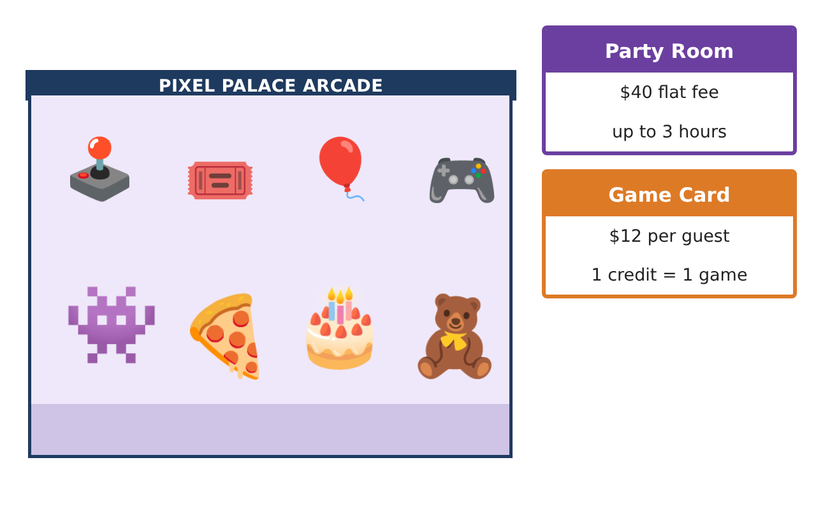
Learning Goals
- I can write and interpret multi-term expressions, including exponents.
- I can generate equivalent expressions and justify them with properties.
- I can use equations to compare plans and find break-even points.
Project Timeline
When | What you will do
Day 1 | Model the Packages
Day 2 | Tickets & Powers
Day 3 | Optimize the Party
Final | Party Package Proposal + reflection
Part 1: Model the Packages
Day 1 · Use the Arcade Price Board. g = guests.
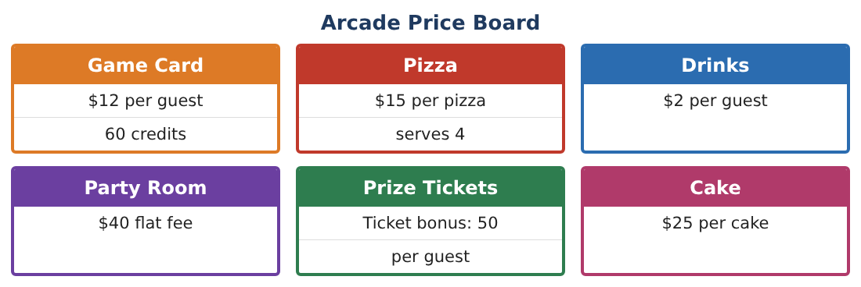
1. Write the cost of the regular package (room, game card, drink, and pizza at $\frac{1}{4}$ pizza per guest) and simplify.

2. The Mega costs 20g. For what number of guests do the two packages cost the same? (Solve by testing values or by reasoning.)

3. A coupon gives $3 off each game card. Write two equivalent expressions for the new regular cost and explain each.

4. Evaluate both of your coupon expressions for g = 16 to show they are equivalent.

Part 2: Tickets & Powers
Day 2 · Prize prices are written with exponents.
5. Order these prizes by ticket cost: 2⁷, 5³, 11², 3⁵.

6. Each guest wins an average of 2(t + 15) tickets where t is bonus tickets. Rewrite without parentheses and find the total for 12 guests with t = 50.

7. Factor 48g + 36 and 45g + 30g², and explain what the factored forms show.

8. Is 3(g + 4) equivalent to 3g + 4? Use a value of g and a property to explain.

Part 3: Optimize the Party
Day 3 · The family budget is $320.
9. How many guests can attend each package within $320? (Use equations, then round sensibly.)

10. With a $3-off coupon, recompute for the regular package. Which package now allows more guests?

11. Design a package for Pixel Palace that is cheaper than the Mega for 10 guests but costs more than the regular package for 25 guests. Write its expression and show both comparisons.

Final Product: Party Package Proposal
Your final product must include:
- Simplified expressions for every package
- Break-even analysis with a table or graph
- Equivalent expressions justified with properties
- Budget equations and solutions
- Your designed package with both comparisons shown
Reflection
R1. Explain the break-even point in words a parent would understand.

R2. Why must you round down guest counts when solving budget equations?

Scoring Rubric
Criteria | 4 – Exceeds | 3 – Meets | 2 – Approaching | 1 – Beginning
Mathematical Accuracy | All calculations and solutions are correct; answers include units and are checked. | Nearly all work is correct; minor errors do not change conclusions. | Several errors; some conclusions are affected. | Many errors or missing work.
Reasoning & Justification | Clear, complete explanations connect every answer to the situation; uses precise vocabulary. | Explanations are mostly clear and connected to the situation. | Explanations are brief or partly unclear. | Little or no explanation.
Application & Design | Expressions and equations model every cost correctly and are used to compare packages and plan within the budget. Goes beyond the minimum with a creative, realistic choice. | Expressions and equations model every cost correctly and are used to compare packages and plan within the budget. | Design is incomplete or only partly uses the math from the unit. | Design is missing or unrelated to the unit math.
Communication & Presentation | Proposal includes expressions, a comparison table, solved equations, and a clear recommendation. Polished, organized, and visually engaging. | Proposal includes expressions, a comparison table, solved equations, and a clear recommendation. Organized and easy to follow. | Product is missing required parts or is hard to follow. | Product is mostly missing.

