6TH GRADE MATH · UNIT 1: RATIOS, RATE, PERCENT AND PROPORTIONS  Bake Sale Boss  Scale recipes, compare prices, and price your treats for a school bake sale. | CP2  2–3 class periods

Name: ________________________________ Date: ______________ Period: ______
The Scenario
Your class is running a bake sale to raise money for a field trip. The recipes you found make the wrong number of treats, the store sells ingredients in different sizes, and you need to set prices that make a profit.
You will use ratios, rates, and percents to scale recipes, find the best buys, and plan a booth that earns as much money as possible.
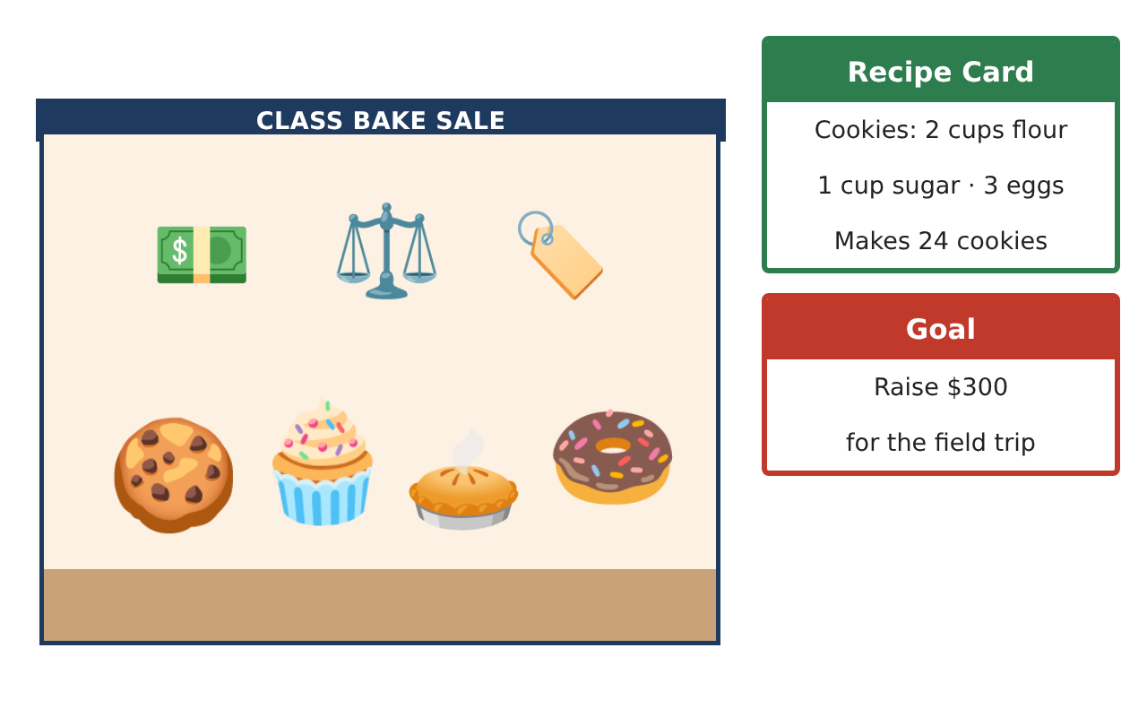
Learning Goals
- I can use a ratio table to scale a recipe.
- I can find a unit price to choose the better buy.
- I can find a percent of a number to plan prices and discounts.
Project Timeline
When | What you will do
Day 1 | Scale the Recipe
Day 2 | Best Buys
Day 3 | Price Your Treats
Final | Bake Sale Business Plan + reflection
Part 1: Scale the Recipe
Day 1 · Use the Recipe Card: 2 cups flour, 1 cup sugar, and 3 eggs make 24 cookies.
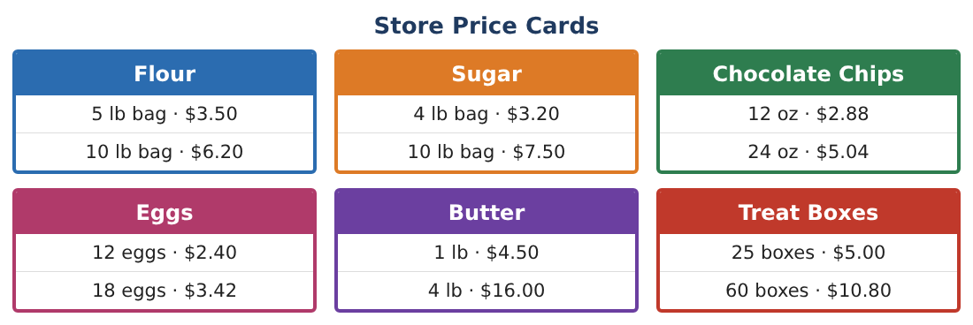
1. Write the ratio of cups of flour to cups of sugar three ways.
Starter: ___ to ___, ___ : ___

2. Complete a ratio table to find the flour needed for 48, 72, and 96 cookies.
Starter: Cookies 24 | 48 | 72 | 96; Flour 2 | ___ | ___ | ___

3. How many eggs do you need for 72 cookies?

4. You have 10 cups of flour. How many cookies can you make? Show your ratio table.

Part 2: Best Buys
Day 2 · Use the Store Price Cards. Divide to find the price for 1 unit.
5. Find the price per pound for each bag of flour. Which is the better buy?
Starter: $3.50 ÷ 5 = ___ per pound

6. Find the price per egg for each carton. Which is the better buy?

7. Find the price per box for each pack of treat boxes. Which is the better buy?

8. Tell a friend why the bigger package is not ALWAYS the better buy.

Part 3: Price Your Treats
Day 3 · Plan the prices for your booth.
9. You sell cookies for $0.50 each. How much money do you make if you sell 120 cookies?

10. At the end of the day, cookies are 20% off. What is 20% of $0.50? What is the new price?
Starter: 20% = $\frac{20}{100}$ = 0.20, so 0.20 × $0.50 = ___

11. Choose two treats and a price for each. If you sell 100 of each, how much money do you make? Is that more or less than 50% of the $300 goal?

Final Product: Bake Sale Business Plan
Your final product must include:
- A scaled recipe with a ratio table
- Your shopping list with unit prices
- Your price list for at least two treats
- Total money you expect to make
- A booth sign that shows one sale price
Reflection
R1. How did a ratio table help you scale the recipe?

R2. Why do you divide to find a unit price?

Scoring Rubric
Criteria | 4 – Exceeds | 3 – Meets | 2 – Approaching | 1 – Beginning
Mathematical Accuracy | All calculations and solutions are correct; answers include units and are checked. | Nearly all work is correct; minor errors do not change conclusions. | Several errors; some conclusions are affected. | Many errors or missing work.
Reasoning & Justification | Clear, complete explanations connect every answer to the situation; uses precise vocabulary. | Explanations are mostly clear and connected to the situation. | Explanations are brief or partly unclear. | Little or no explanation.
Application & Design | Recipes are scaled correctly, best buys are justified with unit prices, and prices are set with percents to meet the goal. Goes beyond the minimum with a creative, realistic choice. | Recipes are scaled correctly, best buys are justified with unit prices, and prices are set with percents to meet the goal. | Design is incomplete or only partly uses the math from the unit. | Design is missing or unrelated to the unit math.
Communication & Presentation | Business plan includes scaled recipes, a shopping list, a price list, profit, and a booth sign. Polished, organized, and visually engaging. | Business plan includes scaled recipes, a shopping list, a price list, profit, and a booth sign. Organized and easy to follow. | Product is missing required parts or is hard to follow. | Product is mostly missing.

