6TH GRADE MATH · UNIT 6: GEOMETRY  Dream Bedroom Makeover  Use area, surface area, and volume to redesign a bedroom on a budget. | CP1  2–3 class periods

Name: ________________________________ Date: ______________ Period: ______
The Scenario
A TV show is giving a student a bedroom makeover, and your design team is in charge. You need new flooring, a rug, paint for the walls, and storage boxes, and everything must fit the budget.
You will use area, surface area, and volume to measure the room, plan materials, and present your design.
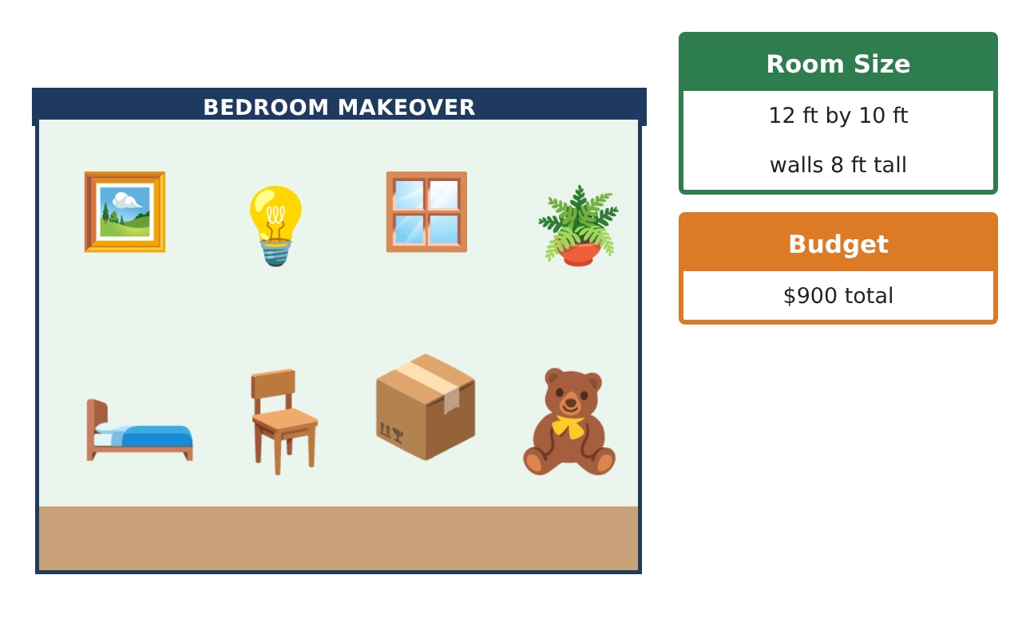
Learning Goals
- I can find areas of composite figures by decomposing them.
- I can use nets to find surface area in context.
- I can find volume with fractional edge lengths.
Project Timeline
When | What you will do
Day 1 | Flooring Choices
Day 2 | Paint & Surfaces
Day 3 | Storage & Final Budget
Final | Makeover Design Board + reflection
Part 1: Flooring Choices
Day 1 · The room is an L-shape: a 12 ft by 10 ft rectangle plus a 4 ft by 3 ft closet.
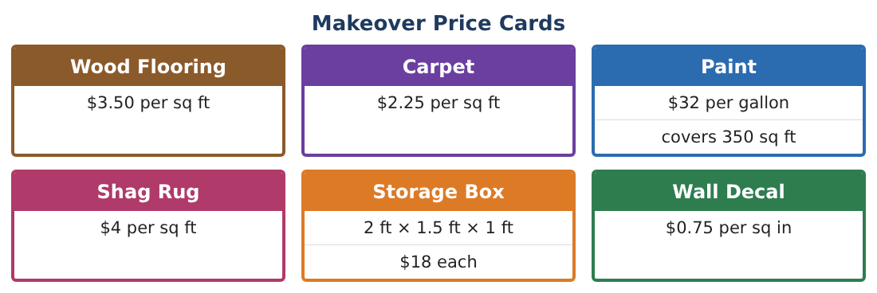
1. Find the total floor area.

2. Compare the cost of wood flooring and carpet for the whole floor. How much more is wood?

3. A rug is a trapezoid with bases 8 ft and 5 ft and height 6 ft. Find its area and cost.

4. A triangular wall decal has base 18 in and height 12 in. Find its area and cost.

Part 2: Paint & Surfaces
Day 2 · Walls are 8 ft tall. Subtract a 3 ft by 7 ft door and two 4 ft by 3$\frac{1}{2}$ ft windows.
5. Find the area of the four walls of the 12 ft by 10 ft room.

6. Subtract the door and windows. How much wall area will be painted?

7. Two coats are needed. How many gallons should you buy, and what is the cost?

8. Find the surface area of one storage box (2 ft × 1.5 ft × 1 ft) using a net. How much fabric covers 4 boxes?

Part 3: Storage & Final Budget
Day 3 · Use the Makeover Price Cards. Budget: $900.
9. A closet shelf is 4 ft by 1$\frac{1}{2}$ ft by 2$\frac{1}{2}$ ft of space. How many storage boxes (2 × 1.5 × 1 ft) fit by volume? Can they actually fit?

10. Find the cost of the boxes that fit.

11. Choose flooring, a rug, paint, decals, and boxes. Find the total and show it is under $900.

Final Product: Makeover Design Board
Your final product must include:
- Floor plan with all measurements
- Area calculations for flooring, rug, and decal
- Paintable wall area and gallons
- Storage volume and arrangement
- Itemized budget under $900
Reflection
R1. Why can the number of boxes that fit by volume be more than the number that actually fit?

R2. How did decomposing shapes help you find areas?

Scoring Rubric
Criteria | 4 – Exceeds | 3 – Meets | 2 – Approaching | 1 – Beginning
Mathematical Accuracy | All calculations and solutions are correct; answers include units and are checked. | Nearly all work is correct; minor errors do not change conclusions. | Several errors; some conclusions are affected. | Many errors or missing work.
Reasoning & Justification | Clear, complete explanations connect every answer to the situation; uses precise vocabulary. | Explanations are mostly clear and connected to the situation. | Explanations are brief or partly unclear. | Little or no explanation.
Application & Design | Areas, surface areas, and volumes are computed correctly and used to choose materials within the budget. Goes beyond the minimum with a creative, realistic choice. | Areas, surface areas, and volumes are computed correctly and used to choose materials within the budget. | Design is incomplete or only partly uses the math from the unit. | Design is missing or unrelated to the unit math.
Communication & Presentation | Design board shows the floor plan, calculations, materials list, and total cost. Polished, organized, and visually engaging. | Design board shows the floor plan, calculations, materials list, and total cost. Organized and easy to follow. | Product is missing required parts or is hard to follow. | Product is mostly missing.

