PRE-ALGEBRA (8TH) · UNIT 4: SYSTEMS OF LINEAR EQUATIONS  Food Truck Face-Off  Use systems of equations to compare food trucks and find break-even points. | CP1  2–3 class periods

Name: ________________________________ Date: ______________ Period: ______
The Scenario
Two food trucks want a spot at the spring festival: a taco truck and a burger truck. Each truck has a daily rental fee and a cost for each item it makes, and the festival committee wants to know which truck will do better.
You will write and solve systems of equations to compare costs, solve customer orders, and recommend a plan.
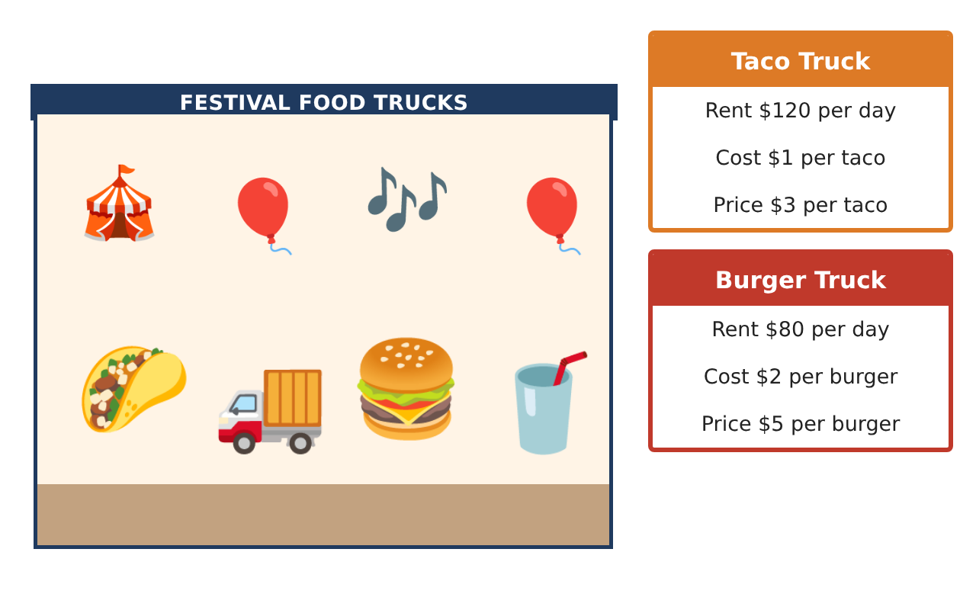
Learning Goals
- I can write and solve systems by graphing, substitution, and elimination.
- I can recognize systems with no solution or infinitely many solutions.
- I can use systems to compare profits and make a recommendation.
Project Timeline
When | What you will do
Day 1 | Costs & Break-Even
Day 2 | Orders & Elimination
Day 3 | Profit Showdown
Final | Food Truck Business Report + reflection
Part 1: Costs & Break-Even
Day 1 · Use the truck cards. Let x be the number of items.
1. Solve the cost system y = x + 120 and y = 2x + 80 by substitution, and interpret the solution.

2. Find each truck's break-even point (revenue = cost).

3. Graph both cost lines. For how many items is the taco truck's cost lower?

Part 2: Orders & Elimination
Day 2 · Solve each system.
4. A group buys 14 items for $54 (tacos $3, burgers $5). How many of each?

5. Solve by elimination: 4t + 3b = 39 and 2t + 5b = 37.

6. How many solutions does each system have? (a) y = 3x + 2 and 6x − 2y = −4 (b) y = 2x + 1 and y = 2x − 5

Part 3: Profit Showdown
Day 3 · Profit = price − cost per item, times the number sold, minus rent.
7. Write each truck's profit equation and decide whether the profits are ever equal for the same number of items.

8. The taco truck sells 3 tacos for every burger the burger truck sells. If the burger truck sells b burgers, for which b does the taco truck earn more?

9. Write a recommendation to the committee using your results.

Final Product: Food Truck Business Report
Your final product must include:
- Cost and break-even analysis
- Solved orders by substitution and elimination
- Examples of no-solution and infinite-solution systems
- Profit comparison with an inequality
- Business report with a recommendation
Reflection
R1. What do parallel lines mean in a business setting?

R2. When is elimination faster than substitution?

Scoring Rubric
Criteria | 4 – Exceeds | 3 – Meets | 2 – Approaching | 1 – Beginning
Mathematical Accuracy | All calculations and solutions are correct; answers include units and are checked. | Nearly all work is correct; minor errors do not change conclusions. | Several errors; some conclusions are affected. | Many errors or missing work.
Reasoning & Justification | Clear, complete explanations connect every answer to the situation; uses precise vocabulary. | Explanations are mostly clear and connected to the situation. | Explanations are brief or partly unclear. | Little or no explanation.
Application & Design | Systems are set up and solved correctly with all methods, and solution types are identified. Goes beyond the minimum with a creative, realistic choice. | Systems are set up and solved correctly with all methods, and solution types are identified. | Design is incomplete or only partly uses the math from the unit. | Design is missing or unrelated to the unit math.
Communication & Presentation | Business report explains costs, break-even points, and the recommendation with supporting work. Polished, organized, and visually engaging. | Business report explains costs, break-even points, and the recommendation with supporting work. Organized and easy to follow. | Product is missing required parts or is hard to follow. | Product is mostly missing.

