PRE-ALGEBRA (8TH) · UNIT 4: SYSTEMS OF LINEAR EQUATIONS  Food Truck Face-Off  Use systems of equations to compare food trucks and find break-even points. | CP2  2–3 class periods

Name: ________________________________ Date: ______________ Period: ______
The Scenario
Two food trucks want a spot at the spring festival: a taco truck and a burger truck. Each truck has a daily rental fee and a cost for each item it makes, and the festival committee wants to know which truck will do better.
You will write and solve systems of equations to compare costs, solve customer orders, and recommend a plan.
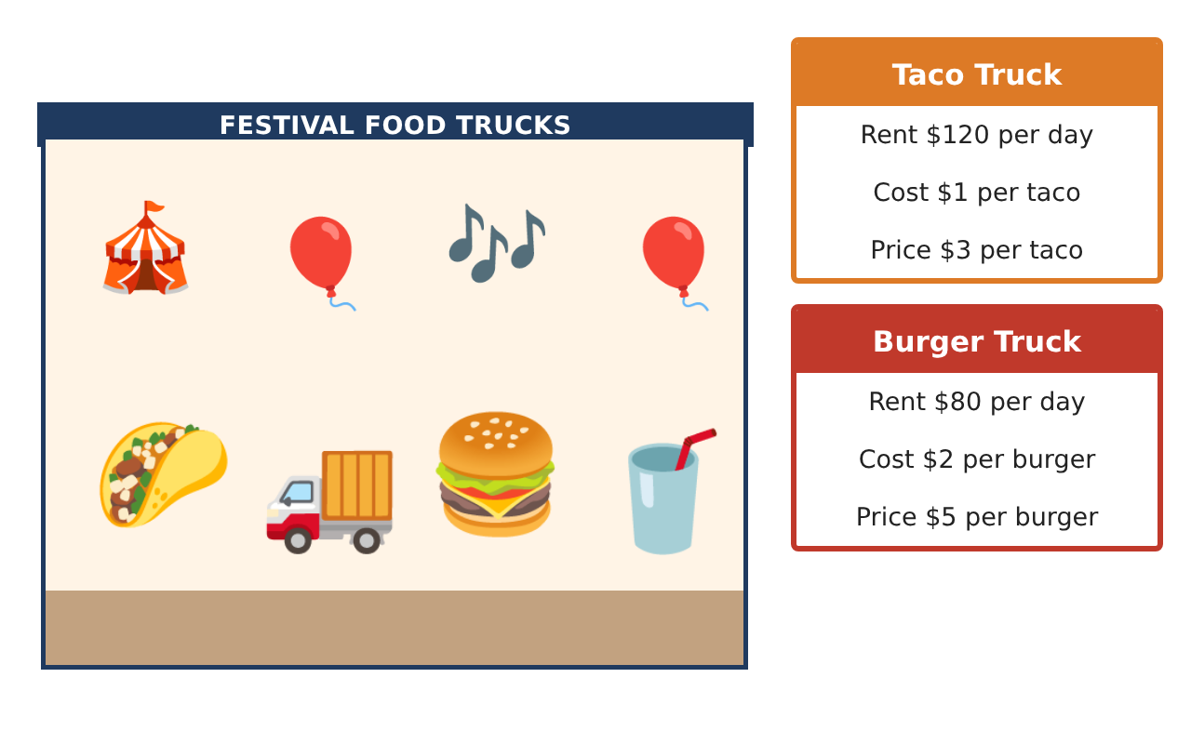
Learning Goals
- I can write equations for two situations and find where they are equal.
- I can solve a system by substitution.
- I can solve a system by elimination and check the solution.
Project Timeline
When | What you will do
Day 1 | Cost Lines
Day 2 | Customer Orders
Day 3 | Elimination & Profit
Final | Food Truck Business Report + reflection
Part 1: Cost Lines
Day 1 · Taco truck: $120 rent + $1 per taco. Burger truck: $80 rent + $2 per burger. Let x be the number of items made.
1. Write a cost equation for each truck.
Starter: Taco: y = ___x + ___

2. Complete a table for x = 0, 20, 40, 60. Where are the costs equal?

3. Solve the system by substitution to check: x + 120 = 2x + 80.

Part 2: Customer Orders
Day 2 · Tacos cost $3 and burgers cost $5. A group buys 10 items for $38.
4. Write a system for the number of tacos t and burgers b.

5. Solve the system by substitution.

6. Check your answer in both equations.

Part 3: Elimination & Profit
Day 3 · Use elimination and the price cards.
7. Solve by elimination: 2t + 3b = 21 and 2t + b = 11.

8. Each truck sells 50 items. Find each truck's profit (sales minus costs).

9. Which truck would you choose for the festival? Use your numbers.

Final Product: Food Truck Business Report
Your final product must include:
- Cost equations and a table showing where they meet
- Solved customer order with a check
- An elimination solution
- Profit for each truck
- A recommendation to the festival committee
Reflection
R1. What does the point (40, 160) mean for the two trucks?

R2. How do you check a solution to a system?

Scoring Rubric
Criteria | 4 – Exceeds | 3 – Meets | 2 – Approaching | 1 – Beginning
Mathematical Accuracy | All calculations and solutions are correct; answers include units and are checked. | Nearly all work is correct; minor errors do not change conclusions. | Several errors; some conclusions are affected. | Many errors or missing work.
Reasoning & Justification | Clear, complete explanations connect every answer to the situation; uses precise vocabulary. | Explanations are mostly clear and connected to the situation. | Explanations are brief or partly unclear. | Little or no explanation.
Application & Design | Systems are set up and solved correctly with all methods, and solution types are identified. Goes beyond the minimum with a creative, realistic choice. | Systems are set up and solved correctly with all methods, and solution types are identified. | Design is incomplete or only partly uses the math from the unit. | Design is missing or unrelated to the unit math.
Communication & Presentation | Business report explains costs, break-even points, and the recommendation with supporting work. Polished, organized, and visually engaging. | Business report explains costs, break-even points, and the recommendation with supporting work. Organized and easy to follow. | Product is missing required parts or is hard to follow. | Product is mostly missing.

