PRE-ALGEBRA (8TH) · UNIT 4: SYSTEMS OF LINEAR EQUATIONS  Food Truck Face-Off  Use systems of equations to compare food trucks and find break-even points. | Honors  2–3 class periods

Name: ________________________________ Date: ______________ Period: ______
The Scenario
Two food trucks want a spot at the spring festival: a taco truck and a burger truck. Each truck has a daily rental fee and a cost for each item it makes, and the festival committee wants to know which truck will do better.
You will write and solve systems of equations to compare costs, solve customer orders, and recommend a plan.
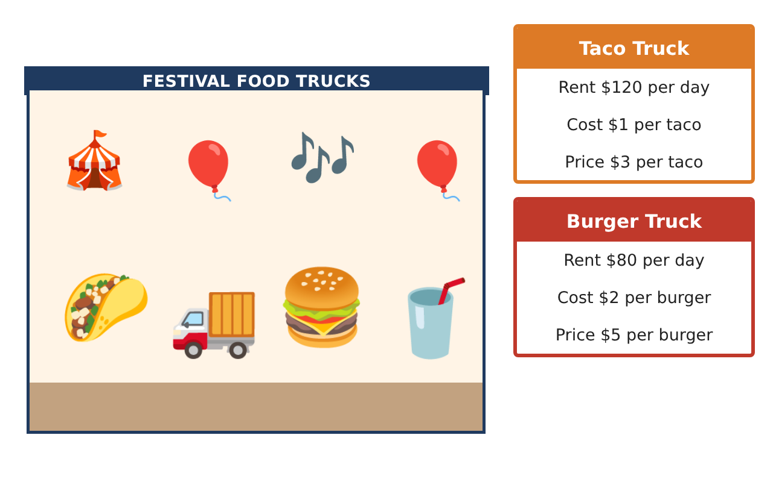
Learning Goals
- I can analyze systems with three linear models.
- I can set up and solve systems from multi-condition word problems.
- I can use parameters to control the number of solutions and design a plan.
Project Timeline
When | What you will do
Day 1 | Three Trucks
Day 2 | Festival Orders
Day 3 | Pricing Strategy
Final | Food Truck Business Report + reflection
Part 1: Three Trucks
Day 1 · Truck C: y = 1.5x + 100. Taco: y = x + 120. Burger: y = 2x + 80.
1. Find where each pair of cost lines meets.

2. Which truck has the lowest cost for fewer than 40 items? For more than 40 items?

3. Explain why three lines with different slopes can meet in one point.

Part 2: Festival Orders
Day 2 · Tacos $3, burgers $5, drinks $2.
4. A school buys 100 items for $330, with as many drinks as tacos. How many of each did they buy?

5. For which k does 2x + 3y = 12 and 4x + ky = 24 have infinitely many solutions?

6. Explain why no value of k makes that system have no solution.

Part 3: Pricing Strategy
Day 3 · Use the burger truck card.
7. The burger truck sells 50 burgers at $5. If it raises the price to $6, it expects to sell 20% fewer. Compare the profits.

8. Design a third truck (rent, cost per item, price) that breaks even at exactly 30 items. Show the equation.

9. Write a system whose solution shows when your truck's profit equals the burger truck's profit, and solve it.

Final Product: Food Truck Business Report
Your final product must include:
- Three-line analysis with the common point
- Three-item order solved and checked
- Parameter analysis for the number of solutions
- Pricing comparison
- Designed truck with break-even and profit system
Reflection
R1. How can you predict the number of solutions from the slopes and intercepts?

R2. Why can raising a price increase profit even when fewer items sell?

Scoring Rubric
Criteria | 4 – Exceeds | 3 – Meets | 2 – Approaching | 1 – Beginning
Mathematical Accuracy | All calculations and solutions are correct; answers include units and are checked. | Nearly all work is correct; minor errors do not change conclusions. | Several errors; some conclusions are affected. | Many errors or missing work.
Reasoning & Justification | Clear, complete explanations connect every answer to the situation; uses precise vocabulary. | Explanations are mostly clear and connected to the situation. | Explanations are brief or partly unclear. | Little or no explanation.
Application & Design | Systems are set up and solved correctly with all methods, and solution types are identified. Goes beyond the minimum with a creative, realistic choice. | Systems are set up and solved correctly with all methods, and solution types are identified. | Design is incomplete or only partly uses the math from the unit. | Design is missing or unrelated to the unit math.
Communication & Presentation | Business report explains costs, break-even points, and the recommendation with supporting work. Polished, organized, and visually engaging. | Business report explains costs, break-even points, and the recommendation with supporting work. Organized and easy to follow. | Product is missing required parts or is hard to follow. | Product is mostly missing.

