PRE-ALGEBRA (8TH) · UNIT 2: EQUATIONS AND EXPRESSIONS  Phone Plan Showdown  Write and solve equations to find the best cell phone plan for any customer. | CP1  2–3 class periods

Name: ________________________________ Date: ______________ Period: ______
The Scenario
A phone store has hired you to help customers choose a plan. Each plan has a monthly fee and a price per gigabyte of data, and customers want to know which plan is cheapest for them.
You will write expressions and solve equations to compare the plans and build a guide that any customer can use.
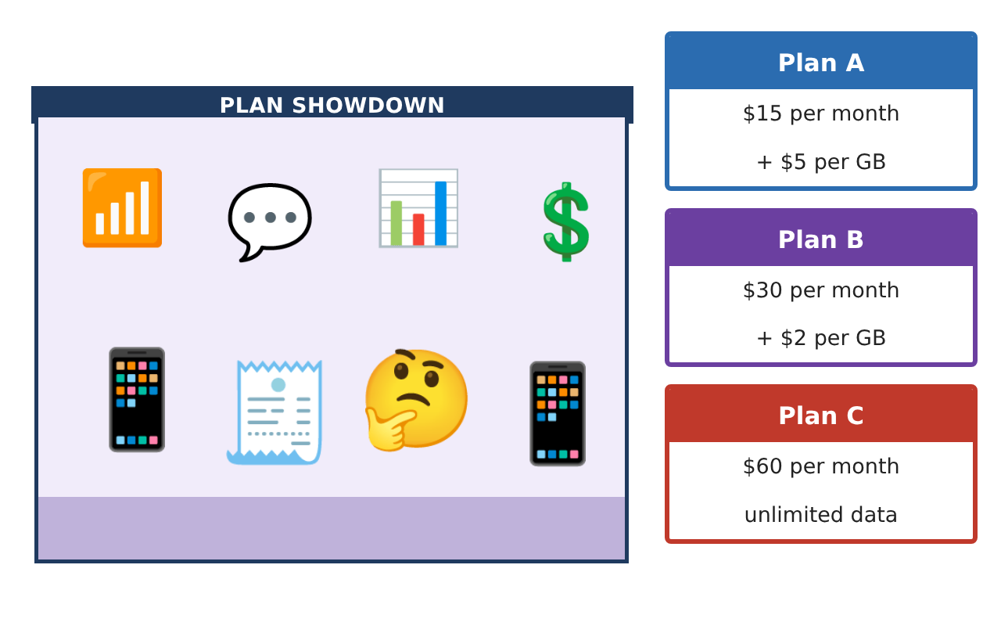
Learning Goals
- I can write and simplify expressions using the distributive property and like terms.
- I can solve multi-step equations with variables on both sides.
- I can tell when an equation has one, no, or infinitely many solutions.
Project Timeline
When | What you will do
Day 1 | Plans as Expressions
Day 2 | Solving Equations
Day 3 | Special Cases & Recommendations
Final | Plan Comparison Guide + reflection
Part 1: Plans as Expressions
Day 1 · Let g be the GB used each month.
1. Write expressions for the monthly cost of Plans A, B, and C.

2. A family has 3 lines on Plan A, each using g GB, plus a $10 family fee. Write and simplify the total cost.

3. A customer uses g GB in month 1 and 3 more GB in month 2. Write and simplify the two-month cost on Plan A.

Part 2: Solving Equations
Day 2 · Show each step.
4. Solve 15 + 5g = 30 + 2g and explain what the solution means.

5. Solve 3(g − 2) + 4 = 2g + 7.

6. The family's Plan A bill was $160. How many GB did each line use?

Part 3: Special Cases & Recommendations
Day 3 · Compare all three plans.
7. How many solutions does each equation have? Explain. (a) 2(5g + 15) = 10g + 30 (b) 5g + 15 = 5g + 20

8. For which amounts of data is Plan B the cheapest of all three plans?

9. A customer averages 12 GB each month. Which plan do you recommend? Show the costs.

Final Product: Plan Comparison Guide
Your final product must include:
- Simplified cost expressions, including the family plan
- Solutions to every equation with steps
- Ranges of data where each plan is cheapest
- A customer guide (table or graph) with recommendations
- An example of a no-solution and an infinite-solution equation from the plans
Reflection
R1. What does it mean in context when an equation has no solution?

R2. How did combining like terms help you compare plans?

Scoring Rubric
Criteria | 4 – Exceeds | 3 – Meets | 2 – Approaching | 1 – Beginning
Mathematical Accuracy | All calculations and solutions are correct; answers include units and are checked. | Nearly all work is correct; minor errors do not change conclusions. | Several errors; some conclusions are affected. | Many errors or missing work.
Reasoning & Justification | Clear, complete explanations connect every answer to the situation; uses precise vocabulary. | Explanations are mostly clear and connected to the situation. | Explanations are brief or partly unclear. | Little or no explanation.
Application & Design | Expressions and equations model the plans correctly, solutions are correct, and solution types are explained. Goes beyond the minimum with a creative, realistic choice. | Expressions and equations model the plans correctly, solutions are correct, and solution types are explained. | Design is incomplete or only partly uses the math from the unit. | Design is missing or unrelated to the unit math.
Communication & Presentation | Customer guide clearly states which plan is best for each amount of data and why. Polished, organized, and visually engaging. | Customer guide clearly states which plan is best for each amount of data and why. Organized and easy to follow. | Product is missing required parts or is hard to follow. | Product is mostly missing.

