PRE-ALGEBRA (8TH) · UNIT 2: EQUATIONS AND EXPRESSIONS  Phone Plan Showdown  Write and solve equations to find the best cell phone plan for any customer. | CP2  2–3 class periods

Name: ________________________________ Date: ______________ Period: ______
The Scenario
A phone store has hired you to help customers choose a plan. Each plan has a monthly fee and a price per gigabyte of data, and customers want to know which plan is cheapest for them.
You will write expressions and solve equations to compare the plans and build a guide that any customer can use.
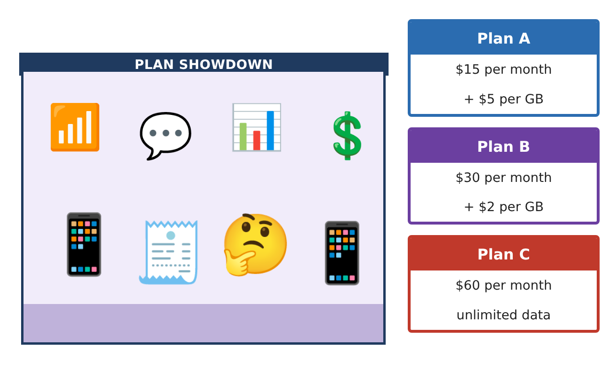
Learning Goals
- I can write an expression for a cost that has a fixed part and a rate.
- I can solve two-step equations.
- I can solve an equation with the variable on both sides to compare two plans.
Project Timeline
When | What you will do
Day 1 | Write the Costs
Day 2 | Solve for the Data
Day 3 | Which Plan Wins?
Final | Plan Comparison Guide + reflection
Part 1: Write the Costs
Day 1 · Let g be the number of gigabytes (GB) used in a month.
1. Write an expression for the monthly cost of Plan A and of Plan B.
Starter: Plan A: ___ + ___g

2. Find the cost of each plan for a customer who uses 4 GB.

3. Simplify 3(5g + 2) − 4g.

Part 2: Solve for the Data
Day 2 · Work backward from a bill.
4. A Plan A bill was $50. How many GB were used? Solve 15 + 5g = 50.
Starter: 15 + 5g = 50 → 5g = ___ → g = ___

5. A Plan B bill was $46. How many GB were used?

6. Solve 2(x + 4) = 18.

Part 3: Which Plan Wins?
Day 3 · Compare the plans.
7. For how many GB do Plans A and B cost the same? Solve 15 + 5g = 30 + 2g. What is the cost?

8. Which plan is cheaper for 3 GB? For 8 GB?

9. At how many GB does Plan B cost the same as Plan C ($60)?

Final Product: Plan Comparison Guide
Your final product must include:
- Cost expressions for every plan
- Bills solved backward to find the data used
- Break-even points for A vs B and B vs C
- A recommendation chart: which plan for light, medium, and heavy users
- A short ad for your favorite plan
Reflection
R1. What does the solution of 15 + 5g = 30 + 2g mean for a customer?

R2. Why do you do the same thing to both sides of an equation?

Scoring Rubric
Criteria | 4 – Exceeds | 3 – Meets | 2 – Approaching | 1 – Beginning
Mathematical Accuracy | All calculations and solutions are correct; answers include units and are checked. | Nearly all work is correct; minor errors do not change conclusions. | Several errors; some conclusions are affected. | Many errors or missing work.
Reasoning & Justification | Clear, complete explanations connect every answer to the situation; uses precise vocabulary. | Explanations are mostly clear and connected to the situation. | Explanations are brief or partly unclear. | Little or no explanation.
Application & Design | Expressions and equations model the plans correctly, solutions are correct, and solution types are explained. Goes beyond the minimum with a creative, realistic choice. | Expressions and equations model the plans correctly, solutions are correct, and solution types are explained. | Design is incomplete or only partly uses the math from the unit. | Design is missing or unrelated to the unit math.
Communication & Presentation | Customer guide clearly states which plan is best for each amount of data and why. Polished, organized, and visually engaging. | Customer guide clearly states which plan is best for each amount of data and why. Organized and easy to follow. | Product is missing required parts or is hard to follow. | Product is mostly missing.

