PRE-ALGEBRA (8TH) · UNIT 2: EQUATIONS AND EXPRESSIONS  Phone Plan Showdown  Write and solve equations to find the best cell phone plan for any customer. | Honors  2–3 class periods

Name: ________________________________ Date: ______________ Period: ______
The Scenario
A phone store has hired you to help customers choose a plan. Each plan has a monthly fee and a price per gigabyte of data, and customers want to know which plan is cheapest for them.
You will write expressions and solve equations to compare the plans and build a guide that any customer can use.
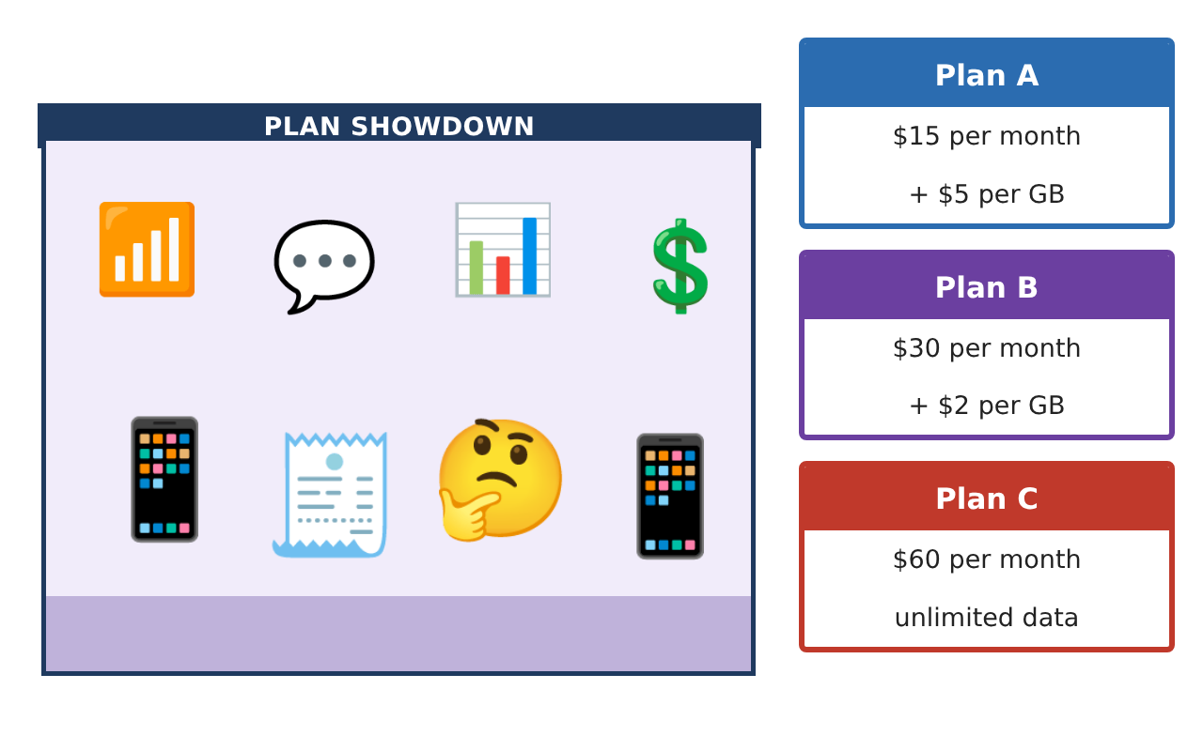
Learning Goals
- I can model tiered pricing with expressions.
- I can solve and analyze multi-step equations, including equations with parameters.
- I can design a plan and prove when it beats another plan.
Project Timeline
When | What you will do
Day 1 | Tiered Plans
Day 2 | Equation Analysis
Day 3 | Design a Plan
Final | Plan Comparison Guide + reflection
Part 1: Tiered Plans
Day 1 · Plan D: $10 per month plus $6 per GB for the first 5 GB and $3 per GB after that.
1. Write a simplified expression for the cost of Plan D when g > 5.

2. Write an expression for the average cost per GB on Plan B.

3. Write and simplify an expression for how much more Plan A costs than Plan B over a year for g GB each month.

Part 2: Equation Analysis
Day 2 · Show each step.
4. When do Plans D and B cost the same? Check that your answer fits the condition g ≥ 5.

5. Solve $\frac{1}{3}$(6g − 9) + 2 = 2(g − 1) + 1. What kind of solution set is it?

6. For what value of k does 4g + k = 4g + 12 have infinitely many solutions? For which values does it have no solution?

Part 3: Design a Plan
Day 3 · Create a plan that competes with Plan B.
7. For how many GB is the average cost per GB on Plan B exactly $5?

8. Design a plan that costs more than Plan A at 2 GB but less than Plan B from 8 GB to 12 GB. Show the costs at 2, 8, and 12 GB.

9. Use algebra to prove whether your plan is cheaper than Plan B for every amount of data.

Final Product: Plan Comparison Guide
Your final product must include:
- Tiered-plan expression and average-cost expression
- Equation solutions with solution-type analysis
- Parameter analysis (values of k)
- Your designed plan with a cost table
- A written proof comparing your plan with Plan B
Reflection
R1. Why does the coefficient of g decide whether two plans can ever cost the same?

R2. How is the average cost per GB different from the price per GB?

Scoring Rubric
Criteria | 4 – Exceeds | 3 – Meets | 2 – Approaching | 1 – Beginning
Mathematical Accuracy | All calculations and solutions are correct; answers include units and are checked. | Nearly all work is correct; minor errors do not change conclusions. | Several errors; some conclusions are affected. | Many errors or missing work.
Reasoning & Justification | Clear, complete explanations connect every answer to the situation; uses precise vocabulary. | Explanations are mostly clear and connected to the situation. | Explanations are brief or partly unclear. | Little or no explanation.
Application & Design | Expressions and equations model the plans correctly, solutions are correct, and solution types are explained. Goes beyond the minimum with a creative, realistic choice. | Expressions and equations model the plans correctly, solutions are correct, and solution types are explained. | Design is incomplete or only partly uses the math from the unit. | Design is missing or unrelated to the unit math.
Communication & Presentation | Customer guide clearly states which plan is best for each amount of data and why. Polished, organized, and visually engaging. | Customer guide clearly states which plan is best for each amount of data and why. Organized and easy to follow. | Product is missing required parts or is hard to follow. | Product is mostly missing.

