PRE-ALGEBRA (8TH) · UNIT 3: LINEAR AND FUNCTIONAL RELATIONSHIPS  Road Trip Rate Lab  Compare cars on a road trip using tables, graphs, and equations. | CP1  2–3 class periods

Name: ________________________________ Date: ______________ Period: ______
The Scenario
Your class is planning a road trip to a national park, and three family cars are going. Each car's speed is given a different way: one with a table, one with a graph, and one with an equation.
You will compare the cars, write functions for distance and fuel, and plan when everyone will arrive and how much the gas will cost.
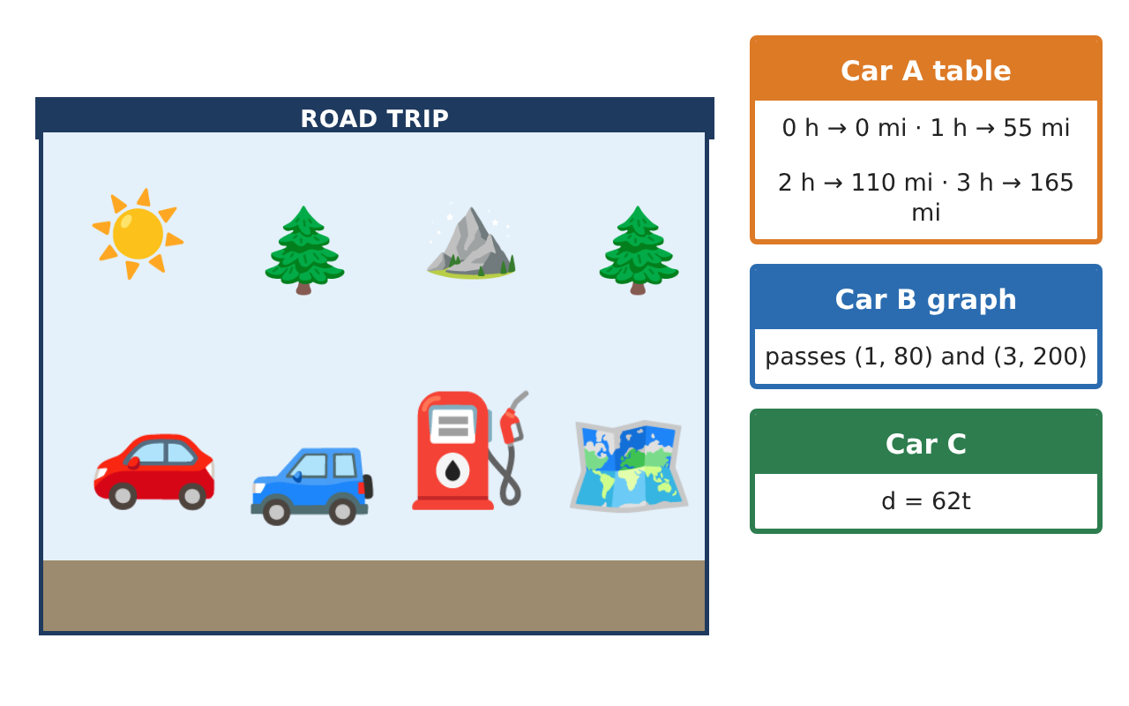
Learning Goals
- I can find and interpret the rate of change and initial value of a linear function.
- I can compare functions given in different forms.
- I can solve problems with linear functions and identify nonlinear functions.
Project Timeline
When | What you will do
Day 1 | Three Representations
Day 2 | Catching Up
Day 3 | Plan the Trip
Final | Road Trip Plan + reflection
Part 1: Three Representations
Day 1 · Use the car cards.
1. Write a function for Car A from the table. Is it proportional? Explain.

2. Car B's graph passes through (1, 80) and (3, 200). Find the slope and y-intercept, and write the function.

3. Order the cars from fastest to slowest.

Part 2: Catching Up
Day 2 · Use your functions.
4. When does Car C catch Car B? How far have they driven?

5. The gas left is g(d) = 14 − $\frac{d}{30}$. What is the slope, and what does it mean?

6. Is f(t) = t² + 3 a linear function? Use a table to explain.

Part 3: Plan the Trip
Day 3 · The park is 500 miles away. Gas costs $3.60 per gallon.
7. Car A drives 55 mph and makes one 1.5-hour stop. How long is the trip, to the nearest tenth of an hour?

8. How much does gas cost for the 500-mile trip at 30 miles per gallon?

9. Write a function for gas cost c per mile driven d, and interpret its slope.

Final Product: Road Trip Plan
Your final product must include:
- Functions for every car, with slopes and intercepts interpreted
- Catch-up time and distance
- Gas and cost functions
- Total trip time and cost
- A comparison chart: table, graph, and equation for each car
Reflection
R1. How can you compare two functions when one is a graph and one is an equation?

R2. How can you tell from a table that a function is nonlinear?

Scoring Rubric
Criteria | 4 – Exceeds | 3 – Meets | 2 – Approaching | 1 – Beginning
Mathematical Accuracy | All calculations and solutions are correct; answers include units and are checked. | Nearly all work is correct; minor errors do not change conclusions. | Several errors; some conclusions are affected. | Many errors or missing work.
Reasoning & Justification | Clear, complete explanations connect every answer to the situation; uses precise vocabulary. | Explanations are mostly clear and connected to the situation. | Explanations are brief or partly unclear. | Little or no explanation.
Application & Design | Rates, functions, and comparisons are correct and interpreted in context. Goes beyond the minimum with a creative, realistic choice. | Rates, functions, and comparisons are correct and interpreted in context. | Design is incomplete or only partly uses the math from the unit. | Design is missing or unrelated to the unit math.
Communication & Presentation | Trip plan shows each car's function, arrival time, and cost with clear labels. Polished, organized, and visually engaging. | Trip plan shows each car's function, arrival time, and cost with clear labels. Organized and easy to follow. | Product is missing required parts or is hard to follow. | Product is mostly missing.

