PRE-ALGEBRA (8TH) · UNIT 3: LINEAR AND FUNCTIONAL RELATIONSHIPS  Road Trip Rate Lab  Compare cars on a road trip using tables, graphs, and equations. | CP2  2–3 class periods

Name: ________________________________ Date: ______________ Period: ______
The Scenario
Your class is planning a road trip to a national park, and three family cars are going. Each car's speed is given a different way: one with a table, one with a graph, and one with an equation.
You will compare the cars, write functions for distance and fuel, and plan when everyone will arrive and how much the gas will cost.
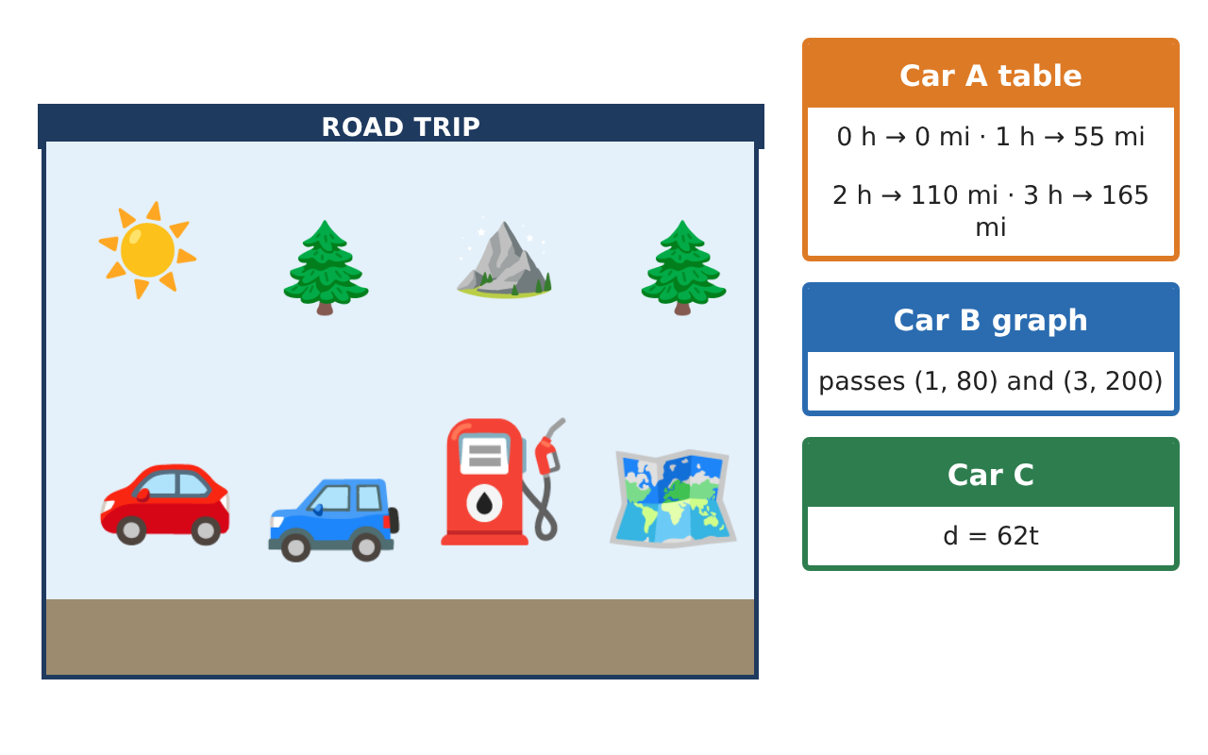
Learning Goals
- I can find a rate of change (slope) from a table, a graph, or an equation.
- I can write and use a linear function y = mx + b.
- I can tell whether a relationship is linear.
Project Timeline
When | What you will do
Day 1 | Car A from a Table
Day 2 | Comparing Cars
Day 3 | Gas and Patterns
Final | Road Trip Plan + reflection
Part 1: Car A from a Table
Day 1 · Car A: 0 h → 0 miles, 1 h → 55 miles, 2 h → 110 miles, 3 h → 165 miles.
1. What is Car A's rate of change (speed)?
Starter: Change in miles ÷ change in hours = ___

2. Write an equation for Car A's distance d after t hours.

3. How far does Car A go in 4.5 hours?

Part 2: Comparing Cars
Day 2 · Car B starts 20 miles ahead and drives 60 mph: d = 60t + 20. Car C: d = 62t.
4. Which car is faster, Car A or Car C? How do you know?

5. How far from the start is Car B after 3 hours?

6. What do the 60 and the 20 mean in d = 60t + 20?

Part 3: Gas and Patterns
Day 3 · Each car has a 14-gallon tank and gets 30 miles per gallon.
7. Gas left after d miles is g = 14 − $\frac{d}{30}$. How much gas is left after 150 miles?

8. How many miles can a car go before the tank is empty?

9. A square tile with side s has area A: s = 1, 2, 3 → A = 1, 4, 9. Is this relationship linear? Explain.

Final Product: Road Trip Plan
Your final product must include:
- Rates for Cars A, B, and C
- An equation for each car
- Distance after different times
- Gas-remaining function and range of the tank
- A trip poster that compares the cars
Reflection
R1. How can you find a rate of change from a table?

R2. What does the y-intercept mean on a distance graph?

Scoring Rubric
Criteria | 4 – Exceeds | 3 – Meets | 2 – Approaching | 1 – Beginning
Mathematical Accuracy | All calculations and solutions are correct; answers include units and are checked. | Nearly all work is correct; minor errors do not change conclusions. | Several errors; some conclusions are affected. | Many errors or missing work.
Reasoning & Justification | Clear, complete explanations connect every answer to the situation; uses precise vocabulary. | Explanations are mostly clear and connected to the situation. | Explanations are brief or partly unclear. | Little or no explanation.
Application & Design | Rates, functions, and comparisons are correct and interpreted in context. Goes beyond the minimum with a creative, realistic choice. | Rates, functions, and comparisons are correct and interpreted in context. | Design is incomplete or only partly uses the math from the unit. | Design is missing or unrelated to the unit math.
Communication & Presentation | Trip plan shows each car's function, arrival time, and cost with clear labels. Polished, organized, and visually engaging. | Trip plan shows each car's function, arrival time, and cost with clear labels. Organized and easy to follow. | Product is missing required parts or is hard to follow. | Product is mostly missing.

