PRE-ALGEBRA (8TH) · UNIT 3: LINEAR AND FUNCTIONAL RELATIONSHIPS  Road Trip Rate Lab  Compare cars on a road trip using tables, graphs, and equations. | Honors  2–3 class periods

Name: ________________________________ Date: ______________ Period: ______
The Scenario
Your class is planning a road trip to a national park, and three family cars are going. Each car's speed is given a different way: one with a table, one with a graph, and one with an equation.
You will compare the cars, write functions for distance and fuel, and plan when everyone will arrive and how much the gas will cost.
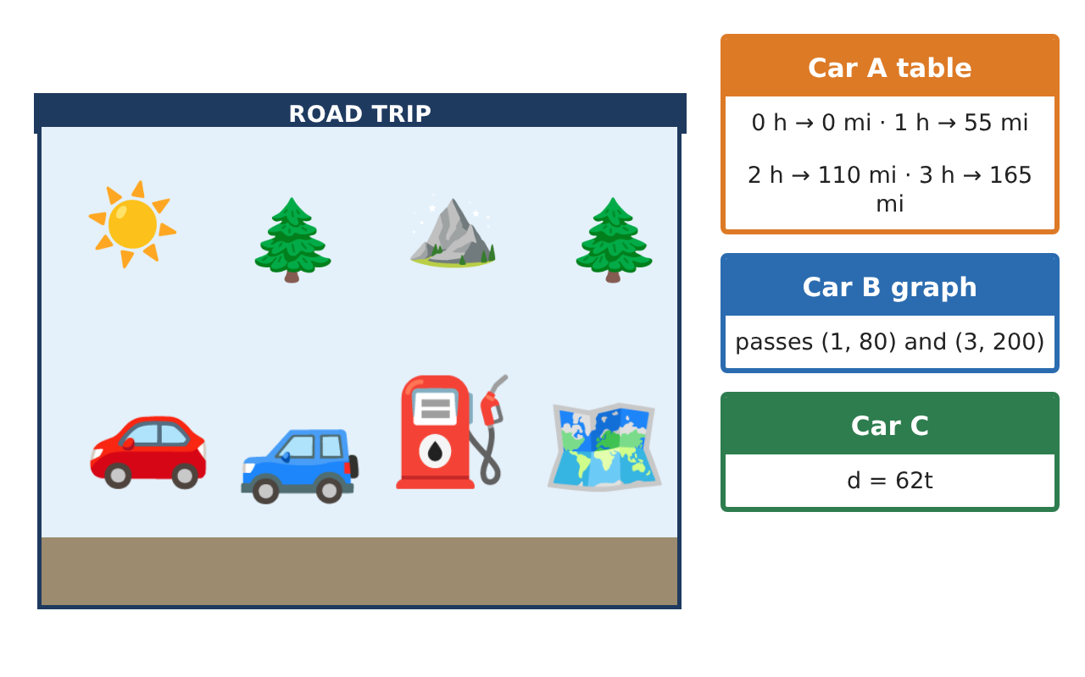
Learning Goals
- I can build linear functions from two points and interpret them in context.
- I can solve catch-up and comparison problems with linear functions.
- I can distinguish linear and nonlinear models and reason about average rates.
Project Timeline
When | What you will do
Day 1 | Building Functions
Day 2 | Chases and Curves
Day 3 | Average Speed
Final | Road Trip Plan + reflection
Part 1: Building Functions
Day 1 · Use the car cards.
1. Car D was 130 miles from home after 2 hours and 310 miles after 5 hours. Write its function and interpret the initial value.

2. After how many hours is Car D 50 miles ahead of Car A (d = 55t)?

3. f(x) = 2x − 3 and g is given by the table (0, 1), (1, 4), (2, 7). Which has the greater rate of change? The greater initial value?

Part 2: Chases and Curves
Day 2 · Show your work.
4. Car C (62 mph) leaves 1.5 hours after Car A (55 mph) from the same place. When does Car C catch up, and how far have they gone?

5. Stopping distance is about d = 0.05v² feet at speed v mph. Find d at 20, 40, and 60 mph. Is the model linear?

6. Car A costs $0.12 per mile; Car E gets 24 mpg with gas at $3.36. Which costs more for 500 miles, and by how much?

Part 3: Average Speed
Day 3 · Plan a trip with several legs.
7. A car drives 2 hours at 60 mph and 1 hour at 30 mph. What is its average speed?

8. Explain why the answer is not (60 + 30) ÷ 2 = 45 mph.

9. Design a three-leg trip of 500 miles that arrives in exactly 9 hours. Give each leg's speed and time.

Final Product: Road Trip Plan
Your final product must include:
- Functions built from two points
- Catch-up and lead calculations
- Linear vs. nonlinear analysis
- Cost comparison of two cars
- A designed multi-leg trip with average speed
Reflection
R1. Why does a constant rate of change make a function linear?

R2. When is average speed equal to the average of the speeds?

Scoring Rubric
Criteria | 4 – Exceeds | 3 – Meets | 2 – Approaching | 1 – Beginning
Mathematical Accuracy | All calculations and solutions are correct; answers include units and are checked. | Nearly all work is correct; minor errors do not change conclusions. | Several errors; some conclusions are affected. | Many errors or missing work.
Reasoning & Justification | Clear, complete explanations connect every answer to the situation; uses precise vocabulary. | Explanations are mostly clear and connected to the situation. | Explanations are brief or partly unclear. | Little or no explanation.
Application & Design | Rates, functions, and comparisons are correct and interpreted in context. Goes beyond the minimum with a creative, realistic choice. | Rates, functions, and comparisons are correct and interpreted in context. | Design is incomplete or only partly uses the math from the unit. | Design is missing or unrelated to the unit math.
Communication & Presentation | Trip plan shows each car's function, arrival time, and cost with clear labels. Polished, organized, and visually engaging. | Trip plan shows each car's function, arrival time, and cost with clear labels. Organized and easy to follow. | Product is missing required parts or is hard to follow. | Product is mostly missing.

