PRE-ALGEBRA (8TH) · UNIT 5: PATTERNS AND BIVARIATE DATA  Screen Time & Sleep Study  Use scatter plots, lines of fit, and two-way tables to study screen time and sleep. | CP1  2–3 class periods

Name: ________________________________ Date: ______________ Period: ______
The Scenario
The school health committee wonders whether screen time is connected to how much students sleep. They collected data from students and want a clear, honest report.
You will analyze the data with scatter plots, a line of best fit, and a two-way table, and present what the data can and cannot tell us.
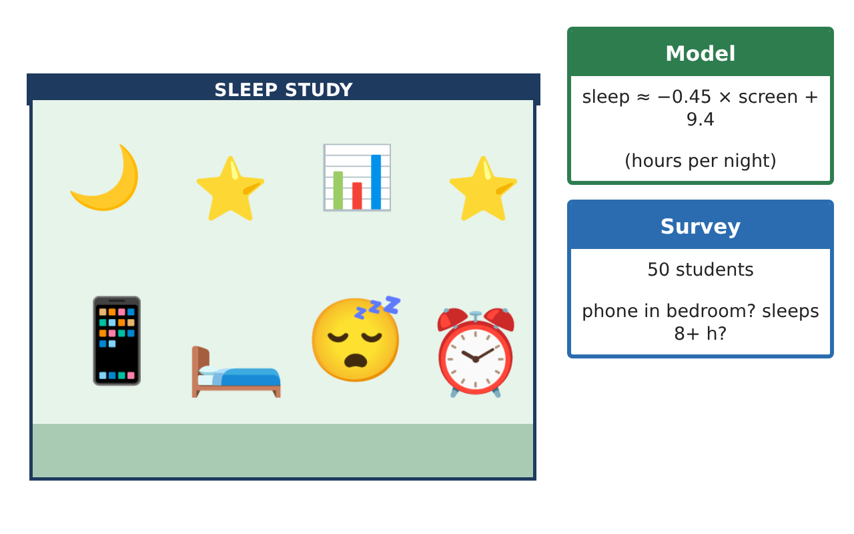
Learning Goals
- I can describe patterns of association, clusters, and outliers.
- I can write and use a linear model and compute residuals.
- I can use relative frequencies to describe association in a two-way table.
Project Timeline
When | What you will do
Day 1 | Patterns
Day 2 | Predictions & Residuals
Day 3 | Relative Frequencies
Final | Research Poster + reflection
Part 1: Patterns
Day 1 · Use the Study Data card.
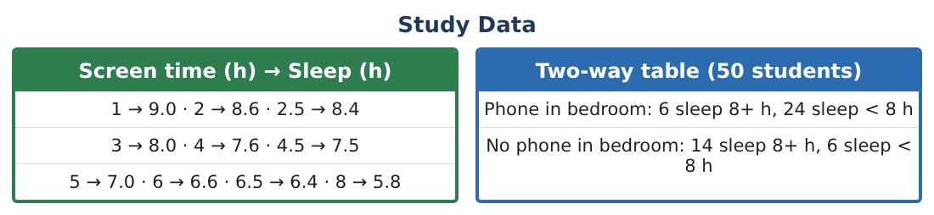
1. Describe the direction, form, and strength of the association.

2. Draw a line through (1, 9) and (8, 5.8). Find its slope and equation.

3. Compare your line with the model y = −0.45x + 9.4. Are they close? Explain.

Part 2: Predictions & Residuals
Day 2 · Use y = −0.45x + 9.4.
4. Predict sleep for 5.5 hours of screen time.

5. Find the residual for the student with 5 hours of screen time and 7.0 hours of sleep.

6. Use the model to predict sleep for 20 hours of screen time. Is this prediction reasonable?

Part 3: Relative Frequencies
Day 3 · Use the survey of 50 students.
7. Make a row relative-frequency table (percents within each row).

8. What percent of all 50 students have a phone in the bedroom and sleep 8+ hours?

9. Does the table prove that phones in bedrooms cause less sleep? Explain.

Final Product: Research Poster
Your final product must include:
- Scatter plot with a hand-drawn line and the model
- Predictions and a residual
- Relative-frequency table
- Discussion of association vs. causation
- Research poster for the health committee
Reflection
R1. What does a negative residual mean?

R2. Why is extrapolation risky?

Scoring Rubric
Criteria | 4 – Exceeds | 3 – Meets | 2 – Approaching | 1 – Beginning
Mathematical Accuracy | All calculations and solutions are correct; answers include units and are checked. | Nearly all work is correct; minor errors do not change conclusions. | Several errors; some conclusions are affected. | Many errors or missing work.
Reasoning & Justification | Clear, complete explanations connect every answer to the situation; uses precise vocabulary. | Explanations are mostly clear and connected to the situation. | Explanations are brief or partly unclear. | Little or no explanation.
Application & Design | Scatter plot, model, predictions, and two-way analysis are accurate and correctly interpreted. Goes beyond the minimum with a creative, realistic choice. | Scatter plot, model, predictions, and two-way analysis are accurate and correctly interpreted. | Design is incomplete or only partly uses the math from the unit. | Design is missing or unrelated to the unit math.
Communication & Presentation | Poster states findings clearly and explains limits (association vs. causation, extrapolation). Polished, organized, and visually engaging. | Poster states findings clearly and explains limits (association vs. causation, extrapolation). Organized and easy to follow. | Product is missing required parts or is hard to follow. | Product is mostly missing.

