PRE-ALGEBRA (8TH) · UNIT 5: PATTERNS AND BIVARIATE DATA  Screen Time & Sleep Study  Use scatter plots, lines of fit, and two-way tables to study screen time and sleep. | CP2  2–3 class periods

Name: ________________________________ Date: ______________ Period: ______
The Scenario
The school health committee wonders whether screen time is connected to how much students sleep. They collected data from students and want a clear, honest report.
You will analyze the data with scatter plots, a line of best fit, and a two-way table, and present what the data can and cannot tell us.
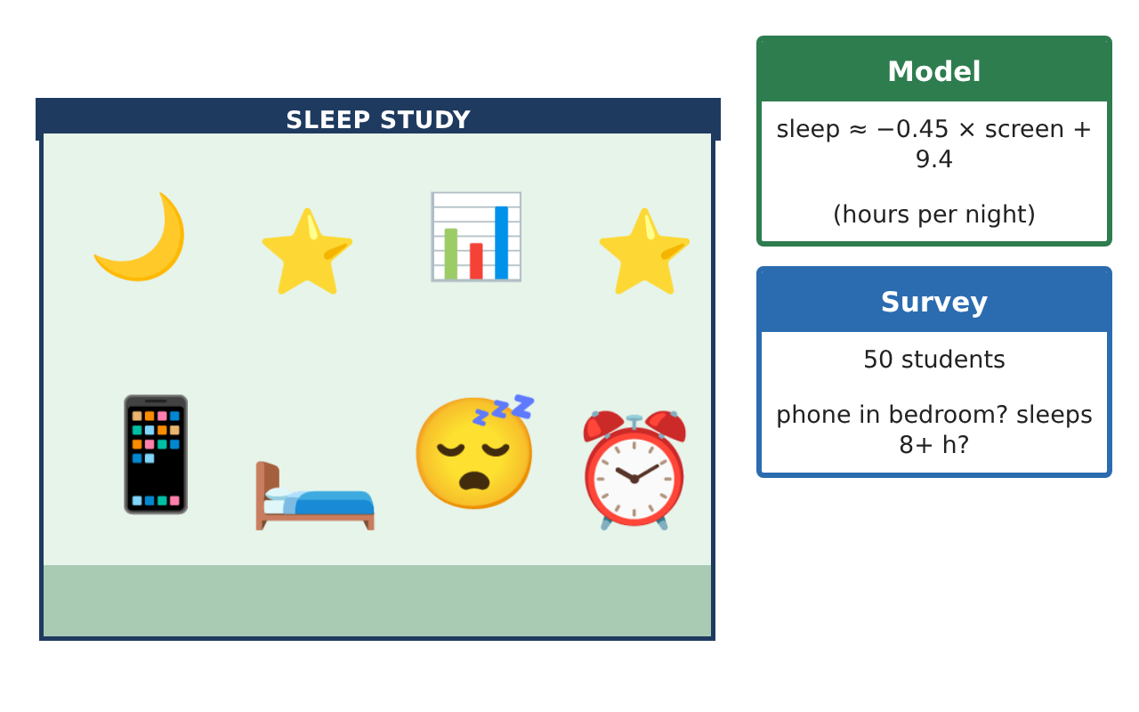
Learning Goals
- I can make a scatter plot and describe the association.
- I can use a line of best fit to make a prediction.
- I can read a two-way table and compare percents.
Project Timeline
When | What you will do
Day 1 | Scatter Plot
Day 2 | The Line of Fit
Day 3 | Two-Way Table
Final | Research Poster + reflection
Part 1: Scatter Plot
Day 1 · Use the Study Data card.
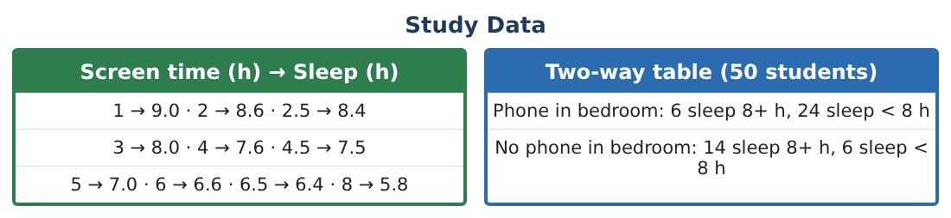
1. Make a scatter plot with screen time on the x-axis and sleep on the y-axis. Describe the association.
Starter: As screen time goes up, sleep ___

2. A new student reports 8 hours of screen time and 9 hours of sleep. Is this point an outlier? Explain.

3. Use the line sleep ≈ −0.45 × screen + 9.4 to predict sleep for 7 hours of screen time.

Part 2: The Line of Fit
Day 2 · Use y = −0.45x + 9.4.
4. Predict the sleep for 3.5 hours of screen time.

5. What does the slope −0.45 mean?

6. What does the y-intercept 9.4 mean?

Part 3: Two-Way Table
Day 3 · Use the survey of 50 students.
7. How many students have a phone in the bedroom? How many sleep 8 or more hours?

8. What percent of students with a phone in the bedroom sleep 8+ hours? What percent of students without one?

9. Is there an association between a phone in the bedroom and sleeping 8+ hours? Explain.

Final Product: Research Poster
Your final product must include:
- Scatter plot with the line of best fit
- Two predictions with the line
- Slope and intercept explained in words
- Two-way table with percents
- A research poster with one clear finding
Reflection
R1. What does a negative association look like on a scatter plot?

R2. Why compare percents instead of counts in the two-way table?

Scoring Rubric
Criteria | 4 – Exceeds | 3 – Meets | 2 – Approaching | 1 – Beginning
Mathematical Accuracy | All calculations and solutions are correct; answers include units and are checked. | Nearly all work is correct; minor errors do not change conclusions. | Several errors; some conclusions are affected. | Many errors or missing work.
Reasoning & Justification | Clear, complete explanations connect every answer to the situation; uses precise vocabulary. | Explanations are mostly clear and connected to the situation. | Explanations are brief or partly unclear. | Little or no explanation.
Application & Design | Scatter plot, model, predictions, and two-way analysis are accurate and correctly interpreted. Goes beyond the minimum with a creative, realistic choice. | Scatter plot, model, predictions, and two-way analysis are accurate and correctly interpreted. | Design is incomplete or only partly uses the math from the unit. | Design is missing or unrelated to the unit math.
Communication & Presentation | Poster states findings clearly and explains limits (association vs. causation, extrapolation). Polished, organized, and visually engaging. | Poster states findings clearly and explains limits (association vs. causation, extrapolation). Organized and easy to follow. | Product is missing required parts or is hard to follow. | Product is mostly missing.

