PRE-ALGEBRA (8TH) · UNIT 5: PATTERNS AND BIVARIATE DATA  Screen Time & Sleep Study  Use scatter plots, lines of fit, and two-way tables to study screen time and sleep. | Honors  2–3 class periods

Name: ________________________________ Date: ______________ Period: ______
The Scenario
The school health committee wonders whether screen time is connected to how much students sleep. They collected data from students and want a clear, honest report.
You will analyze the data with scatter plots, a line of best fit, and a two-way table, and present what the data can and cannot tell us.
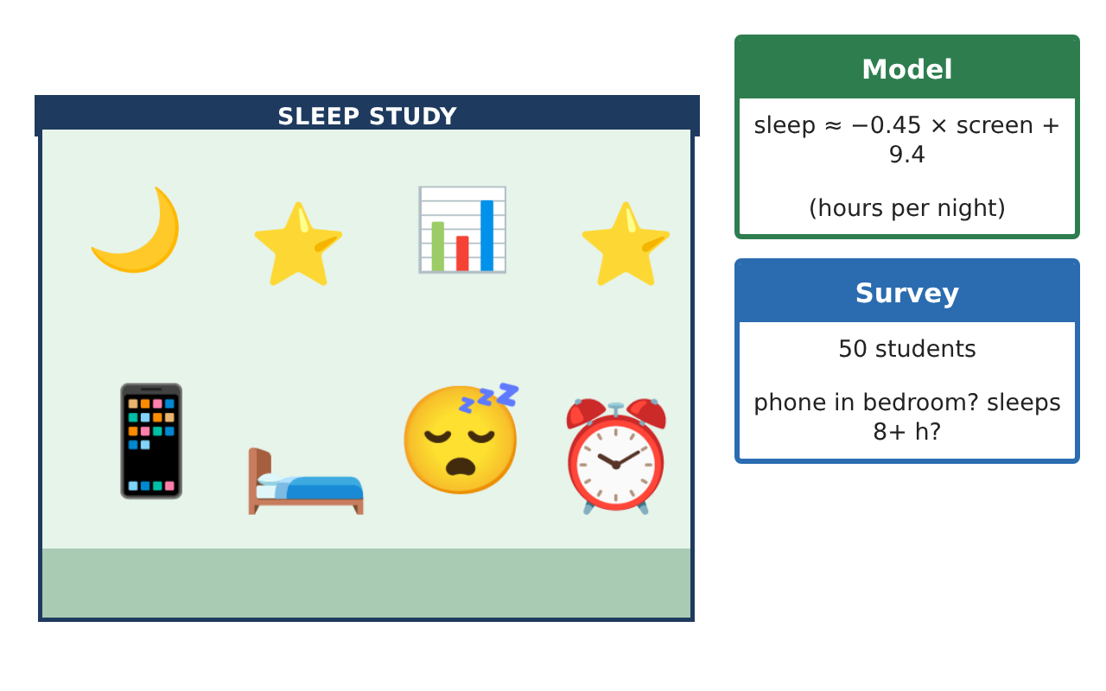
Learning Goals
- I can find and evaluate a linear model, including the point of averages.
- I can use a model to answer questions and judge its limits.
- I can analyze categorical data and design a study.
Project Timeline
When | What you will do
Day 1 | Building the Model
Day 2 | Using the Model
Day 3 | Categorical Data
Final | Research Poster + reflection
Part 1: Building the Model
Day 1 · Use the Study Data card.
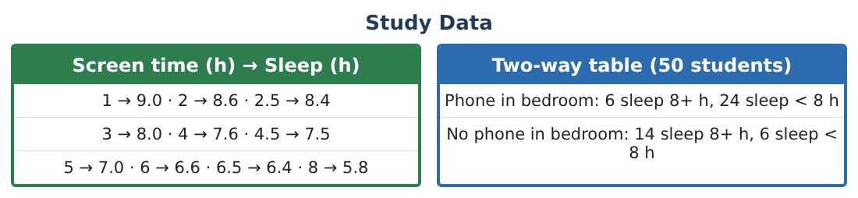
1. Write the line through (2, 8.6) and (6, 6.6). Compare it with y = −0.45x + 9.4.

2. Find the mean screen time and the mean sleep. Does the model pass close to (mean x, mean y)?

3. Find the residuals for x = 2 and x = 8 using the model.

Part 2: Using the Model
Day 2 · Use y = −0.45x + 9.4.
4. Doctors recommend at least 8 hours of sleep. According to the model, what is the most screen time that predicts 8 hours?

5. About how much less sleep does the model predict for a student with 6 hours of screen time than for one with 2 hours?

6. Describe an experiment that could test whether screen time causes less sleep.

Part 3: Categorical Data
Day 3 · Use the survey of 50 students.
7. Find the difference in the percent who sleep 8+ hours between the two groups.

8. If the whole school of 600 students had the same pattern, how many would have a phone in the bedroom and sleep 8+ hours?

9. Write your own survey question pair for a two-way table about sleep, and explain what result would show an association.

Final Product: Research Poster
Your final product must include:
- Model built from two points and checked against the mean point
- Residual analysis
- Model-based recommendation
- Experiment design
- Two-way analysis and a new survey proposal
Reflection
R1. Why does a good line of fit pass near the point of averages?

R2. How is a residual plot useful?

Scoring Rubric
Criteria | 4 – Exceeds | 3 – Meets | 2 – Approaching | 1 – Beginning
Mathematical Accuracy | All calculations and solutions are correct; answers include units and are checked. | Nearly all work is correct; minor errors do not change conclusions. | Several errors; some conclusions are affected. | Many errors or missing work.
Reasoning & Justification | Clear, complete explanations connect every answer to the situation; uses precise vocabulary. | Explanations are mostly clear and connected to the situation. | Explanations are brief or partly unclear. | Little or no explanation.
Application & Design | Scatter plot, model, predictions, and two-way analysis are accurate and correctly interpreted. Goes beyond the minimum with a creative, realistic choice. | Scatter plot, model, predictions, and two-way analysis are accurate and correctly interpreted. | Design is incomplete or only partly uses the math from the unit. | Design is missing or unrelated to the unit math.
Communication & Presentation | Poster states findings clearly and explains limits (association vs. causation, extrapolation). Polished, organized, and visually engaging. | Poster states findings clearly and explains limits (association vs. causation, extrapolation). Organized and easy to follow. | Product is missing required parts or is hard to follow. | Product is mostly missing.

