PRE-ALGEBRA (8TH) · UNIT 7: GEOMETRY  Skate Park Design  Use the Pythagorean Theorem, distance, and volume to design a skate park. | CP1  2–3 class periods

Name: ________________________________ Date: ______________ Period: ______
The Scenario
The town is building a new skate park, and the design team wants student input. Ramps must have the right lengths, paths must be planned on the map, and the concrete must be ordered in the right amount.
You will use right triangles, the distance formula, and volume formulas to create a blueprint and a concrete order.
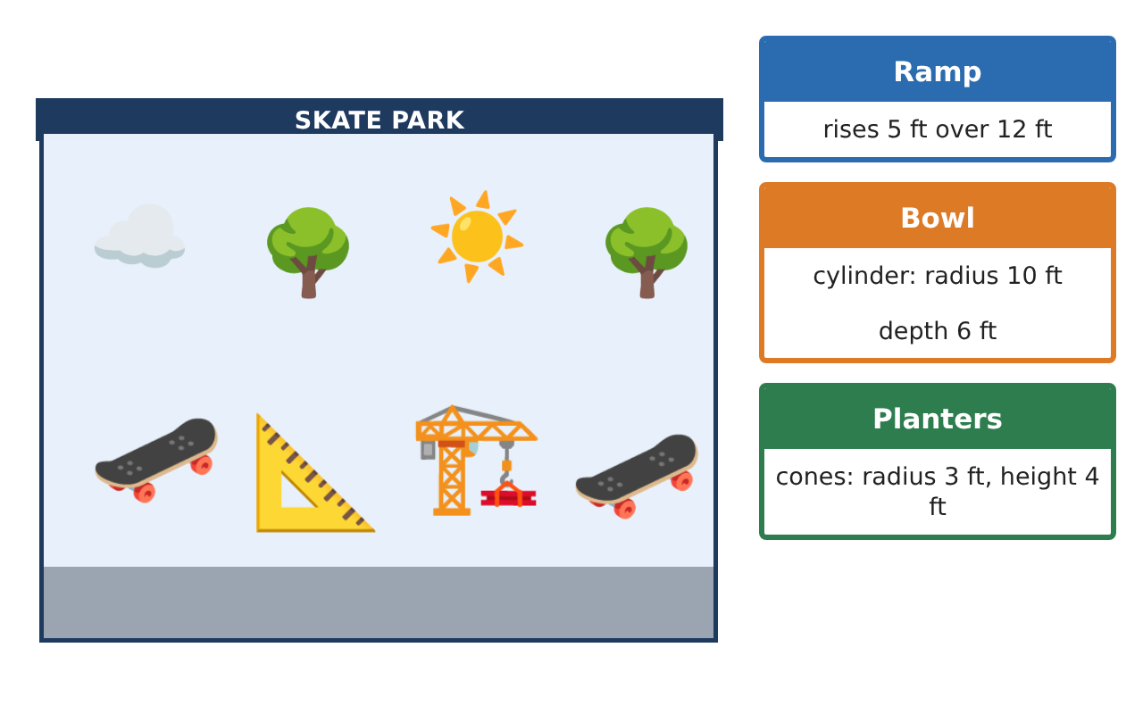
Learning Goals
- I can use the Pythagorean Theorem and its converse in real situations.
- I can use the Pythagorean Theorem to find distances on the coordinate plane.
- I can use volume formulas to plan materials.
Project Timeline
When | What you will do
Day 1 | Building Ramps
Day 2 | Planning Paths
Day 3 | Ordering Concrete
Final | Skate Park Blueprint + reflection
Part 1: Building Ramps
Day 1 · Use the Pythagorean Theorem.
1. A 10-foot ramp covers a base of 8 feet. How high does it rise?

2. A 15-foot rail reaches 9 feet high. How far along the ground does it reach?

3. A builder measures a frame with sides 9, 12, and 16 feet. Is the corner a right angle?

Part 2: Planning Paths
Day 2 · Each grid unit on the map is 5 feet.
4. Find the distance between (−3, 4) and (5, −2) in units and in feet.

5. Is the triangle with vertices (0, 0), (6, 0), and (6, 8) a right triangle? How long is the longest side?

6. How much shorter is the diagonal path across a 60-foot by 80-foot park than walking along two edges?

Part 3: Ordering Concrete
Day 3 · Concrete is sold by the cubic yard (1 yd³ = 27 ft³).
7. How many cubic yards of concrete would fill the bowl (radius 10 ft, depth 6 ft)? Round to the nearest tenth.

8. How much soil fills 6 cone planters (radius 3 ft, height 4 ft)?

9. Twenty spherical balls of radius 1 foot are made from concrete. How many cubic feet are needed?

Final Product: Skate Park Blueprint
Your final product must include:
- Ramp and rail measurements with converse checks
- Path distances on the map
- Concrete order in cubic yards
- Soil and decoration volumes
- Blueprint with all measurements
Reflection
R1. How does the converse of the Pythagorean Theorem help a builder?

R2. Why must you convert cubic feet to cubic yards by dividing by 27, not 3?

Scoring Rubric
Criteria | 4 – Exceeds | 3 – Meets | 2 – Approaching | 1 – Beginning
Mathematical Accuracy | All calculations and solutions are correct; answers include units and are checked. | Nearly all work is correct; minor errors do not change conclusions. | Several errors; some conclusions are affected. | Many errors or missing work.
Reasoning & Justification | Clear, complete explanations connect every answer to the situation; uses precise vocabulary. | Explanations are mostly clear and connected to the situation. | Explanations are brief or partly unclear. | Little or no explanation.
Application & Design | Pythagorean Theorem, distance, and volume calculations are correct and used to make design decisions. Goes beyond the minimum with a creative, realistic choice. | Pythagorean Theorem, distance, and volume calculations are correct and used to make design decisions. | Design is incomplete or only partly uses the math from the unit. | Design is missing or unrelated to the unit math.
Communication & Presentation | Blueprint and concrete order are labeled with units and show all work. Polished, organized, and visually engaging. | Blueprint and concrete order are labeled with units and show all work. Organized and easy to follow. | Product is missing required parts or is hard to follow. | Product is mostly missing.

