PRE-ALGEBRA (8TH) · UNIT 7: GEOMETRY  Skate Park Design  Use the Pythagorean Theorem, distance, and volume to design a skate park. | Honors  2–3 class periods

Name: ________________________________ Date: ______________ Period: ______
The Scenario
The town is building a new skate park, and the design team wants student input. Ramps must have the right lengths, paths must be planned on the map, and the concrete must be ordered in the right amount.
You will use right triangles, the distance formula, and volume formulas to create a blueprint and a concrete order.
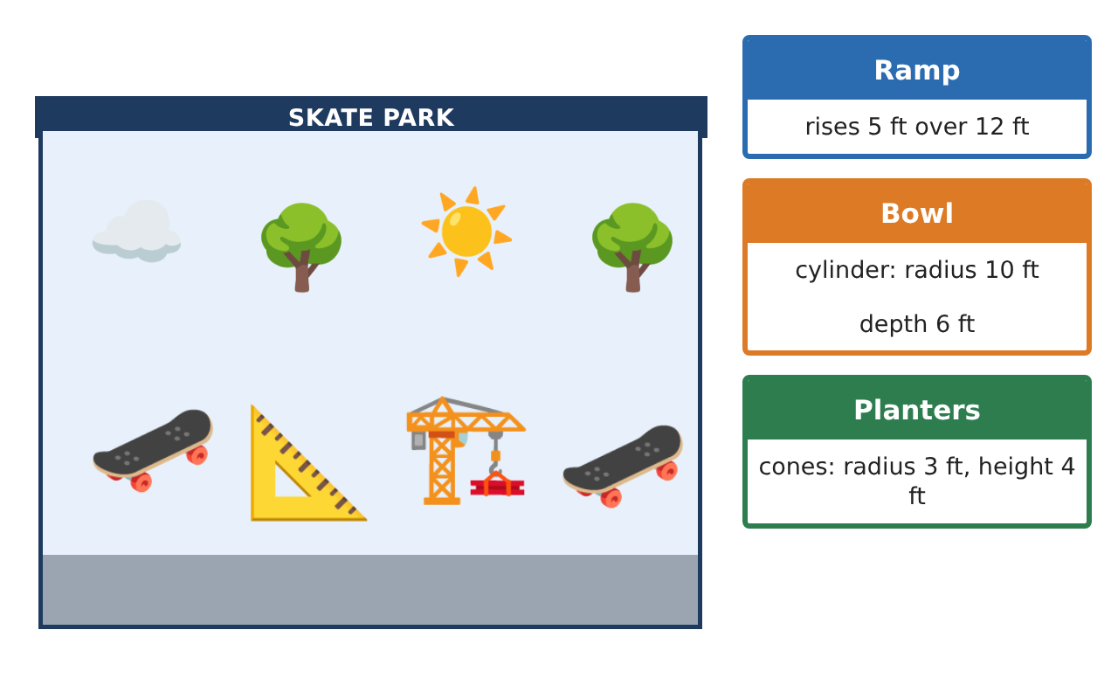
Learning Goals
- I can apply the Pythagorean Theorem in two and three dimensions.
- I can use distance and midpoint ideas to plan a site.
- I can compare volumes and solve for missing dimensions.
Project Timeline
When | What you will do
Day 1 | Ramps in 2D and 3D
Day 2 | Site Layout
Day 3 | Bowl Engineering
Final | Skate Park Blueprint + reflection
Part 1: Ramps in 2D and 3D
Day 1 · Use the Pythagorean Theorem.
1. A storage box is 3 ft by 4 ft by 12 ft. How long is the longest pole that fits inside (corner to opposite corner)?

2. A ramp has the same steepness as the 5-over-12 ramp and rises 7.5 feet. Find its run and its length.

3. A support has a hypotenuse of 10 feet and one leg of 7 feet. Find the other leg exactly and to the nearest hundredth.

Part 2: Site Layout
Day 2 · Use the coordinate map.
4. Find the distance between (−4, −1) and (8, 4).

5. A bench goes halfway between those two points. Where is it?

6. Find the perimeter of the triangular zone with vertices (0, 0), (9, 0), and (0, 12).

Part 3: Bowl Engineering
Day 3 · Concrete costs $150 per cubic yard (27 ft³).
7. A new bowl is a half-sphere with radius 9 feet. Find its volume.

8. Compare it with a cylinder bowl of radius 9 feet and depth 9 feet. What fraction of the cylinder is the half-sphere?

9. A cone planter has radius 3 feet and the same volume as a sphere of radius 3 feet. How tall is it?

10. How much would the concrete for the half-sphere bowl cost?

Final Product: Skate Park Blueprint
Your final product must include:
- 3D diagonal and scaled ramp calculations
- Site layout with distance, midpoint, and perimeter
- Bowl design comparison
- Planter dimensions from a volume requirement
- Budgeted concrete order
Reflection
R1. How is finding a 3D diagonal like using the Pythagorean Theorem twice?

R2. Why is a half-sphere bowl $\frac{2}{3}$ of a cylinder with the same radius and depth?

Scoring Rubric
Criteria | 4 – Exceeds | 3 – Meets | 2 – Approaching | 1 – Beginning
Mathematical Accuracy | All calculations and solutions are correct; answers include units and are checked. | Nearly all work is correct; minor errors do not change conclusions. | Several errors; some conclusions are affected. | Many errors or missing work.
Reasoning & Justification | Clear, complete explanations connect every answer to the situation; uses precise vocabulary. | Explanations are mostly clear and connected to the situation. | Explanations are brief or partly unclear. | Little or no explanation.
Application & Design | Pythagorean Theorem, distance, and volume calculations are correct and used to make design decisions. Goes beyond the minimum with a creative, realistic choice. | Pythagorean Theorem, distance, and volume calculations are correct and used to make design decisions. | Design is incomplete or only partly uses the math from the unit. | Design is missing or unrelated to the unit math.
Communication & Presentation | Blueprint and concrete order are labeled with units and show all work. Polished, organized, and visually engaging. | Blueprint and concrete order are labeled with units and show all work. Organized and easy to follow. | Product is missing required parts or is hard to follow. | Product is mostly missing.

