PRE-ALGEBRA (8TH) · UNIT 6: CONGRUENCE AND SIMILARITY  Tile Pattern Studio  Design floor tile patterns with transformations, similarity, and angle facts. | CP1  2–3 class periods

Name: ________________________________ Date: ______________ Period: ______
The Scenario
A community center is redoing its lobby floor and wants a tile pattern designed by students. The pattern starts with one right-triangle tile that is moved around a grid.
You will use transformations, similarity, and angle relationships to build a pattern that fits perfectly and to measure things you cannot reach.
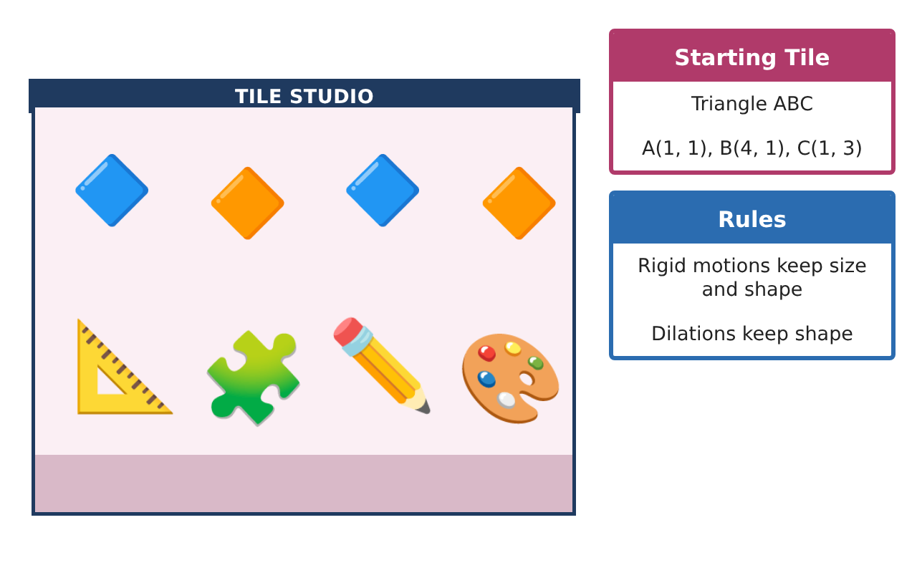
Learning Goals
- I can describe sequences of transformations with coordinate rules.
- I can use dilations and similarity to find lengths and areas.
- I can use angle relationships to solve for unknown angles.
Project Timeline
When | What you will do
Day 1 | Sequences of Moves
Day 2 | Similar Tiles
Day 3 | Solving with Angles
Final | Tile Design Portfolio + reflection
Part 1: Sequences of Moves
Day 1 · Tile ABC: A(1, 1), B(4, 1), C(1, 3).
1. Reflect the tile over the x-axis, then translate it 3 units left. Give the final coordinates.

2. Write the rule for a translation 5 right and 2 up.

3. Rotate the tile 180° about the origin.

Part 2: Similar Tiles
Day 2 · Use dilations and similarity.
4. Dilate the tile by 1.5 from the origin. Find the new coordinates and compare the areas.

5. Are triangles with sides 3, 4, 5 and 4.5, 6, 7.5 similar? Explain.

6. A 6-foot column casts a 4-foot shadow while a flagpole casts a 14-foot shadow. How tall is the flagpole?

Part 3: Solving with Angles
Day 3 · Use angle relationships.
7. A triangular tile has angles 47° and 68°. Find the third angle and the exterior angle next to it.

8. Alternate interior angles measure (3x + 10)° and (5x − 30)°. Find x and the angle.

9. Explain why two tiles with angles of 40° and 75° must be similar.

Final Product: Tile Design Portfolio
Your final product must include:
- Coordinates for a sequence of transformations
- Dilated tile with an area comparison
- An indirect measurement using similar triangles
- Angle equations solved
- Tile design portfolio with rules for every move
Reflection
R1. Why does the area grow by the square of the scale factor?

R2. Why is AA enough to show triangles are similar?

Scoring Rubric
Criteria | 4 – Exceeds | 3 – Meets | 2 – Approaching | 1 – Beginning
Mathematical Accuracy | All calculations and solutions are correct; answers include units and are checked. | Nearly all work is correct; minor errors do not change conclusions. | Several errors; some conclusions are affected. | Many errors or missing work.
Reasoning & Justification | Clear, complete explanations connect every answer to the situation; uses precise vocabulary. | Explanations are mostly clear and connected to the situation. | Explanations are brief or partly unclear. | Little or no explanation.
Application & Design | Transformations, dilations, similarity, and angle relationships are applied correctly. Goes beyond the minimum with a creative, realistic choice. | Transformations, dilations, similarity, and angle relationships are applied correctly. | Design is incomplete or only partly uses the math from the unit. | Design is missing or unrelated to the unit math.
Communication & Presentation | Portfolio shows coordinates, rules, measurements, and a clear final design. Polished, organized, and visually engaging. | Portfolio shows coordinates, rules, measurements, and a clear final design. Organized and easy to follow. | Product is missing required parts or is hard to follow. | Product is mostly missing.

