PRE-ALGEBRA (8TH) · UNIT 6: CONGRUENCE AND SIMILARITY  Tile Pattern Studio  Design floor tile patterns with transformations, similarity, and angle facts. | CP2  2–3 class periods

Name: ________________________________ Date: ______________ Period: ______
The Scenario
A community center is redoing its lobby floor and wants a tile pattern designed by students. The pattern starts with one right-triangle tile that is moved around a grid.
You will use transformations, similarity, and angle relationships to build a pattern that fits perfectly and to measure things you cannot reach.
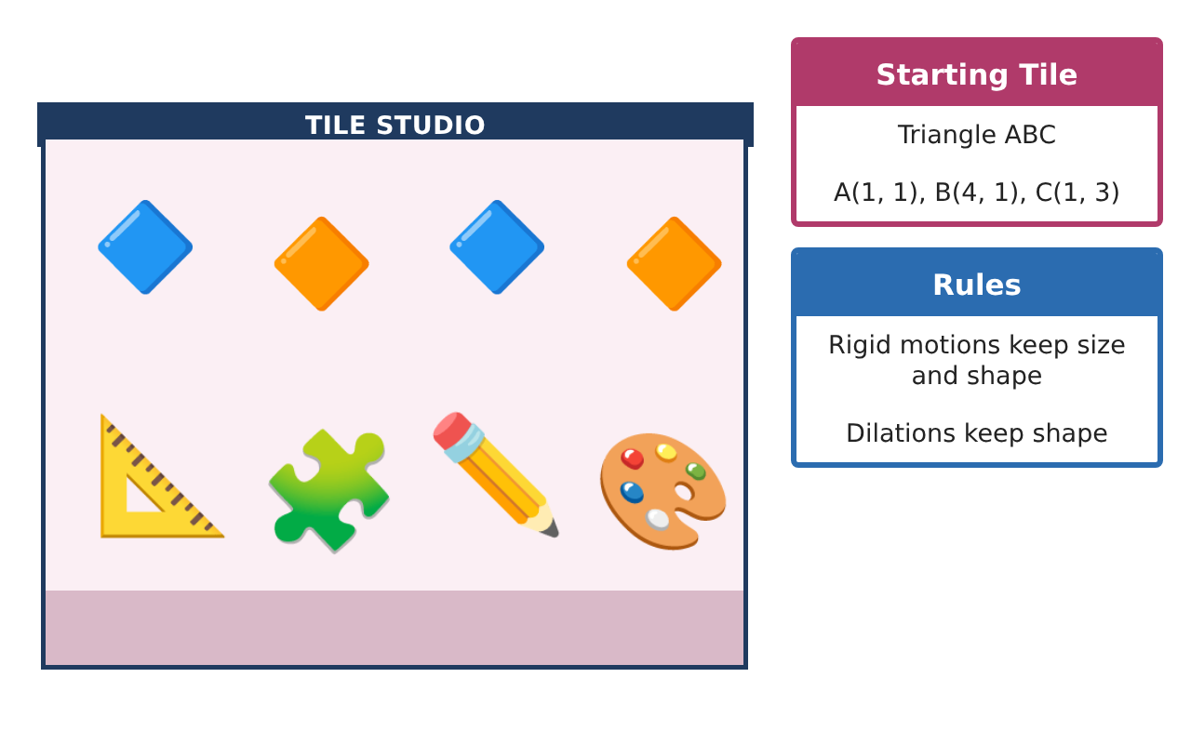
Learning Goals
- I can translate, reflect, and rotate a figure on a coordinate grid.
- I can dilate a figure and explain why the image is similar.
- I can use angle facts about triangles and parallel lines.
Project Timeline
When | What you will do
Day 1 | Slide and Flip
Day 2 | Turn and Grow
Day 3 | Angle Facts
Final | Tile Design Portfolio + reflection
Part 1: Slide and Flip
Day 1 · Tile ABC: A(1, 1), B(4, 1), C(1, 3).
1. Translate the tile 5 units right and 2 units up. Give the new coordinates.
Starter: (x, y) → (x + 5, y + 2)

2. Reflect the original tile over the y-axis. Give the new coordinates.

3. Are the new tiles congruent to the original? Explain.

Part 2: Turn and Grow
Day 2 · Use the original tile.
4. Rotate the tile 90° counterclockwise about the origin. Use (x, y) → (−y, x).

5. Dilate the tile by a scale factor of 2 from the origin.

6. Side AB is 3 units long. How long is A′B′ after the dilation? Is the new tile congruent or similar?

Part 3: Angle Facts
Day 3 · Use the triangle angle sum and parallel lines.
7. The tile has a 90° angle and a 34° angle. Find the third angle.

8. Grout lines form parallel lines cut by a transversal. One angle is 115°. Find a corresponding angle and a same-side interior angle.

9. Design a pattern using at least two different transformations of the tile. Describe each move.

Final Product: Tile Design Portfolio
Your final product must include:
- Coordinates for each transformed tile
- A dilated tile with side lengths
- Angle calculations for the pattern
- Your tile pattern on grid paper
- A description of every transformation used
Reflection
R1. Which transformations make a congruent figure? Which make a similar figure?

R2. How do parallel lines help you find angles in the pattern?

Scoring Rubric
Criteria | 4 – Exceeds | 3 – Meets | 2 – Approaching | 1 – Beginning
Mathematical Accuracy | All calculations and solutions are correct; answers include units and are checked. | Nearly all work is correct; minor errors do not change conclusions. | Several errors; some conclusions are affected. | Many errors or missing work.
Reasoning & Justification | Clear, complete explanations connect every answer to the situation; uses precise vocabulary. | Explanations are mostly clear and connected to the situation. | Explanations are brief or partly unclear. | Little or no explanation.
Application & Design | Transformations, dilations, similarity, and angle relationships are applied correctly. Goes beyond the minimum with a creative, realistic choice. | Transformations, dilations, similarity, and angle relationships are applied correctly. | Design is incomplete or only partly uses the math from the unit. | Design is missing or unrelated to the unit math.
Communication & Presentation | Portfolio shows coordinates, rules, measurements, and a clear final design. Polished, organized, and visually engaging. | Portfolio shows coordinates, rules, measurements, and a clear final design. Organized and easy to follow. | Product is missing required parts or is hard to follow. | Product is mostly missing.

