PRE-ALGEBRA (8TH) · UNIT 7: GEOMETRY  Skate Park Design  Use the Pythagorean Theorem, distance, and volume to design a skate park. | CP2  2–3 class periods

Name: ________________________________ Date: ______________ Period: ______
The Scenario
The town is building a new skate park, and the design team wants student input. Ramps must have the right lengths, paths must be planned on the map, and the concrete must be ordered in the right amount.
You will use right triangles, the distance formula, and volume formulas to create a blueprint and a concrete order.
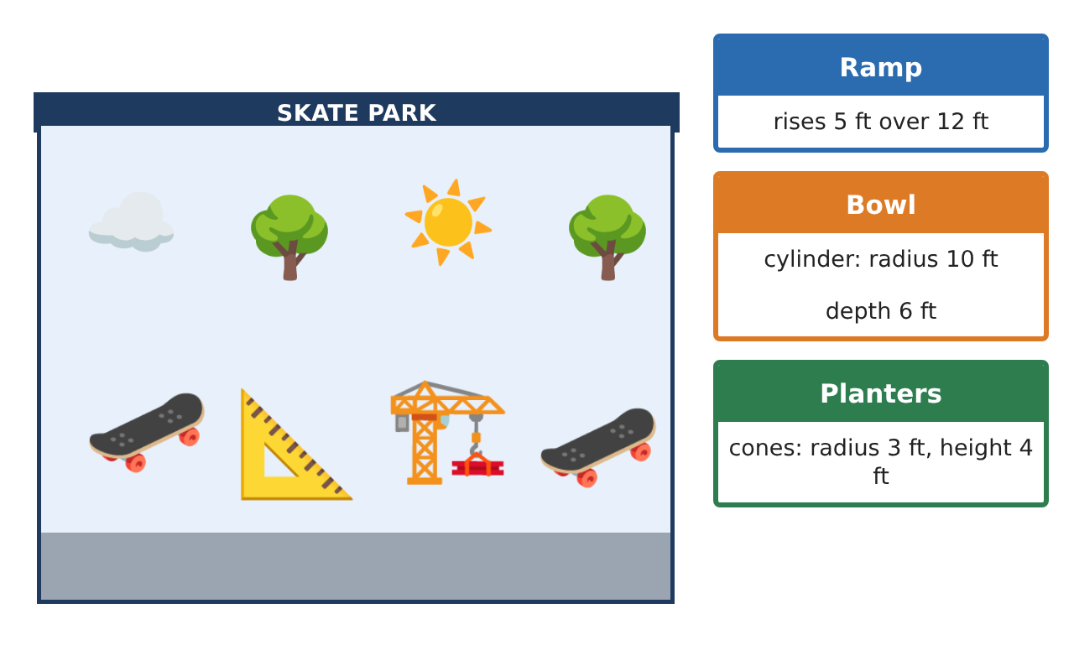
Learning Goals
- I can use the Pythagorean Theorem to find a missing side of a right triangle.
- I can find the distance between two points on a coordinate map.
- I can find volumes of cylinders, cones, and spheres.
Project Timeline
When | What you will do
Day 1 | Ramps and Rails
Day 2 | Map Distances
Day 3 | Concrete and Planters
Final | Skate Park Blueprint + reflection
Part 1: Ramps and Rails
Day 1 · Use a² + b² = c².
1. A ramp rises 5 feet over a run of 12 feet. How long is the ramp surface?
Starter: 5² + 12² = c² → c² = ___

2. A rail goes 8 feet across and 6 feet up. How long is the rail?

3. Is a triangle with sides 7, 24, and 25 feet a right triangle? Explain.

Part 2: Map Distances
Day 2 · Each grid unit on the map is 5 feet.
4. The entrance is at (1, 2) and the half-pipe is at (7, 10). How far apart are they in grid units and in feet?

5. Find the distance between the bench at (−2, 3) and the fountain at (4, −5) in grid units.

6. The park is a 60-foot by 80-foot rectangle. How long is the diagonal path across it?

Part 3: Concrete and Planters
Day 3 · Use π ≈ 3.14 or the π key. Round to the nearest tenth.
7. The bowl is a cylinder with radius 10 feet and depth 6 feet. Find its volume.

8. Each planter is a cone with radius 3 feet and height 4 feet. Find its volume.

9. Decorative concrete balls are spheres with radius 1 foot. Find the volume of one ball.

Final Product: Skate Park Blueprint
Your final product must include:
- Ramp and rail lengths
- Map distances in units and feet
- Volumes of the bowl, a planter, and a ball
- A labeled blueprint on grid paper
- A short presentation to the design team
Reflection
R1. How do you know which side is the hypotenuse?

R2. How is the volume of a cone related to the volume of a cylinder with the same base and height?

Scoring Rubric
Criteria | 4 – Exceeds | 3 – Meets | 2 – Approaching | 1 – Beginning
Mathematical Accuracy | All calculations and solutions are correct; answers include units and are checked. | Nearly all work is correct; minor errors do not change conclusions. | Several errors; some conclusions are affected. | Many errors or missing work.
Reasoning & Justification | Clear, complete explanations connect every answer to the situation; uses precise vocabulary. | Explanations are mostly clear and connected to the situation. | Explanations are brief or partly unclear. | Little or no explanation.
Application & Design | Pythagorean Theorem, distance, and volume calculations are correct and used to make design decisions. Goes beyond the minimum with a creative, realistic choice. | Pythagorean Theorem, distance, and volume calculations are correct and used to make design decisions. | Design is incomplete or only partly uses the math from the unit. | Design is missing or unrelated to the unit math.
Communication & Presentation | Blueprint and concrete order are labeled with units and show all work. Polished, organized, and visually engaging. | Blueprint and concrete order are labeled with units and show all work. Organized and easy to follow. | Product is missing required parts or is hard to follow. | Product is mostly missing.

