PRE-ALGEBRA (8TH) · UNIT 1: REAL NUMBERS AND EXPONENTS  Space Mission Planner  Use scientific notation, exponents, and roots to plan a crewed mission to Mars. | CP1  2–3 class periods

Name: ________________________________ Date: ______________ Period: ______
The Scenario
NASA has asked your class to help plan the first crewed trip to Mars. The distances are enormous, the radio messages take minutes to arrive, and every module of the habitat has to be sized exactly.
You will use scientific notation, exponent rules, and square and cube roots to plan the trip and design the habitat.
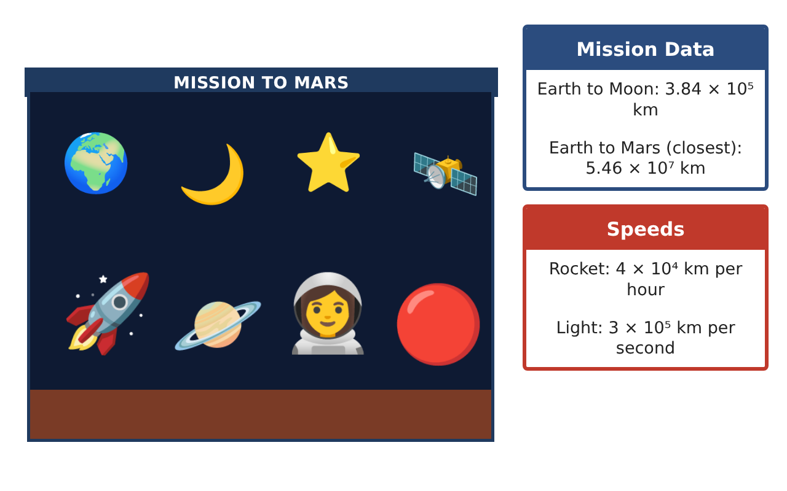
Learning Goals
- I can compute with numbers in scientific notation and choose sensible units.
- I can apply the laws of exponents, including zero and negative exponents.
- I can classify real numbers and estimate irrational square roots.
Project Timeline
When | What you will do
Day 1 | Distances & Comparisons
Day 2 | Time & Supplies
Day 3 | Habitat Math
Final | Mission Plan + reflection
Part 1: Distances & Comparisons
Day 1 · Use the Mission Data Cards.
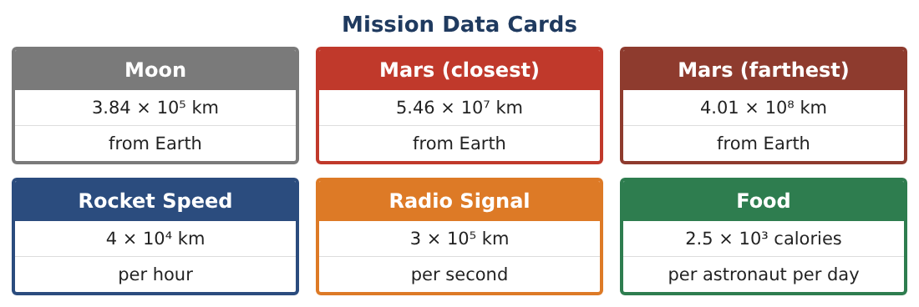
1. Find the difference between the Mars (closest) distance and the Moon distance. Write the answer in scientific notation.

2. About how many times as far is Mars (farthest) as Mars (closest)? Round to the nearest tenth.

3. The spacecraft has a mass of 2.9 × 10⁶ kg and a satellite has a mass of 4.5 × 10³ kg. About how many times as heavy is the spacecraft? Write the answer in scientific notation.

Part 2: Time & Supplies
Day 2 · Use the speeds and the food card.
4. Find the travel time to Mars at its closest in hours (scientific notation) and in days (nearest tenth).

5. Find the radio delay to Mars at its closest and at its farthest. Give each in seconds and in minutes (nearest tenth).

6. A crew of 4 astronauts flies for 60 days. How many calories of food do they need? Write the answer in scientific notation.

Part 3: Habitat Math
Day 3 · Use exponent rules and roots.
7. Simplify (3²)³ · 3⁻⁴ and evaluate.

8. A cube module has a volume of 343 m³. Find its edge. If the edge is doubled, what is the new volume?

9. Classify each number as rational or irrational: √36, √40, 0.25, π, ∛27.

10. Estimate √40 to the nearest tenth without a calculator. Explain.

Final Product: Mission Plan
Your final product must include:
- Distance comparisons in scientific notation
- Travel time, radio delay, and food plan
- Habitat sizes using roots and exponent rules
- A classification of the real numbers used in the plan
- A one-page mission briefing
Reflection
R1. Why does doubling the edge of a cube multiply its volume by 8?

R2. How do you decide whether a square root is rational?

Scoring Rubric
Criteria | 4 – Exceeds | 3 – Meets | 2 – Approaching | 1 – Beginning
Mathematical Accuracy | All calculations and solutions are correct; answers include units and are checked. | Nearly all work is correct; minor errors do not change conclusions. | Several errors; some conclusions are affected. | Many errors or missing work.
Reasoning & Justification | Clear, complete explanations connect every answer to the situation; uses precise vocabulary. | Explanations are mostly clear and connected to the situation. | Explanations are brief or partly unclear. | Little or no explanation.
Application & Design | Scientific notation computations, exponent rules, and roots are used correctly to plan the mission. Goes beyond the minimum with a creative, realistic choice. | Scientific notation computations, exponent rules, and roots are used correctly to plan the mission. | Design is incomplete or only partly uses the math from the unit. | Design is missing or unrelated to the unit math.
Communication & Presentation | Mission plan shows distances, times, supplies, and habitat sizes with labeled work and units. Polished, organized, and visually engaging. | Mission plan shows distances, times, supplies, and habitat sizes with labeled work and units. Organized and easy to follow. | Product is missing required parts or is hard to follow. | Product is mostly missing.

