PRE-ALGEBRA (8TH) · UNIT 1: REAL NUMBERS AND EXPONENTS  Space Mission Planner  Use scientific notation, exponents, and roots to plan a crewed mission to Mars. | CP2  2–3 class periods

Name: ________________________________ Date: ______________ Period: ______
The Scenario
NASA has asked your class to help plan the first crewed trip to Mars. The distances are enormous, the radio messages take minutes to arrive, and every module of the habitat has to be sized exactly.
You will use scientific notation, exponent rules, and square and cube roots to plan the trip and design the habitat.
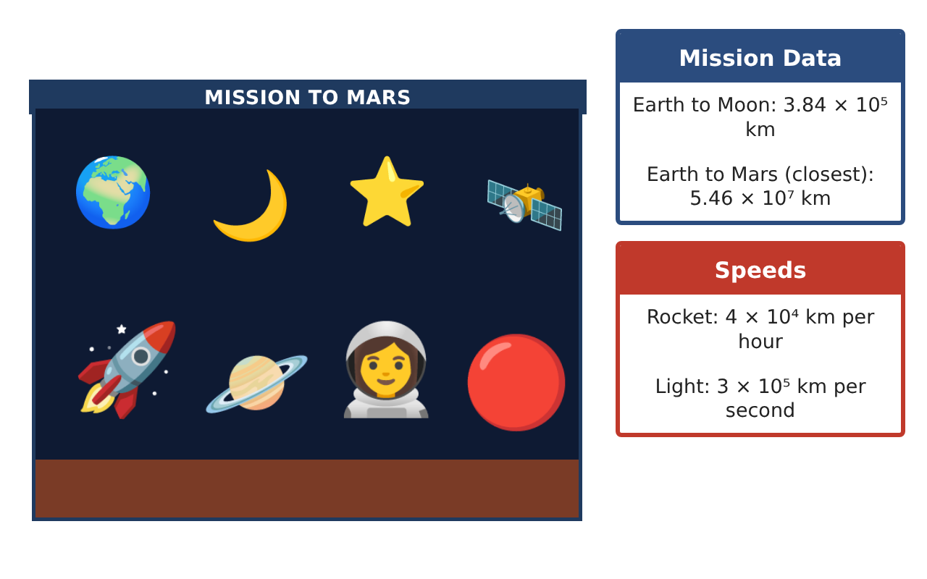
Learning Goals
- I can write very large numbers in scientific notation and standard form.
- I can multiply and divide numbers written in scientific notation.
- I can use square roots, cube roots, and exponent rules.
Project Timeline
When | What you will do
Day 1 | Big Numbers
Day 2 | Travel Time
Day 3 | Habitat Design
Final | Mission Plan + reflection
Part 1: Big Numbers
Day 1 · Use the Mission Data Cards.
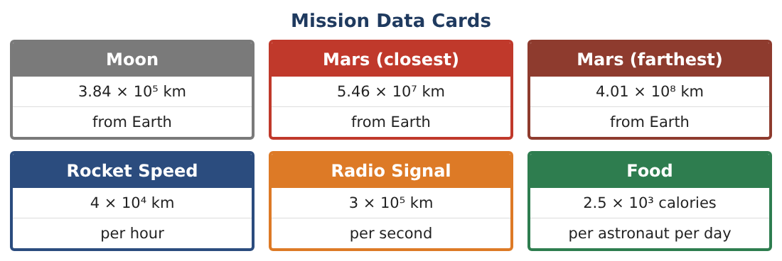
1. Write the distance from Earth to the Moon, 384,000 km, in scientific notation.
Starter: ___ × 10^___

2. Write 5.46 × 10⁷ km in standard form.

3. About how many times as far is Mars (closest) as the Moon? Divide and round to the nearest whole number.

Part 2: Travel Time
Day 2 · Divide distance by speed to find time.
4. The rocket travels 4 × 10⁴ km per hour. How many hours does it take to reach the Moon?
Starter: (3.84 ÷ 4) × 10^(5 − 4) = ___

5. How many hours does the rocket take to reach Mars at its closest? About how many days is that?

6. A radio signal travels 3 × 10⁵ km per second. How many seconds does a message take to reach Mars at its closest?

Part 3: Habitat Design
Day 3 · Use roots and exponent rules to size the habitat.
7. A cube-shaped sleeping module has a volume of 512 cubic meters. How long is each edge?

8. A square solar panel has an area of 49 square meters. How long is each side?

9. Each supply crate holds 2³ boxes, and each box holds 2⁴ meal packs. Write the number of meal packs in one crate as a power of 2 and as a number.

10. Is √50 rational or irrational? Between which two whole numbers is it?

Final Product: Mission Plan
Your final product must include:
- Distances in scientific notation and standard form
- Travel times to the Moon and Mars
- Radio delay to Mars
- Habitat sizes found with roots
- A mission poster with one fact written in scientific notation
Reflection
R1. Why is scientific notation useful for space distances?

R2. How do you divide numbers in scientific notation?

Scoring Rubric
Criteria | 4 – Exceeds | 3 – Meets | 2 – Approaching | 1 – Beginning
Mathematical Accuracy | All calculations and solutions are correct; answers include units and are checked. | Nearly all work is correct; minor errors do not change conclusions. | Several errors; some conclusions are affected. | Many errors or missing work.
Reasoning & Justification | Clear, complete explanations connect every answer to the situation; uses precise vocabulary. | Explanations are mostly clear and connected to the situation. | Explanations are brief or partly unclear. | Little or no explanation.
Application & Design | Scientific notation computations, exponent rules, and roots are used correctly to plan the mission. Goes beyond the minimum with a creative, realistic choice. | Scientific notation computations, exponent rules, and roots are used correctly to plan the mission. | Design is incomplete or only partly uses the math from the unit. | Design is missing or unrelated to the unit math.
Communication & Presentation | Mission plan shows distances, times, supplies, and habitat sizes with labeled work and units. Polished, organized, and visually engaging. | Mission plan shows distances, times, supplies, and habitat sizes with labeled work and units. Organized and easy to follow. | Product is missing required parts or is hard to follow. | Product is mostly missing.

