PRE-ALGEBRA (8TH) · UNIT 1: REAL NUMBERS AND EXPONENTS  Space Mission Planner  Use scientific notation, exponents, and roots to plan a crewed mission to Mars. | Honors  2–3 class periods

Name: ________________________________ Date: ______________ Period: ______
The Scenario
NASA has asked your class to help plan the first crewed trip to Mars. The distances are enormous, the radio messages take minutes to arrive, and every module of the habitat has to be sized exactly.
You will use scientific notation, exponent rules, and square and cube roots to plan the trip and design the habitat.
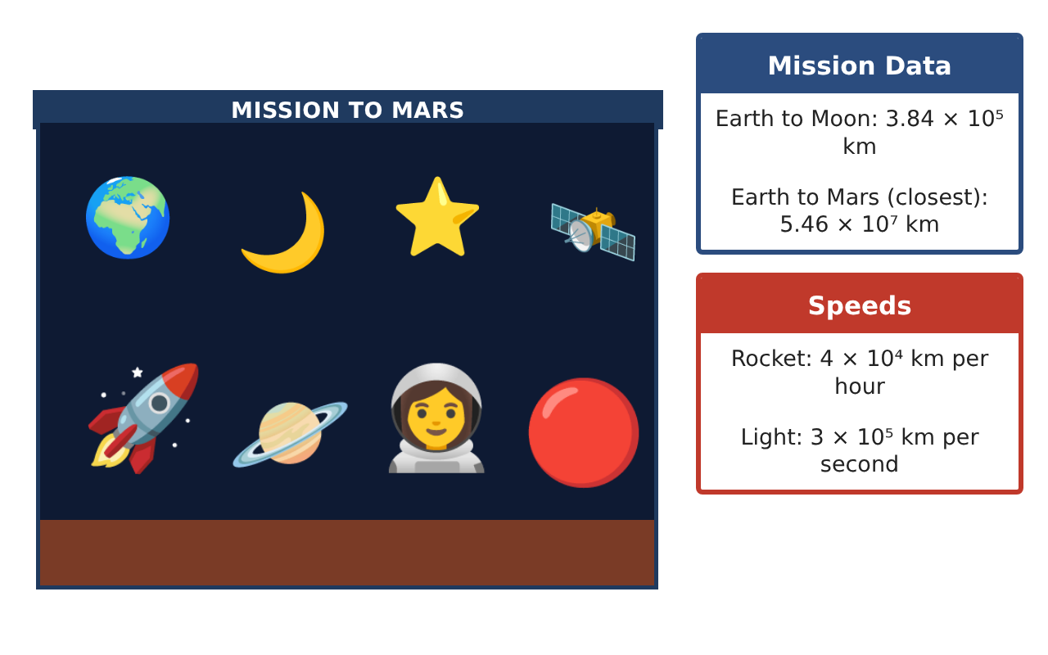
Learning Goals
- I can solve multi-step problems with scientific notation and unit conversions.
- I can simplify expressions with integer exponents and explain the rules.
- I can reason about irrational numbers and approximate them.
Project Timeline
When | What you will do
Day 1 | Beyond Mars
Day 2 | Speed & Time
Day 3 | Habitat Engineering
Final | Mission Plan + reflection
Part 1: Beyond Mars
Day 1 · A light-year is about 9.46 × 10¹² km.
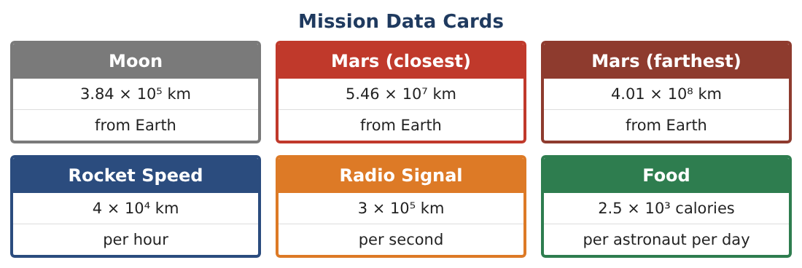
1. Proxima Centauri is 4.24 light-years away. Find the distance in kilometers in scientific notation (three significant digits).

2. How many Earth–Moon distances (3.84 × 10⁵ km) is that? Use scientific notation.

3. A solar film is 0.00000052 m thick. Write this in scientific notation. How many layers make 1 mm?

Part 2: Speed & Time
Day 2 · Use the Mission Data Cards.
4. At 4 × 10⁴ km per hour, how many years would the rocket take to reach Proxima Centauri? (Use 8,760 hours per year.)

5. What speed (km per hour) is needed to reach Mars at its closest in 30 days? Use scientific notation.

6. Mission control sends a question to Mars (closest) and waits for the reply. What is the shortest round-trip wait?

Part 3: Habitat Engineering
Day 3 · Use exponent rules, roots, and reasoning.
7. Simplify (2⁵ · 2⁻²) ÷ (2³)² and evaluate.

8. One cube module has a volume of 1,000 m³. A storage module has 8 times the volume. Find both edge lengths and the ratio of the edges.

9. Show by squaring that √2 is between 1.41 and 1.42. Why does its decimal never end or repeat?

10. The food budget is 1 × 10⁷ calories. Choose a crew size and find the longest mission it supports at 2.5 × 10³ calories per person per day.

Final Product: Mission Plan
Your final product must include:
- Interstellar distance and travel time in scientific notation
- Required speed and communication delays
- Exponent simplifications with explanations
- Habitat module dimensions
- Mission proposal with a crew-size and food-budget recommendation
Reflection
R1. Explain why a⁻ⁿ = $\frac{1}{aⁿ}$ using a pattern of powers.

R2. Why can the product of two irrational numbers be rational? Give an example.

Scoring Rubric
Criteria | 4 – Exceeds | 3 – Meets | 2 – Approaching | 1 – Beginning
Mathematical Accuracy | All calculations and solutions are correct; answers include units and are checked. | Nearly all work is correct; minor errors do not change conclusions. | Several errors; some conclusions are affected. | Many errors or missing work.
Reasoning & Justification | Clear, complete explanations connect every answer to the situation; uses precise vocabulary. | Explanations are mostly clear and connected to the situation. | Explanations are brief or partly unclear. | Little or no explanation.
Application & Design | Scientific notation computations, exponent rules, and roots are used correctly to plan the mission. Goes beyond the minimum with a creative, realistic choice. | Scientific notation computations, exponent rules, and roots are used correctly to plan the mission. | Design is incomplete or only partly uses the math from the unit. | Design is missing or unrelated to the unit math.
Communication & Presentation | Mission plan shows distances, times, supplies, and habitat sizes with labeled work and units. Polished, organized, and visually engaging. | Mission plan shows distances, times, supplies, and habitat sizes with labeled work and units. Organized and easy to follow. | Product is missing required parts or is hard to follow. | Product is mostly missing.

