PRE-ALGEBRA (8TH) · UNIT 6: CONGRUENCE AND SIMILARITY  Tile Pattern Studio  Design floor tile patterns with transformations, similarity, and angle facts. | Honors  2–3 class periods

Name: ________________________________ Date: ______________ Period: ______
The Scenario
A community center is redoing its lobby floor and wants a tile pattern designed by students. The pattern starts with one right-triangle tile that is moved around a grid.
You will use transformations, similarity, and angle relationships to build a pattern that fits perfectly and to measure things you cannot reach.
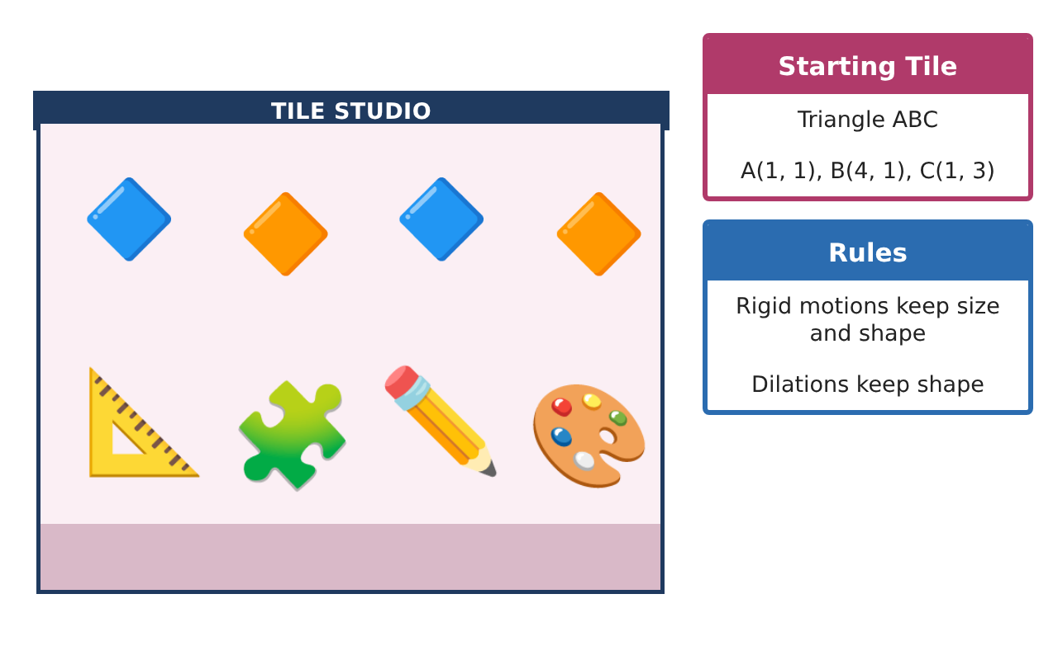
Learning Goals
- I can find single transformations equivalent to sequences and prove it with coordinates.
- I can use dilations about any center and similarity relationships.
- I can use angle facts to decide which polygons tile a floor.
Project Timeline
When | What you will do
Day 1 | Equivalent Moves
Day 2 | Similarity at Work
Day 3 | Which Shapes Tile?
Final | Tile Design Portfolio + reflection
Part 1: Equivalent Moves
Day 1 · Tile ABC: A(1, 1), B(4, 1), C(1, 3).
1. Show that reflecting over the y-axis and then over the x-axis is the same as one rotation. Which one?

2. Find a transformation (or sequence) that maps ABC to A″(−1, −1), B″(−1, −4), C″(−3, −1).

3. Dilate the tile by a scale factor of 2 centered at C(1, 3).

Part 2: Similarity at Work
Day 2 · Use dilations and similar triangles.
4. A tile is dilated by a scale factor of 3. The original area is 3 square units. Find the new area.

5. A student's eyes are 5 feet high. She stands 4 feet from a floor mirror and sees the top of a building 48 feet from the mirror. How tall is the building?

6. Two grout lines are parallel and two transversals meet at a point, forming two triangles. Explain why the triangles are similar.

Part 3: Which Shapes Tile?
Day 3 · A shape tiles a floor at a point if its angles fit exactly around that point (360°).
7. Explain why regular hexagons tile a floor but regular pentagons do not.

8. A triangle has angles (2x)°, (3x + 5)°, and (4x − 14)°. Find each angle.

9. Design a tessellation that uses the original tile and its images under two different transformations. Describe the moves and show why the angles fit.

Final Product: Tile Design Portfolio
Your final product must include:
- Coordinate proofs of equivalent transformations
- Dilation about a point other than the origin
- Indirect measurement with the mirror method
- Tessellation analysis with angle sums
- Designed tessellation with documentation
Reflection
R1. How can you prove two sequences of transformations are equivalent?

R2. Why do any triangle and any quadrilateral tile a floor?

Scoring Rubric
Criteria | 4 – Exceeds | 3 – Meets | 2 – Approaching | 1 – Beginning
Mathematical Accuracy | All calculations and solutions are correct; answers include units and are checked. | Nearly all work is correct; minor errors do not change conclusions. | Several errors; some conclusions are affected. | Many errors or missing work.
Reasoning & Justification | Clear, complete explanations connect every answer to the situation; uses precise vocabulary. | Explanations are mostly clear and connected to the situation. | Explanations are brief or partly unclear. | Little or no explanation.
Application & Design | Transformations, dilations, similarity, and angle relationships are applied correctly. Goes beyond the minimum with a creative, realistic choice. | Transformations, dilations, similarity, and angle relationships are applied correctly. | Design is incomplete or only partly uses the math from the unit. | Design is missing or unrelated to the unit math.
Communication & Presentation | Portfolio shows coordinates, rules, measurements, and a clear final design. Polished, organized, and visually engaging. | Portfolio shows coordinates, rules, measurements, and a clear final design. Organized and easy to follow. | Product is missing required parts or is hard to follow. | Product is mostly missing.

